**TRAINING MANUAL FOR**

**NATIONAL FOOD SECURITY MISSION**

**COMMERCIAL CROPS (JUTE)**

**(2018-19)**

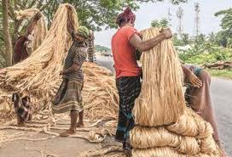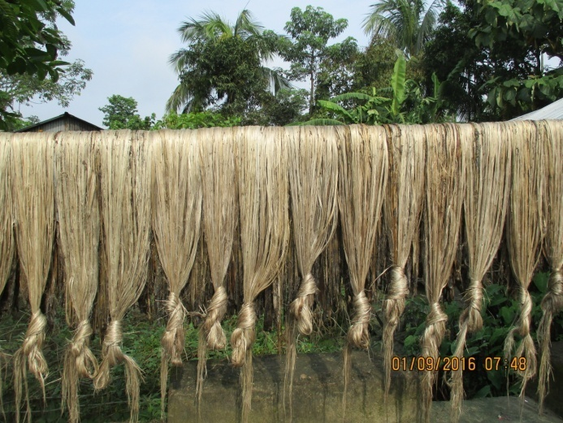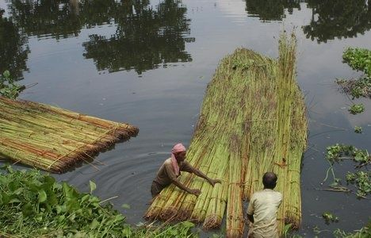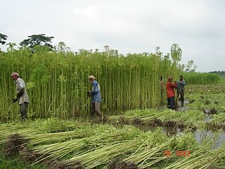

**DIRECTORATE OF AGRICULTURE**

**MEGHALAYA, SHILLONG.**

***Foreword***

In response to the need of the department and the Agronomy sector in particular, we have develop the training manual on National Food Security Mission**-** Commercial Crops (Jute**)** for use by the functionaries in imparting training to the target growers, which is in accordance with the prescribed guidelines laid down for successful implementation of the scheme.

The manual is designed to provide technical knowhow to the Stake holders, with the sole aim to foster and step up the level of production and productivity of food grain in the state on one hand, and on the other hand, it provides trainers with detailed guidelines on how to conduct workshop and training in an efficient manner.

The department is confident that through this manual, the participants in the training will acquire the knowledge intended for achieving the purpose of the scheme.



**Date: 7th Aug, 2018**  **Shri. R. Langstieh**

**Director (Research &Training)**

**Meghalaya::Shillong**

**CONTENTS**

|  |  |  |
| --- | --- | --- |
| **SL.NO** | **PARTICULARS** | **PAGE NO.** |
| 1. | Objective of the Training under NFSM Commercial Crop (Jute) | 1 |
| 1. | Details of Budget Estimate | 2 |
| 2. | Tentative Training Programme: Day-1 | 3 |
| 3. | Jute and its Potential in Meghalaya | 4 |
| 4. | Package and Practices of Jute | 5-9 |
| 5. | Advanced Jute Technology on Retting and Grading | 10-18 |
| 6. | Tentative Training Programme: Day-2 | 19 |
| 7. | Seed Production of Jute Crop | 20-22 |
| 8. | Harvest and Post Harvest Management for Jute Seed Production | 23 |

**OBJECTIVES OF THE TRAINING ON**

**NATIONAL FOOD SECURITY MISSION COMMERCIAL CROPS (JUTE)**

**Introduction**

Jute is one of the important cash crop in Meghalaya and one of the important components under the National Food Security Scheme. Under Commercial Crop (Jute) training is one of the important components. Training of trainers/farmers play a crucial role in speedy dissemination of improved crop production practices. Training has to be imparted to stake holders of whom the farmers play a vital role along with trainers/experts in the field of commercial crop production with the aim of increasing the production and productivity of Jute in the State and the country as a whole. Training has to be organize in two days; both at Kharif season. The number of participants in a group of each day is 20 nos and the participants in all the two days will be the same.

**The main objectives of the training are to:**

1. Create awareness amongst the farmers of the latest and improved technologies of cultivation which could lead to the increase in commercial crop production**.**
2. Increasing production of commercial crops (Jute) through area expansion and productivity enhancement in a sustainable manner in the identified districts of the country.
3. To enhance their skill in adoption, implementation and field application of the latest and proven technologies for enhancing the production and productivity of Jute crop in all the districts within the state.
4. To encourage all stakeholders to invest more aggressively whatever inputs available to them (quality seeds of new varieties, organic manure, liming, tools and implements etc), their time and other resources to reach the goal of self sufficiency in commercial crop in the state.
5. To advocate the farmers on restoring soil health and productivity at the individual farm level.
6. Enhancing farm level economy (i.e. farm profits) to restore confidence amongst the farmers.
7. Promotion and extension of Improved Technologies i.e., seed, post harvest technique (Conventional/ Improved), resource conservation technologies along with capacity building of the farmers/ extension functionaries.

**DETAILS OF BUDGET ESTIMATE FOR**

**2 DAYS TRAINING**

**AT STATE LEVEL FOR 2018-19**

|  |  |  |
| --- | --- | --- |
| **Particulars** | **Rate** | **Total Amount** |
| Honorarium to Resource Person | Rs. 500 per lecture for 10 lectures | 5000 |
| Refreshment for inaugural session for 50 persons | Rs. 50 per head | 2500 |
| Boarding and Lodging for 20 trainees | Rs. 500 per head per day | 20000 |
| Training kit including publication for 20 trainees | Rs. 400 per trainee | 8000 |
| Contingencies including audio visual arrangements, stationary, field visit etc. | 4500 | 4500 |
| **Total** | | **40000** |

**TENTATIVE TRAINING PROGRAMME UNDER NFSM COMMERCIAL CROPS (JUTE)**

**FOR THE YEAR 2018-19**

**TRAINING: DAY-1**

|  |  |  |  |  |
| --- | --- | --- | --- | --- |
| **Sl No.** | **Date** | **Time** | **Subject** | **Resource Person** |
| 1. |  | 09:00- 10:00 am | Registration |  |
| 2. |  | 10:00- 11:00 am | Inaugural Session |  |
|  |  | 11:00-11:30 am | Refreshment |  |
| 3. |  | 11:30- 12:30 pm | Jute and Its Potential in Meghalaya | Crop/Subject Matter Specialist- ICAR/KVKs/SAUs |
| 4. |  | 12:30- 1:30pm | Package and Practices of Jute | --do-- |
| 5. |  | 01:30 -2:00 pm | Lunch Break |  |
|  |  | 02:00- 3:00pm | Advanced Jute Technology on Retting and Grading | --do-- |
| 6. |  | 03:00- 04:00 pm | Farmer’s Interaction | --do-- |

**TRAINING: DAY-1**

**TIME:** **11:30AM- 12:30PM (1 HOUR)**

**JUTE AND ITS POTENTIAL IN MEGHALAYA**

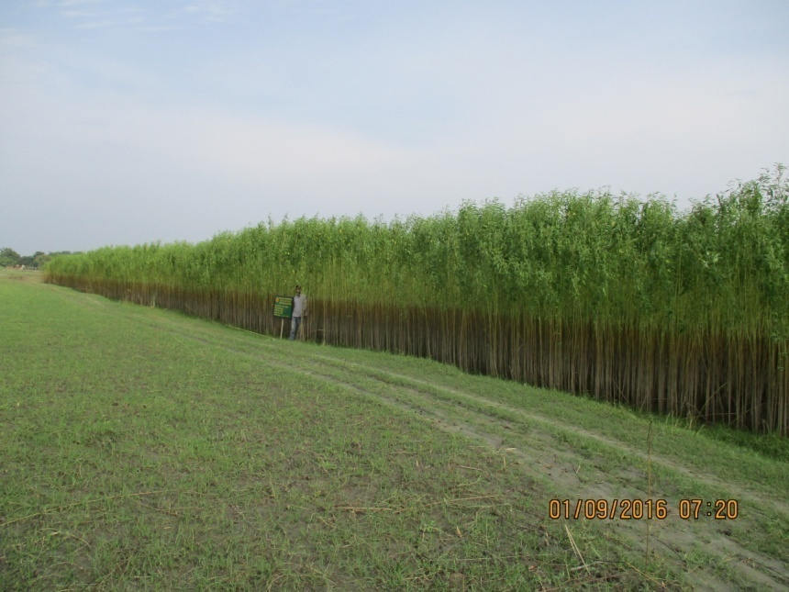In the region of Meghalaya, farmers are usually small and marginal in nature and Jute is one of the important **cash crop** grown as it generates employment and plays an integral part in the farming life as it fit in the traditional rice-rice cropping system in the summer season (Pre Kharif). Major cultivation of Jute is mainly in the plains belt of Garo Hills for many years learning the profession from the neighbouring areas of Assam. Jute in Meghalaya occupies 6982 ha of area, with a production of 72805 metric tonnes and average of 1892 kg/ha (weighing in bales of 180kg/each). The entire life-cycle of jute from cultivation to usage and disposal, it is environmental friendly and produces no toxic material. Hence, the demand of jute and its diversified products for blending of jute with other natural or man-made fibres for furnishing, interior decoration, garments, dress materials, geotextiles, agro-textiles, handicrafts, soft luggage etc. has increased tremendously because of environmental consciousness around the world. To fulfill the increasing demand of jute, it is inevitable to increase the productivity of jute fibre in sustainable manner but in Meghalaya as per statistical data of 2016-17, Jute yield varies among districts from 950 to 2100 bale of 180kg/each. This yield gap can be narrowed down through adoption of improved production technologies. Those agronomic practices, which are cost effective, ecofriendly and energy efficient should be practiced for sustaining the jute fibre production system and environment and thereby society.

**JUTE CROP IN WEST GARO HILLS, MEGHALAYA**

**TRAINING: DAY-1**

**TIME:** **12:30PM- 1:30PM (1 HOUR)**

**PACKAGE AND PRACTICES OF JUTE**

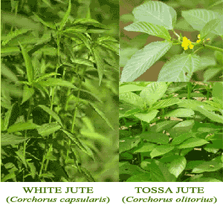

**Sowing Time:**

|  |  |  |
| --- | --- | --- |
| **Sowing time and Suitable varieties for Meghalaya** | | |
|  | ***C. Olitorius*** | ***C. Capsularis*** | |
| Early sowing:  Crop sown from mid-March to First week of April | JRO-524 (Navin)  AAOJ 1 (Tarun)  JRO 204 (Suren) | JRC 212 (Sabuj Sona), JRC  321(Sonali), JRC 80 (Mitali),  JRC 698 (Shrabanti), JRC 4444 (Baldev), AAOJ 1(Tarun) | |
| Normal sowing:  3rd -4th week of April | JRO 8432( Shakti), JRO 128 (Surya),  JBO 2003 H (Ira) S 19 (Subala) AAOJ1 (Tarun) |
| Late sowing: Last week  April – first week May | JRO-524 (Navin), JRO 8432 (Shakti), JRO 128 (Surya), JRO 66 (Golden jublee tossa), JRO 632 (Baisaki Tosa), |

**Seed source and seed treatment**: Certified seeds with proper germination percentage (80-90%) should be collected from NSC centres, Agricultural Development Office (Minikits) and other authorized seed distributors of jute. Bolder seeds should be preferred by screening for getting healthy plant. Before sowing, 100 jute seeds should be kept in wet blotting paper/ cotton cloth in a bowl for 24 -36 hours. If 80-90 % seed germinated it should be selected for sowing.

**Land preparation**: The land should preferably be well drained and having high organic matter content. The field should be ploughed for 2 to 3 times to get fine tilth and properly levelled using ladder as available. A field ditch (20 cm × 30 cm) should be made and connected to a safe outlet to provide drainage to avoid early water logging stress.

**Sowing method and seed rate**: Broadcasting is the most prevalent method of sowing of jute. Good germinating seeds @ 5-6 kg/ha should be broadcasted in prepared jute field criss- cross wise (East to West or vice versa followed by North to South or vice-versa) for uniform seed distribution and desirable plant stand. After sowing, planking should be done to cover the jute seeds. But recommended for line sowing of jute using CRIJAF 4-row seed drill with optimum spacing of 25cm × 5-7cm and seed rate of only 3 kg/ha.

**The following are the advantages of using CRIJAF 4-row seed drill:**

* Facilitates germination by keeping the seeds at proper depth.
* Helps in intercultural operation.
* Reduces labour requirement for thinning and weeding operation.
* Produces uniform jute plant of desired girth
* Increases net return over broadcasting method and
* Reduces seed requirement from 5-6 kg/ha to 3 kg/ha.

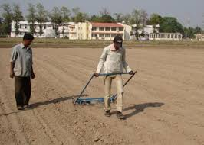A post sowing irrigation should be given to assure proper germination and plant stand if necessary.

**Operation of CRIJAF 4-row seed drill in the Field**

**Nutrient and plant protection measures**

**Intercultural operation**: Optimum plant population is pre-requisite for proper growth and development and getting higher fibre yield for both broadcasted and line sown jute. The optimum plant population for jute should be 4.5 to 5.0 lakhs/ha (45-50 plant/m2), hence, thinning is very much needed and first thinning should be done within 15 to 21 DAS and second at 35 DAS. Line sowing by CRIJAF seed drill eliminates thinning.

**Organic fertilizer and manures application**: Jute is very much responsive to organic fertilizers and as such Rock Phosphate @ 250 kg/ha should be applied in the furrows before sowing. Application of FYM or any other organic manure @ 10 t/ha is recommended before sowing as it not only maximize the yield but also improves the soil quality.

**Weed management**: One hand weeding at 20-30 days after sowing (DAS) to provide optimum weed control. In row crop, weeds between rows can be smothered by a wheel hoe fitted with scrappers or tines. Recently CRIJAF has developed two weeding implement namely Nail weeder and Herbicide brush which can be used for better weed management.

**Water management**: The water requirement for proper growth and development of jute is about 50-64 cm and if normal pre-monsoon rainfall prevails then no need to irrigate the crop. But, now a days due very erratic behaviour of rainfall in pre-monsoon season in eastern India reduced the fibre production. The jute crop is very sensitive to water stress and water logging in the early growth stages. Hence, for better growth to get maximum yield proper irrigation as well as drainage facility should be made. The jute field should be connected with a safe out let through a field ditch (30-40 cm depth and 20 cm wide) to remove excess water from jute field. One pre-sowing irrigation and two additional irrigations at hair cracking stage are sufficient for better growth and fibre yield. One life saving irrigation followed by soil mulching (at field capacity) by CRIJAF nail weeder produced higher fibre compared to traditional rainfed sowing of crop.

**Plant protection measures**: Major incidence of Bihar hairy caterpillar, cut worm, yellow-mite, stem weevil, semilooper and mealy bug. can be controlled checked by cultural practices like optimal date of sowing, proper weed management, plucking of infested leaves should be followed with Spraying of Derisom @3ml/litre. Disease can be controlled by applying Bio- fungicide like *Bacillus* sp. Application of Jeevamrut in 15 days interval is also advisable.

**Harvest and post harvest management**

**Harvesting:** Harvesting is done in mid July at any time before flowering between 120 and 150 days after sowing. The plants are cut at the base very close to the ground with the sickle. Harvested plants are to be kept in the field in 2-3 days to desiccate the foliage to enhance the soil fertility through defoliation of leaves.

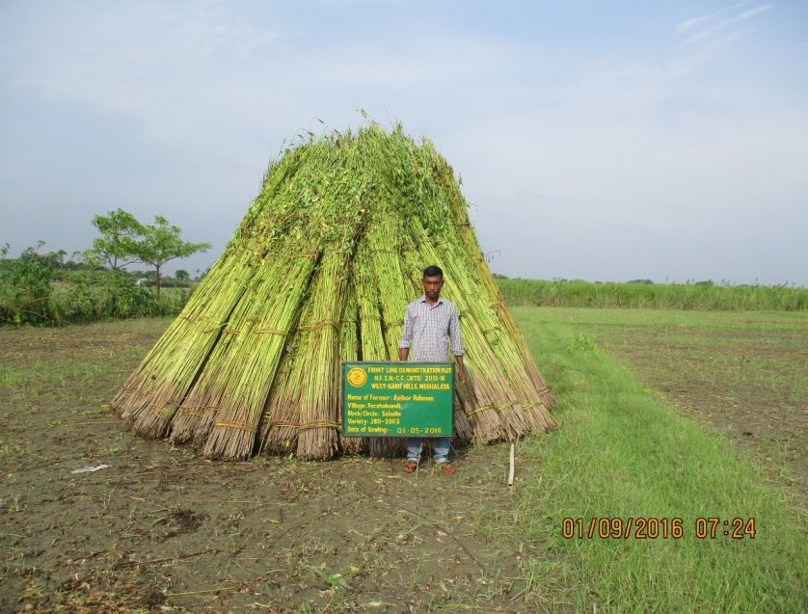

**Harvested Jute crop in West Garo Hills, Meghalaya**

**Retting**: The process of separation and extraction of fibers from non-fibrous tissues and woody part of the stem through dissolution and decomposition of pectins, gums and other mucilaginous substances is called retting. The whole plants are preferably retted in slow moving clean water. In conventional methods, retting is completed between 21 – 25 days depending upon the climatic condition and fibre is extracted from the woody part of the stem. The fibre recovery in jute varies from 6-7% of the green biomass. The quality of jute fibre (strength, fineness and colour) depends upon proper retting which is influence by different factors like age of plant, manure dose, quality of retting water etc. the lack of proper slow moving water farmers prefer to ret their plants in stagnant water like pond, ditches without proper care which lead to reduces the fibre quality by brownish colour of fibre (shymala) and do not get good price in the market.

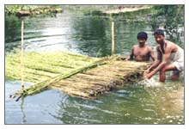

**Retting of Jute**

**Stripping (Fibre Extraction):** Fibres are removed from the stalk by any one of the following methods:    
(i) Single plants are taken and their fibers are taken off.

(ii) Taken off a handful of stalks, breaking it in a to and fro motion in water.

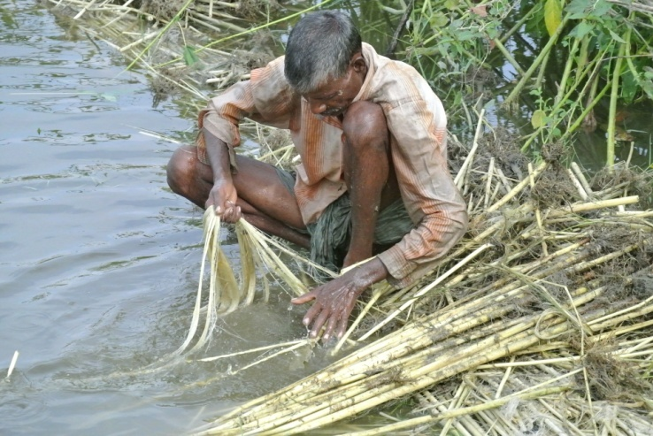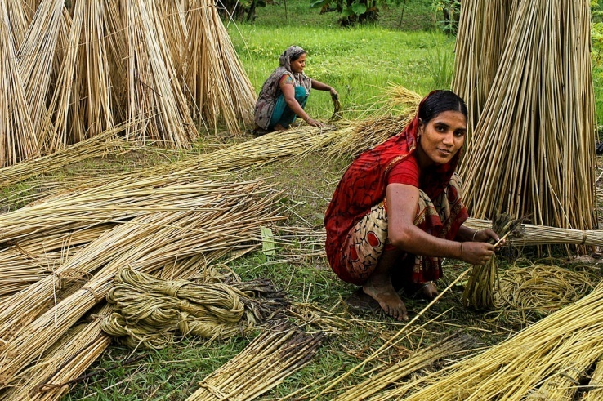(iii) Washing the stalks first by standing in waist deep water and then stripping afterwards. When there is a plenty of water, bundles of stalks are laid in the pond ditches or slow moving streams and left for 5-15 days under water.  The bunch of stem is held in one hand and the root end tapped lightly with a mallet.  After loosens the rest of fibres, fibres are extracted and washed

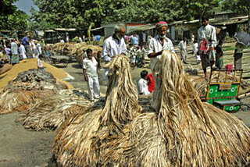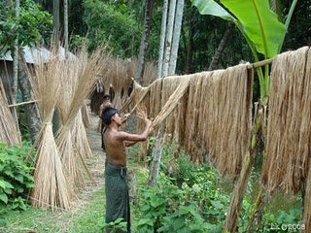

**Graded/Sorted of Jute Fibre**

**Jute Fibre being Dried**

**Bundle Stalk fibre extraction (Stripping) in Jute through to and fro motion in water**

**Single Stalk fibre extraction (Stripping) in Jute**

**Washing and Drying:** Extracted fibres are washed in clean water.  The dark colour of fibres can be removed by dipping them in tamarind water for 15 to 20 minutes and again washed in clean water.  After squeezing excess water the fibres are hang on bamboo railing for sun drying for 2-3 days.

**Bailing and Packing:** The raw jute fibre is graded into TD1 to TD8. Packing into Kutcha bales of about 180 Kg/each. Then they are marketed in the local market or nearby markets.

**TRAINING: DAY-1**

**TIME:** **2:00PM- 3:00PM (1 HOUR)**

**ADVANCED JUTE TECHNOLOGY ON RETTING AND GRADING**

**Jute retting: A key factor for quality fibre production**

The quality of the jute fibre is genetically controlled and it varies among varieties on the basis of anatomical features of the fibre cells and their orientation. Coarser and light-body fibre is obtained from sandy soils whereas clay-loam soils with silt give fibre of superior quality. Climate and the nutrition pattern also affect the fibre. But the most important single factor is ‘retting’ which, if faulty, spoils the positive contributions of the variety, soil, climate etc. Under-retting gives coarse and over-retting dazed and weak fibre. The bundles are kept standing in water, 30 cm deep, and later placed side by side in retting water, usually in 2 to 3 layers and are tied together. They are covered with water-hyacinth or any weed that does not release tannin and iron. The float is then weighed down with seasoned logs or with concrete blocks or are kept submerged (at least 10 cm below the surface of the water) with bamboo-crating. Clods of earth used as a covering material or as weighing agent produce dark fibre of low value. Gently flowing, fairly deep, clear and soft water is ideal for retting. The optimum temperature is around 34oC; ditches, tanks and pools are also used for retting. Incomplete submergence produces ‘croppy’ fibre of extremely low value.

Most of the defects in fibre are due to faulty retting. Over–retting results in ‘dazed’ weak fibre. Retting is a microbiological process and, therefore, the end-point is determined by inspecting a few plants each day from the tenth day onwards. If fibre slips out easily from the wood on pressure from the thumb and fingers, retting is considered complete.

With this background in view, alternative method has been evolved which is as followed:

**1. Improved retting technology**: In improved retting technology, use of retting powder ‘CRIJAF Sona’ contains efficient retting microorganisms properly applied on jute bundle and immersed in water with putting weight bag filled with cement sand rocks etc. improves the retting processes. This technique reduces retting time from 21 days to 12-16 days and enhance the fibre quality from at least 2 grades from TD6 to TD4.

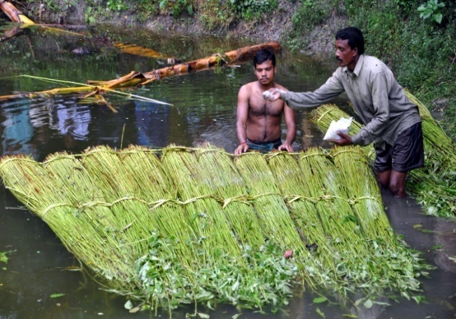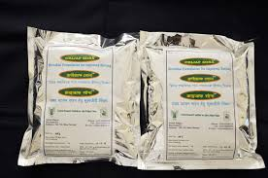

**CRIJAF “Sona” and application to jute crops during retting**

**2. Jute retting by application of chemical accelerator**

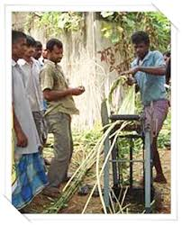Ribboning of green stems by mechanical devices and retting the ribbons in a small volume of water instead of stem retting. In ribbon retting the volume of biomass to be retted comes down to about 40% only. The retting time is also reduced. The release of organic matter into water is less than one third that of stem retting. Such factors enable the ribbon retting to be conducted in almost one-fourth the water used in stem retting and more number of rettings can be done in the same water.

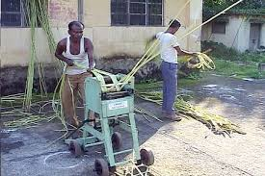

**Extraction of green ribbon using jute fibre extractor**

**3. Retting of whole jute plant with retting accelerator**

This retting technology requires less time for extraction and requires low volume of water. In this process the defoliated jute bundles (50kg) are immersed in a tank or confined water bodies with ratio of plant to water is 1:2. The bundles are stacked in reverse direction and at a place around 30-40 bundles can be placed. The retting accelerator is diluted in the water and uniformly poured in the tank. A few packets were also dusted on the plant heaps and finally the plants were covered with waste jute hessian.

**In- situ Jute Retting with microbial consortium**

* Slow moving soft water produces best quality fibre, but such conditions are rarely prevailed in the jute growing areas of India.
* Scarcity of water or low rainfall during retting time compels farmers to ret their jute crop in stagnant muddy water resulting in low quality jute fibre.
* Under such situation, mechano-microbial retting process developed by CRIJAF proves to be suitable for farmers.
* By this process, farmers can ret their jute crop after ribboning within a period of 7-9 days in very less quantity of water with improvement in fibre quality and more net income than conventional method of retting.
* In-situ jute retting in micro pond with microbial consortium is another suitable option left for jute farmers as an alternative to conventional method of retting in less time, reduced volume of water with quality improvement.

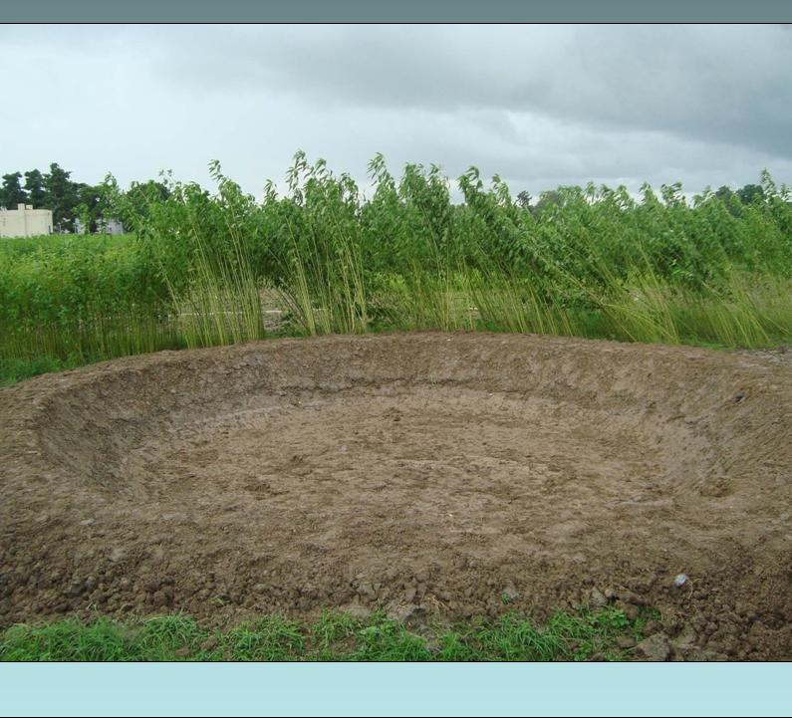

**Micro pond for in – situ jute retting**

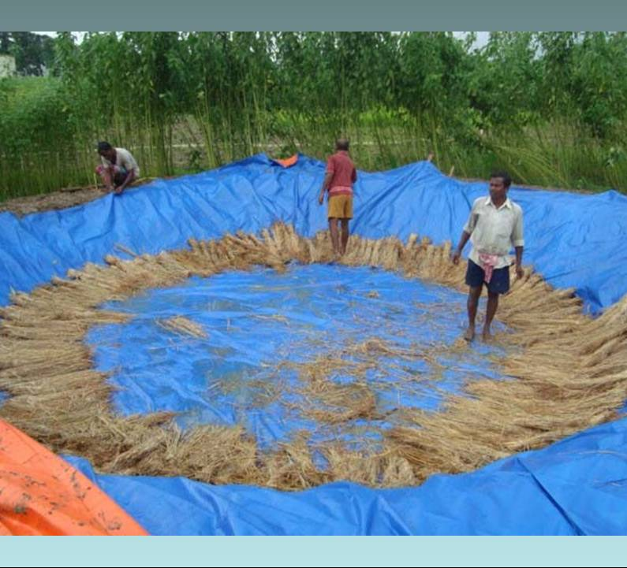

**Radial straw arrangement along periphery**

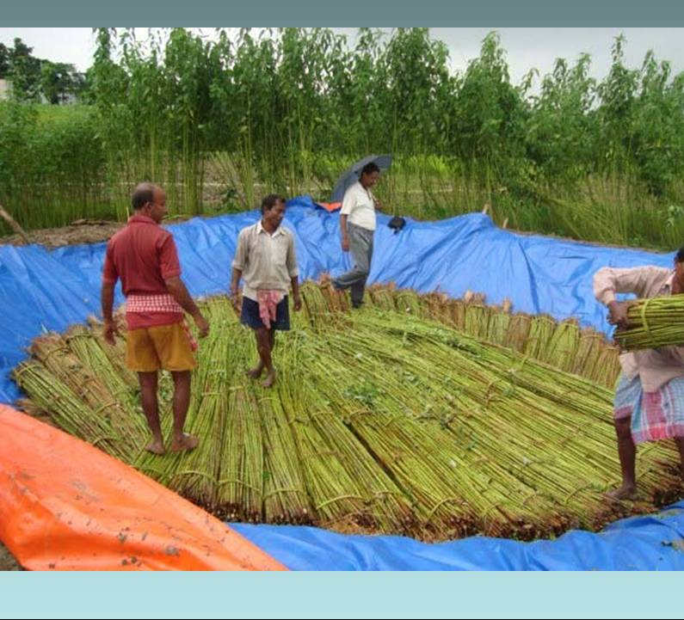

**Radial arrangement of jute bundles in micro retting tank**

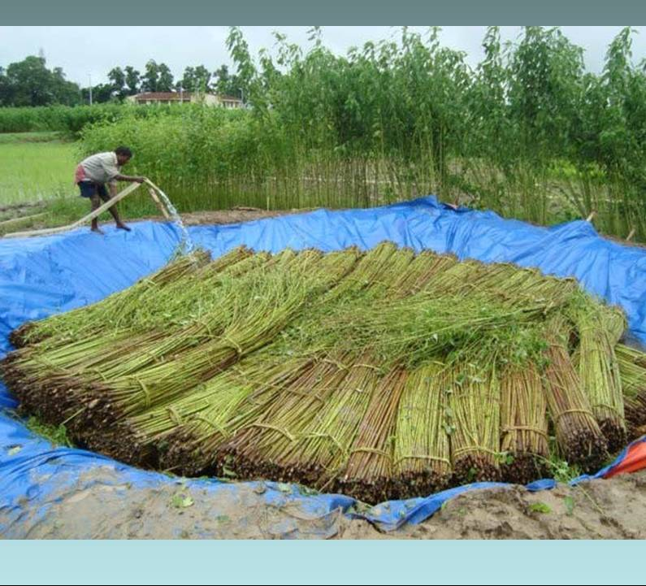

**Application of underground water in micro retting tank**

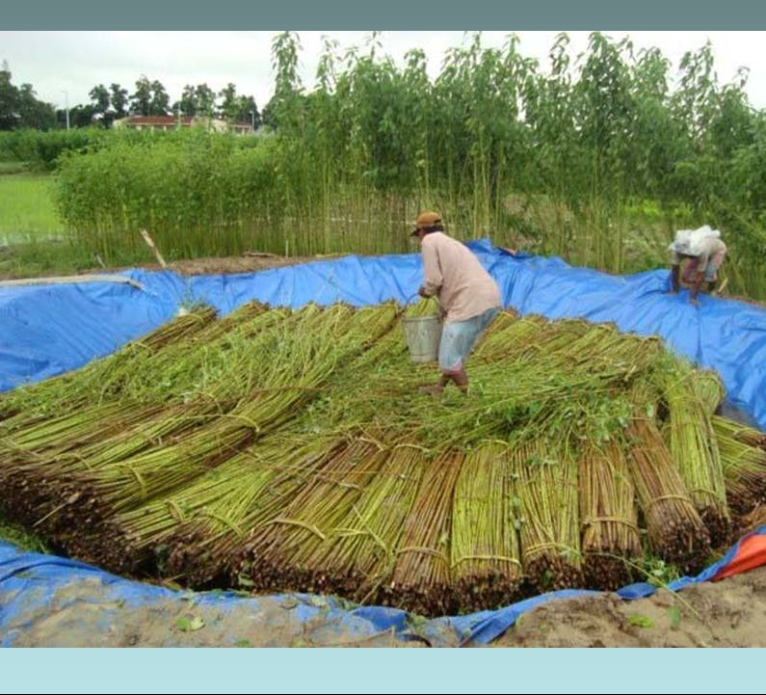

**Application of microbial consortium on jute bundles**

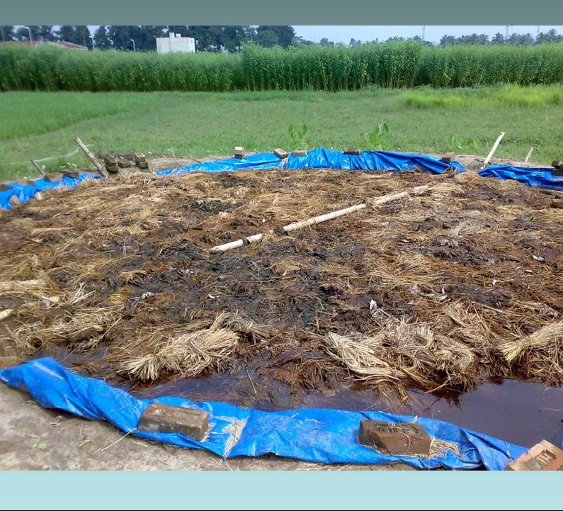

**Well ret jute bundles under straw jak**

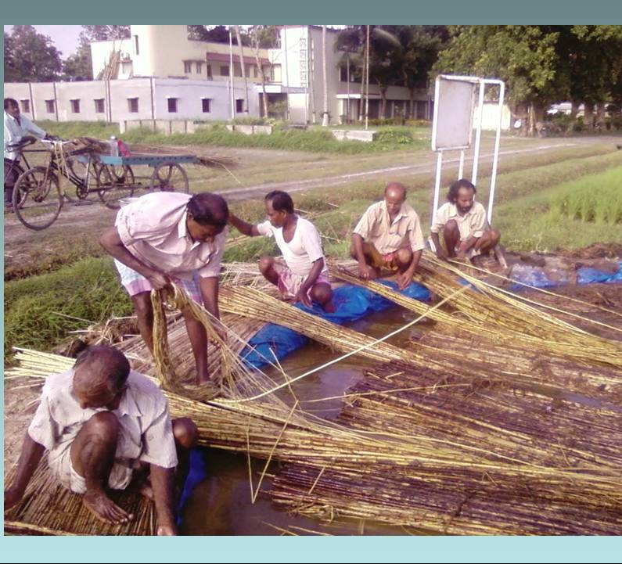

**Fibre extraction at the micro pond**

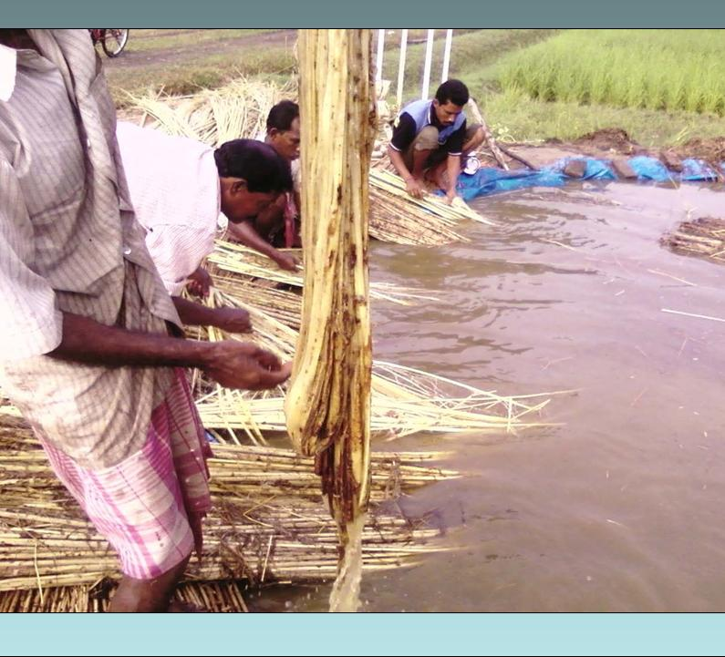

**Washing of fibre at the micro pond**

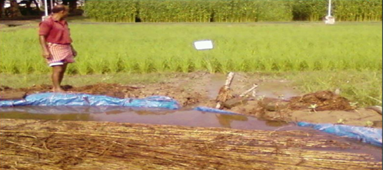

**Diversion of nutrient rich water from retting tank to rice field for irrigation**

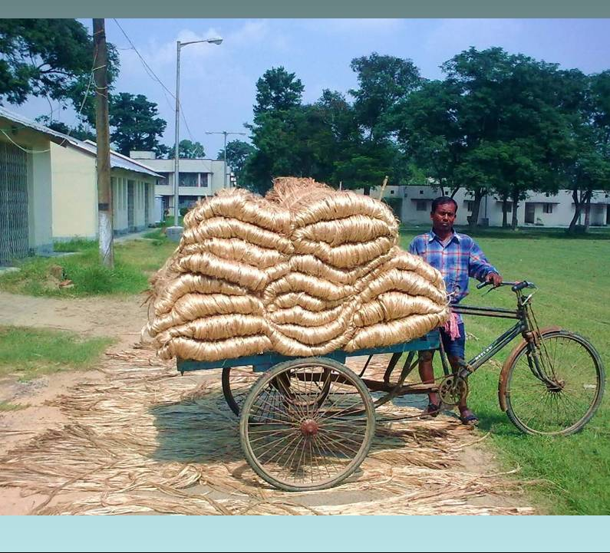

**Golden coloured and lustrous fibre obtained from micro pond is ready for marketing**

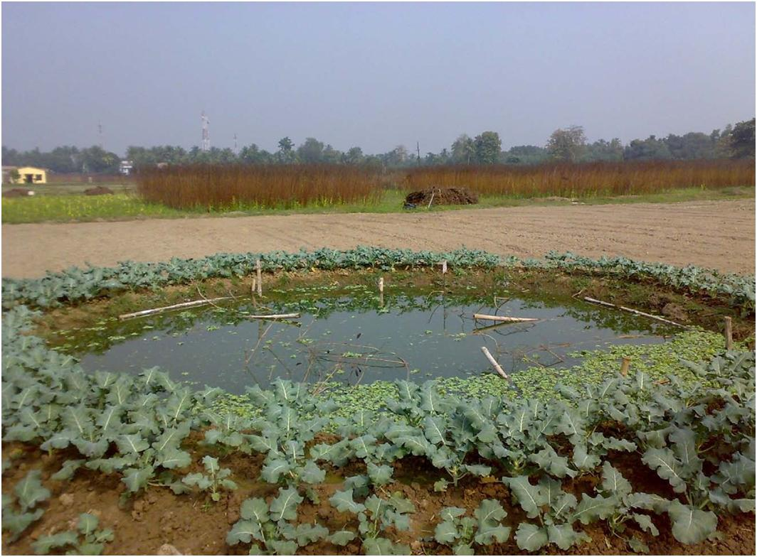

**Growing of vegetables on the embankment of retting tank**

**JUTE GRADING:**

Grading is the most important parameter for fetching good price in the market. Six physical parameters viz., strength, fineness, colour, root content, defects and density of jute fibres are assessed for sorting out the fibre into eight different grades. Relative weightage is given to each physical parameter by standard scoring system and the grade of fibre is determined by total score of the six parameters. In India with object of enabling the cultivators to get proper price for their fibre, (BIS) introduced a standard for grading of raw jute on the basis of its quality. Both white and tossa jute fibres are classified into eight grades, W1-W8, and TD1-TD8. Each grade is assessed by scoring six characters - strength, fineness, defects, root contents, colour and density.

**Table:** **Grades and grading of White Jute (W) and Tossa Jute (TD)**

|  |  |
| --- | --- |
| **Grade** | **Characteristics** |
| W1/TD1 | Very good strength and colour, very fine heavy bodied fibre, free from major and minor defects. Maximum root content: W1-10%, TD1-5%. |
| W2/TD2 | Good strength and colour, fine heavy bodied fibre, free from major and minor defects. Maximum root content: W2-15%, TD2-10%. |
| W3/TD3 | Fairly good colour and strength well separated medium bodied fibre, free from major and minor defects except a few specks. Maximum root content: W3-20%, TD3-15%. |
| W4/TD4 | Fair, average strength and colour, well separated medium bodied fibre, free from major defects and substantially free from specks and loose sticks. Maximum root content: W4-26 % , TD4-20 % |
| W5/TD5 | Average strength and colour, fine from major defects. Maximum root content: W5-36%, TD5-26%. |
| W6/TD6 | Average strength, free from centre root and dazed/over-retted fibre and reasonably free from entangled sticks. Maximum root content: W6-46%, TD6 - 35%. |
| W7/TD7 | Weak mixed fibre with maximum root content: W7-57%. TD7-35%. |
| W8/TD8 | Entangled or any other jute not suitable for any of the above grade but of commercial value |

**GRADING PROCESS:**

There are two systems for grading of jute

• Hand and Eye Method

• Instrumental Method

**Hand & Eye Method**: An expert grader can easily assess the physical characteristics viz., fineness, density and strength of the fibre by his experience testing by hand only while visual assessment will judge colour, root content and defects by a close look at the fibre. 'Hand & Eye Method' is generally used in the market for on the spot assessment of the quality and grading of fibres. This method is subjective and assessment may vary from grader to grader.

**Instrumental Method**: In this method all the six physical characters of fibre essential for determining grade are measured by fibre testing instruments. The use of instrument is essential for an accurate and objective evaluation of grades. In this method all the six physical parameters of fibre essential for determining grade are measured by fibre testing ‎instruments. This fibre testing instruments is used for assessing the quality of fibre quantitatively.

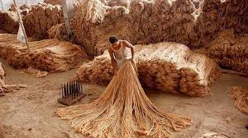

**Hand and Eye Method of Grading Jute**

**TENTATIVE TRAINING PROGRAMME UNDER NFSM COMMERCIAL CROPS (JUTE)**

**FOR THE YEAR 2018-19**

**TRAINING: DAY 2**

|  |  |  |  |  |
| --- | --- | --- | --- | --- |
| **Sl No.** | **Date** | **Time** | **Subject** | **Resource Person** |
|  |  | 10:00- 12:00 pm | Seed Production of Jute Crop | Crop/Subject Matter Specialist- ICAR/KVKs/SAUs |
|  |  | 12:30- 01:30 pm | Harvest and Post Harvest Management for Jute seed Production | --do-- |
|  |  | 01:30 - 2:00 pm | Lunch Break |  |
|  |  | 2:00-05:00 pm | Field Visit  (Post harvest technologies) | --do-- |

**TRAINING: DAY-2**

**TIME:** **10:00AM- 12:00PM (2 HOURS)**

**SEED PRODUCTION OF JUTE CROP**

Production and distribution of certified seed of newly released varieties are the need of the hour for further improvement in productivity. Jute seed production can be increased significantly by adopting improved agronomic techniques. Among the improved agronomic techniques, Optimum sowing time is an important factor as the jute requires a well-distributed monsoon rains during the vegetative period and a rain free period during ripening to harvesting and processing for its seed production. When the crop is sown at its optimum time, there is a synchronisation of the growth phases of the crop with the optimum environmental condition which ultimately leads to better expression of the crop in terms of growth and yield. Another important factor is topping (clipping of apical buds). When the apical buds are clipped off, the auxiliary buds develop lateral branches which in turn increases the seed yield by producing more number of pods.

Now a day, the jute has been facing a strong competition from the synthetic materials prevailing in the market. Therefore, there is a felt need to augment the jute production considerably to make its cultivation profitable to the farmers. One of the most vital keys to success in our endeavour for higher fibre production, improved quality seed is an important input. The quality seeds of an improved variety can itself provide 20 percent additional yield of the crop over that obtained from the use of local seed. But, these quality seeds are generally unavailable to the jute growers of Meghalaya. The farmers usually met their requirement by the N.S.C or agencies where the seeds are grown under its supervision in the major growing states like Assam and West Bengal which in turn increases the cultivation cost significantly. On this contrary, in Meghalaya areas adjoining the Garo Hills Plain Belts can be used for the seed production of jute as the prevailing agro-climatic conditions are congenial for this purpose.

**Improved agronomic practices for jute seed production:**

**Sowing Time:**

Conventional sowing time: Mid-May to Mid June

Area under Upland: Mid July

Area under medium/ low land: August- mid September

Sowing time should be adjusted as per land situation and water availability for obtaining maximum seed yield

**Seed Rate and Spacing**:

Seed requirement is usually 3.0 - 3.5 kg/ha for tossa jute when broadcasting is practiced but 2-2.5 kg seed is sufficient if CRIJAF seed drill is used for sowing. Before sowing, 100 jute seeds should be kept in wet blotting paper/ cotton cloth in a bowl for 24 -36 hours. If 80-90 % seed germinated it should be selected for sowing. It is also advisable to inoculation of seed with biofertilisers.

Spacing of 40 cm × 10 cm or 30 cm × 15 cm is optimum for proper growth and development of lateral branches. Plant population of 2.2 - 2.5 lakh per hectare is optimum for harvesting good seed crop of jute.

**Isolation Distance and Field Standards**:

Both the cultivated species of jute (tossa jute and white jute) are self-pollinated crops. The extent of natural out crossing is 2-3% and 10-12% for white and tossa jute, respectively. A minimum of 30 m and 50 m isolation distance should be maintained from seed plots of other varieties of same species for certified and for foundation seed production, respectively. For checking field standards, minimum three field inspections (first before flowering, second during flowering and third before harvesting) are carried out by Seed Certification Agencies.

Field standards for jute seed certification

**Organic Nutrient management**:

The requirement of phosphorus through Rock Phosphate @ 250 kg/ha is most essential as pre soil application in soil in line or furrows. It is also advisable to add composted FYM @ 5 t/ha mixed in soil before 2-3 days before land preparation.

During sowing time, Additional FYM @ 10t /ha is needed to be added during land preparation.

**Intercultural operation & Weed management:**

**Intercultural operation**: Thinning of seedling for maintenance of optimum plant population is the major intercultural operation required for jute seed crop to facilitate growth of lateral branches for obtaining good seed yield. Thinning should be completed within 21 days after sowing when seedlings attain height of 5-6 inches.

**Detopping:** Seed yield of early sown crop is low due to apical dominance and reduced growth of lateral branches (pod bearing). Apical pruning of the plant (detopping) reverses the process and promote formation of lateral branches, which bear fruits. Detopping is recommended at 30-35 days of crop age depending upon plant height and growth in case of July to mid-August sown crop. Detopping is not at all required in case mid-August to September sown crop. Late sown crop produces profuse natural branching resulting higher seed yield.

**Rouging**: Seed plots are inspected throughout the growing season and off types are removed as and when noticed in the field. Distinguishable and stable characters, which helps in identifying a variety, are utilized in identifying deviants for roguing. Commonly used morphological traits of jute are (a) leaf shape and size (b) pigmentation in stem, leaf, leaf vein, stipule, fruit (c) flowering at juvenile stage (d) dehiscence of mature fruit and (e) seed colour. Roguing should be done at least three times during the crop growth period. First roguing is usually done before flowering when all the vegetative traits are stabilized. The second and third roguing should be done at flowering and fruit maturity stage respectively.

**Weed management**: Weed is the major constraint for enhancing the production of seed. Jute seed crop is more affected by weeds compared to fibre crop, as seed crop is grown in late kharif season which is very congenial for weed infestation and its growth. One hand weeding at 20-30 days after sowing (DAS) for controlling remaining and second flush of weeds provide optimum weed control.

**Plant Protection Measures**: Cultural practices like proper weed management, plucking of infested leaves should be followed with spraying of Derisom @3ml/litre. Disease can be controlled by applying Bio- fungicide like *Bacillus* sp. Application of Jeevamrut in 15 days interval is also advisable

**TRAINING: DAY-2**

**TIME:** **12:30PM- 1:30PM (1 HOUR)**

**HARVEST AND POST HARVEST MANAGEMENT FOR JUTE SEED PRODUCTION**

**Harvesting:** In case of mid-July sown crop harvesting can be done within 140 days after sowing while in August and September sown crop maturity is attained within 120 and 100 days respectively after sowing. Crops should be harvested when all the pods turn brown in colour. Threshing is done manually by beating with sticks or through tractor in case of larger bulk of seed crop. The varieties with shattering pods are easily threshed, but the varieties with non-shattering pods should be dried properly in the field for 2-3 days before threshing.

**Cleaning and drying**: The harvested seeds need to be cleaned properly to remove impurities like weed seeds, seeds of other crops, immature seeds, damaged seeds and inert matter like soil, sand, pebbles, chaffs, pieces of stems, leaves etc. Cleaning is usually done by manual winnowing or by power driven cleaner (air screen cleaner, specific gravity separator) depending on the quantity of seed produced. The jute seeds contain over 11% moisture at the time of harvest and it should be reduced to around 9% for safe storage by sun-drying the seeds for 4 to 5 days.

**Packaging, labelling and sealing**: As per the Seeds Act 1966, every class of seed must be packed in cloth bags duly sealed and labelled. The packaging labels must exhibit the crop and variety name, genetic purity (minimum %), physical purity (minimum %), germination (minimum %), and name of the seed producer along with proper lot number. White and azure blue colour tags are used for foundation and certified seeds, respectively. The minimum prescribed standards (Indian Minimum Seed Certification Standard, 1988) for different classes of seeds are given below:

**Seed Yield**:

Under optimum condition seed yield of 600-850 kg/ha (bales of 180kg/each) can be obtained depending upon land situation and package of practices followed.