TRAINING MANUAL FOR NATIONAL FOOD SECURITY MISSION -RICE, PULSES AND COARSE CEREALS
(2018-19)

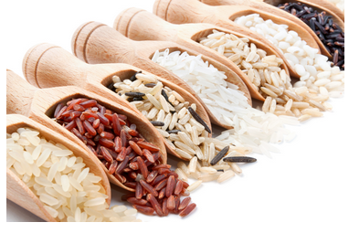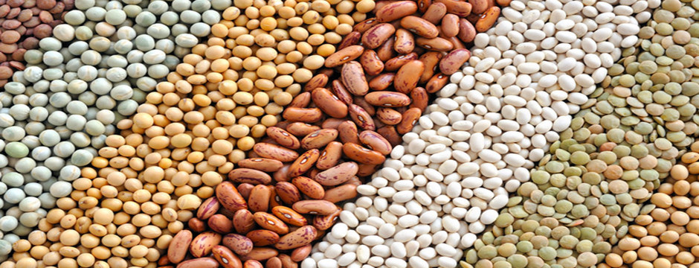
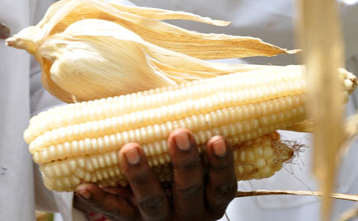
DIRECTORATE OF AGRICULTURE
MEGHALAYA, SHILLONG.
Foreword

In response to the need of the department and the Agronomy sector in particular, we have develop the training manual on National Food Security Mission (Rice, Pulses and Coarse Cereals) for use by the functionaries in imparting training to the target growers, which is in accordance with the prescribed guidelines laid down for successful implementation of the scheme.
The manual is designed to provide technical knowhow to the Stake holders, with the sole aim to foster and step up the level of production and productivity of food grain in the state on one hand, and on the other hand, it provides trainers with detailed guidelines on how to conduct workshop and training in an efficient manner.
The department is confident that through this manual, the participants in the training will acquire the knowledge intended for achieving the purpose of the scheme.

Date: 7th Aug, 2018 Shri. R. Langstieh
Director (Research &Training)
Meghalaya::Shillong

CONTENTS
Sl no. | Particulars | Page
1 | Objective for the training on NFSM | 1
2 | Budget estimate for the training programme | 2
A. PRE KHARIF
3 | Training programme under NFSM scheme for the year 2018-19 Pre-Kharif Season | 3
4 | Modified System of Rice Intensification (SRI) / Integrated Crop Management(ICM) for sali and boro paddy | 4-6
5 | Organic package of practices of soybean | 7-8
6 | Package and practice of maize | 9-12
B. KHARIF
7 | Training programme under NFSM scheme for the year 2018-19 Kharif Season | 13
8 | Management of pest and diseases in rice using bio control/ bio rationals | 14-17
9 | Organic seed production | 18-20
10 | Paddy cum fish culture | 21-22
C. PRE RABI
11 | Training programme under NFSM scheme for the year 2018-19 Pre-Rabi Season | 23
12 | Package of practices of pulses | 24-32
13 | Rape seeds and mustard | 33-36
14 | Demonstration on cultivation of rice based cropping system | 37-39
D. RABI
15 | Training programme under NFSM scheme for the year 2018-19 Rabi Season | 40
16 | Post harvest losses in pulses | 41-43
17 | Milling of pulses | 44-48
18 | Organic compost- 18 days compost(Berkeley compost) | 49-52

OBJECTIVES OF THE TRAINING ON
NATIONAL FOOD SECURITY MISSION- RICE, PULSES AND COARSE CEREALS
Introduction
National Food Security is one of the important missions for the progress of the nation and the State as a whole. One of the main components of the scheme is training. Training of trainers/farmers play a crucial role in speedy dissemination of improved crop production practices. Training has to be imparted to stake holders of whom the farmers play a vital role along with trainers/experts in the field of food grain crop production with the aim of increasing the production and productivity of food grains in the State and the country as a whole. Training has to organized in four sessions; one each at the beginning and after Kharif and Rabi season. The number of participants in a group of each session is 30 nos and the participants in all the four sessions will be the same.

The main objectives of the training are to:
- Create awareness amongst the farmers of the latest and improved technologies of cultivation which could lead to the increase in food grain production.
- To enhance their skill in adoption, implementation and field application of the latest and proven technologies for enhancing the production and productivity of food grains in all the districts within the state.
- To encourage all stakeholders to invest more aggressively whatever inputs available to them (quality seeds of new varieties, organic manure, liming, tools and implements etc), their time and other resources to reach the goal of self sufficiency in food grains in the state.
- To advocate the farmers on restoring soil health and productivity at the individual farm level.

BUDGET ESTIMATE FOR THE TRAINING PROGRAMME
Sl No. | Training Programme | Rate / Training | Nos of Training | Total Amount
1 | Training Programme under National Food Security Mission Scheme-2018-19 | 14000 | 22 | 3,08000.00

DETAILS BUDGET ESTIMATES PER TRAINING

Item | Rate(Rs.) | Amount(Rs.) for 4 sessions
Honorarium for one trainer  Training material & stationary  Refreshment for trainees, supporting staff  Contingency, POL transport etc. | Rs. 500/- per session  Rs. 500/- per session  Rs. 50/- head per session for 35 persons  Rs. 750/- per session | 2000.00  2000.00  7000.00  3000.00

TRAINING PROGRAMME UNDER NFSM SCHEME FOR THE YEAR 2018-19
- Training under Pre- Kharif Season (1st Session)
Sl No. | Date | Time | Subject | Resource Person
1. |  | 10:30- 12:30 pm | Modified System of Rice Intensification | Crop/Subject Matter Specialist- ICAR/KVKs/SAUs
2. |  | 1:00- 3:00 pm | Organic package of practices of Soybean | --do--
3. |  | 3:00- 5:00 pm | Scientific package of practices of Maize | --do--

1ST SESSION
TIME: 10:30AM TO 12:30PM (2 HOURS)

1. MODIFIED SYSTEM OF RICE INTENSIFICATION (SRI) / INTEGRATED CROP MANAGEMENT (ICM) FOR SALI AND BORO PADDY
A majority of the farmers of Meghalaya are small and marginal in nature. Daily wages and agriculture and allied small scale activities are the important source of livelihood for the farmers. Rice (Oryza sativa L.) is the principal food crop of the region and cultivated in about 1,10,455 hectares area with average productivity of below 2 mt/ ha⁻¹ which is far below than the country’s average productivity of 2.4 t ha⁻¹. Rice productivity in the hilly region of Meghalaya, is very low due to traditional agricultural practices (continuous ﬂooding, transplanting of aged seedlings mostly under random planting, inappropriate nutrient and weed management etc.) along with cultivation of low yielding local varieties. Farmers are losing interest in cultivation of rice due to decline in factor productivity and proﬁtability. Hence, there is a need to replace the low yielding, insect pest and disease susceptible local varieties with high yielding, biotic and abiotic stress resistant varieties. There is also greater need to promote improved methods of cultivation for increasing the productivity and efficient utilization of resources. New cultivation techniques like system of rice intensiﬁcation (SRI) has the capacity to improve rice yield substantially.
With the adoption of appropriate crop production technology such as SRI and aerobic production technology etc., it is possible to reduce the yield loss due to climatic aberrations to a great extent and ensure better livelihood. The SRI technique requires less amount of seeds (5–7 kg ha⁻¹) and water, ensures early maturity and sustains soil health. SRI is gaining popularity in many countries including India due to many advantages over conventional method viz. saving of water and seed, high yield and less dependence on chemicals. The SRI is also gaining popularity in North Eastern Regions of India due to its potential for high yields. More rice needs to be produced with less water to feed the burgeoning population, and it is projected that about 47% more food grain mostly rice has to be produced in the NER to meet the requirement by 2050. Since water requirement of rice is much higher in comparison with other crops, rice is targeted locally and globally for conserving. Therefore, much attention is given to rice for efficient water management and technologies are being continuously improved for more water-productive rice cultivation practices. SRI is one such practice that produces more rice with less water. Other choices include reduction in crop duration through short duration rice varieties for growing second crop in succession or change in management practices for sustainable yield.
Certain modiﬁcations in SRI are required to suit the local conditions by using scientiﬁc knowledge of best management practices for increasing the yield and income. Meghalaya indicated need for modifying the SRI practice to suit the local conditions. Modiﬁed SRI/ICM is the intermediate practice between SRI and conventional rice transplanting system which includes transplanting of 20-days-old seedlings in square planting at 20 cm x 20 cm spacing with using two seedlings hill⁻¹ as against transplanting of 10 to 12-days-old seedlings, single seedling hill⁻¹ and wider spacing of 25 cm x 25 cm under SRI. Such practice of transplanting medium aged seedlings at 2 seedlings hill⁻¹ has been found to

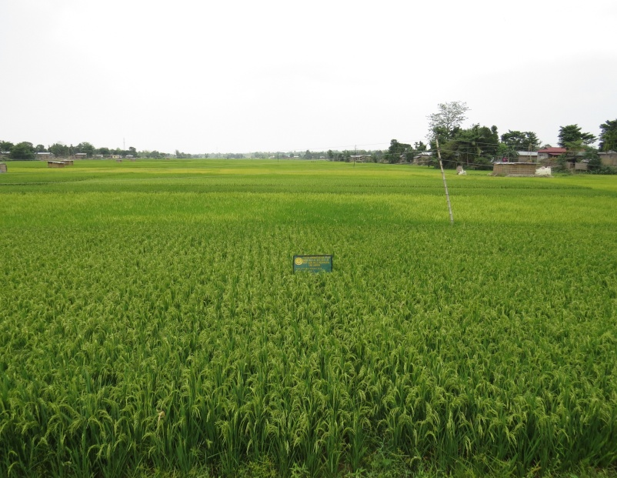
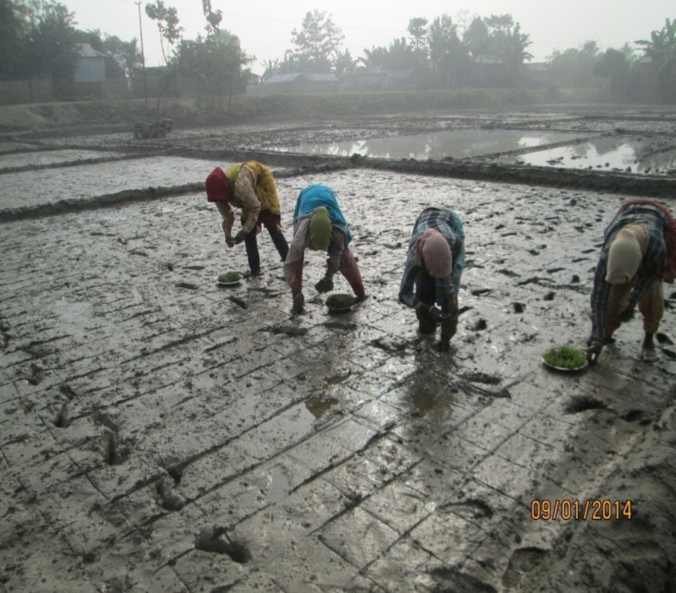
MODIFIED SRI TECHNIQUES FOR HIGHER CROP PRODUCTION IN WEST GARO HILLS

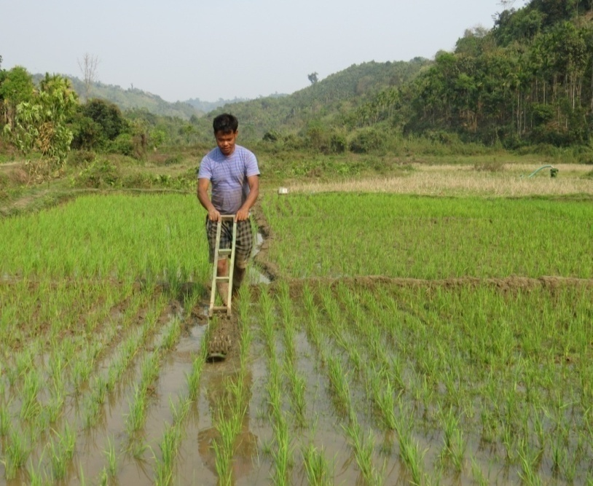
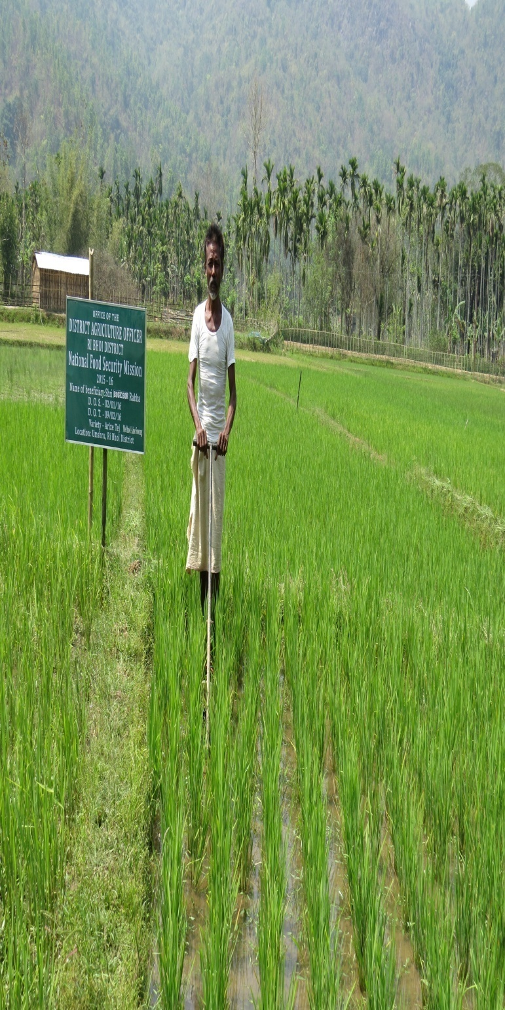
FARMERS OPERATING CONOWEEDER FOR WEED CONTROL AS ONE OF THE OPERATIONS FOR MODIFIED SRI

withstand extreme rainfall events and maintain adequate plant population and hence, enhances rice productivity. It saves inputs and energy, protects the environment and reported to increase rice yield besides sustaining soil fertility. There is also large scope of enhancing cropping intensity by incorporating rabi crops such as pea (Pisum sativum), lentil (Lens culinaris), rapeseed (Brassica napus) etc. after Kharif rice especially in lowlands.
The main 3 advantages in the modified SRI are:
1. The nursery is transplanted much earlier, anywhere between 12th to 18th day decreasing
the disturbance to roots as well as allowing time for tiller growth.
2. Increased distance between plants in SRI allowing for better access to sunlight and more
space for root growth.
3. Weeding and soil loosening using conoweeder after sowing leading to better aeration and
increased tillage.
PACKAGE OF PRACTICES OF MODIFIED SRI
Selection of Land: Medium Upland, Medium Lowland & Lowland areas are very much suitable for MSRI cultivation. In case of Medium Upland & Medium Lowland, the presence of irrigation facility would be helpful for the cultivation.
Land preparation: 2-3 ploughing is required for preparing the land & in the last ploughing, we need to ensure it is upto a depth of 6 inches.
Selection of Seed: For Medium Lowland & Lowland, any improved variety of 150 days duration.
Seed Requirements: 10-12 kg seed is required.
Nursery Preparation: For 1 acre of ‘Transplanting’, preparation of 12 small beds (size 20 ft X 4 ft) is required. Nursery bed should in a corner of our main field for easy transplantation. Prepare drain for drainage of excess water during heavy rain on four sides of the bed. Apply 25 kg of FYM in each of the bed. Then spread the treated and partly germinated seeds in the nursery bed very thinly.
Transplantation: Take seedlings of 16-20 days old for transplantation (depending upon occurrence of a good rain and topography). Pull the seedlings from the nursery bed very carefully (do not disturb the roots) by using a Spade. A spacing of 20 cm X 20 cm is required and transplanting of 2 seedling per hill maintaining the proper spacing with the help of rope.
Main Field Preparation: During the last ploughing, we need to apply 5t/ha of FYM or any organic manures in main field and mixing it with the soil properly. In the main field also, drains should be prepared (4 sides of the main field as well as in the middle of the plot at a distance of every 20 ft). Application of Panchagavya 15 days before transplanting.
Inter-culture operations: Intercultural operations are usually done at 15-20 days, 30-35 days and 40-45 days after transplanting with the help of Conoweeder.
Important points to be taken care of during the practice:
1. There is no need of holding water of 2-2.5 inch on the main field but maintaining water
of 0.5 inch is sufficient
2. There must be provision of alternate drying and soaking of the plot, which will help
Positively in the production
3. For crop protection –visiting the plot regularly should be ensured
4. Put some sticks inside the plot to help birds to come and sit/ incorporation of ITKs
Technologies in protecting the crop
Expected Yield: 6-8 tonnes/ha can be achieved by following the Package of Practices.
1ST SESSION
TIME: 01:00 PM TO 03:00PM (2 HOURS)

2. ORGANIC PACKAGE OF PRACTICES OF SOYBEAN
Soybean (Glycine Max L.) is a very high nutritious crop. It contains about 20 per cent oil and 40 per cent high quality protein. Soybean rich in amino acid (Lycine 5 %), in which most of the cereals are deficient. Soybean oil is used for manufacturing vanaspati ghee and several other industrial products. Soybean used for making high protein food for children. Soybean builds up the soil fertility, by fixing a large amount of atmospheric nitrogen through the root nodules, and also through leaf fall on the ground at maturity. It can be used as fodder, forage can be made into hey, silage etc. Soybean being the richest, cheapest and easiest source of best quality proteins and fats and having a vast multiplicity of uses as food and industrial products is called a wonder crop. Soybean is one of the most important crop in the world and cultivated over an area of 71.87 million hectare
Soil and Climate
Well drained and fertile loamy soils are suitable for cultivation of soybean. The pH ranges from 5.2- 7.5. In acid soils, liming should be done to raise the soil pH. Water logging is injurious to the crop and it grows well in warm and moist climate. The optimum temperature for the cultivation of soybean is 26-30 degree Celsius.
Varieties:-
The recommended varieties are JS-9560, JS-335, Bragg, JSG-19.l
Seed Treatment
Seed treatment with either beejamrut or trichoderma@5g/kg was found effective.
Sowing & Seed Rate:-
Seeds are sown at a depth of 3-5 cm at a spacing of 30-35 x 10-15 cm. A seed rate of 70-75 kg/ha is recommended.
Sowing time:-
April to June-July for High altitude
Summer: June-July for mid and low altitude
Winter: August- September for low altitude

Nutrient management
Soybean, being leguminous crop does not require high dose of nitrogen. Apply 5-7 t/ha of well decomposed farmyard manure (FYM) about 15-20 days before sowing along with 150 kg rock phosphate. It is also advisable to apply 3-4 tonnes of vermicompost/ha alongwith 150 kg/ha rock phosphate. Green manuring crop like tephrosia, crotolaria and sesbania should be applied @ 10 t/ha at15-20 days before sowing the crop.
Weed & Plant Protection management
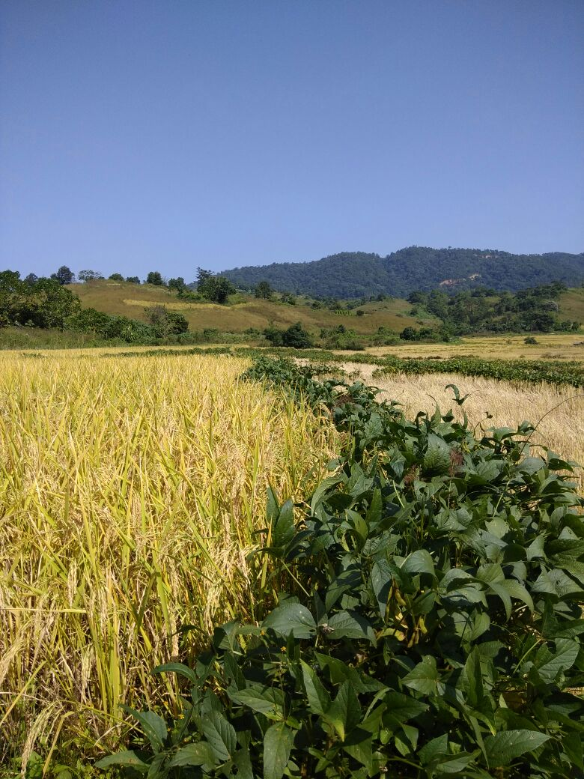
Paddy Cultivation with Soybean in the bunds adding additional income to the farmers in Sung Valley, West Jaintia Hills, District
The Crop should be kept weed free up to 60 Days After Sowing (DAS). One mechanical weeding (20 DAS) and two hand weeding (30 and 50 DAS) are sufficient for higher seed yield. Mulching is also done with weed biomass such as eupatorium and ambrosia @ l0 t/ha, which reduce the weed population, it also add nutrient to the soil and ultimately improve the crop productivity.
Application of Derisom @ 3 ml/lit of water or neem oil @ 3 ml/lit of water is recommended for effective control of insect pest and diseases.

Cropping system
Intercropping of Soybean with maize (2:2) and rice (4:2) has been found promising. The most suitable cropping systems found were maize + soybean 2:2 (kharif) - mustard (rabi) and maize + groundnut 1:2 (kharif) - mustard (rabi). It has also been noticed that resource conservation technologies, such as straw mulching play an important role by conserving moisture in rabi oilseed production under upland.

Harvesting
Harvesting is done when the crop is fully matured. Seed are sundried and stored in a cool and dry place.

Yield
Soybean seed yield ranges from 2.0 -2.5 t/ha under organic farming.

1ST SESSION
TIME: 03:00 PM TO 05:00PM (2 HOURS)

- PACKAGE AND PRACTICE OF MAIZE

Introduction:
Maize (Zea mays L.) is one of the most versatile emerging crops having wider adaptability under varied agro-climatic conditions. Globally, maize is known as queen of cereals because it has the highest genetic yield potential among the cereals. It is grown in as a rainfed crop in upland and jhum land both as mono or mixed crop. It has very high yield potential and is a promising crop for the purpose of human consumption as well as animal feed. In addition to staple food for human being and quality feed for animals, maize serves as a basic raw material as an ingredient to thousands of industrial products that includes starch, oil, protein, alcoholic beverages, food sweeteners, pharmaceutical, cosmetic, film, textile, gum, package and paper industries etc. The yield of maize can be increased through adoption of high yielding varieties and improved technology.
1. VARIETIES RECOMMENDED
A. For Higher and Mid-altitudes (800 m above MSL)
Local Varieties:
- Local white Kernel
- Local Yellow Kernel
High Yielding Varieties (HYVs):
- HQPM-1 (High quality Protein Maize).
- RCM-75 (Research Complex Meghalaya).
- RCM-76, RCM-1-2, DA61A.
B. HYV For Lower Altitudes (Below 800m)
- HQPM varieties
C. HYBRID VARIETIES
- Hybrid All-rounder, HQPM varieties.

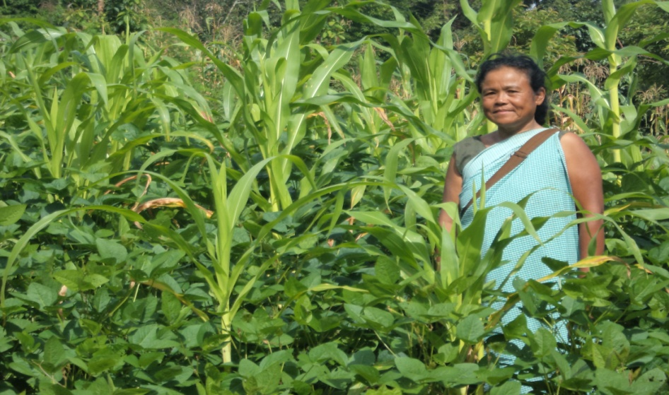
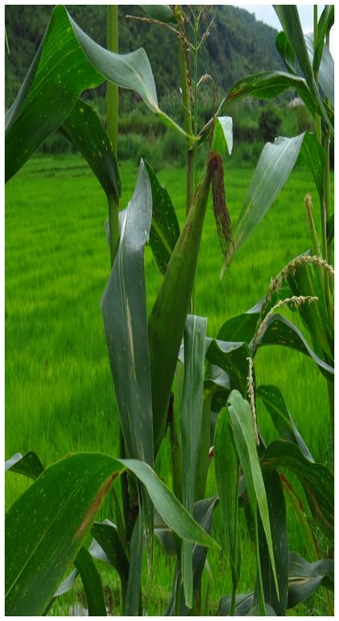
MAIZE CULTIVATION IN RI BHOI DISTRICT OF MEGHALAYA
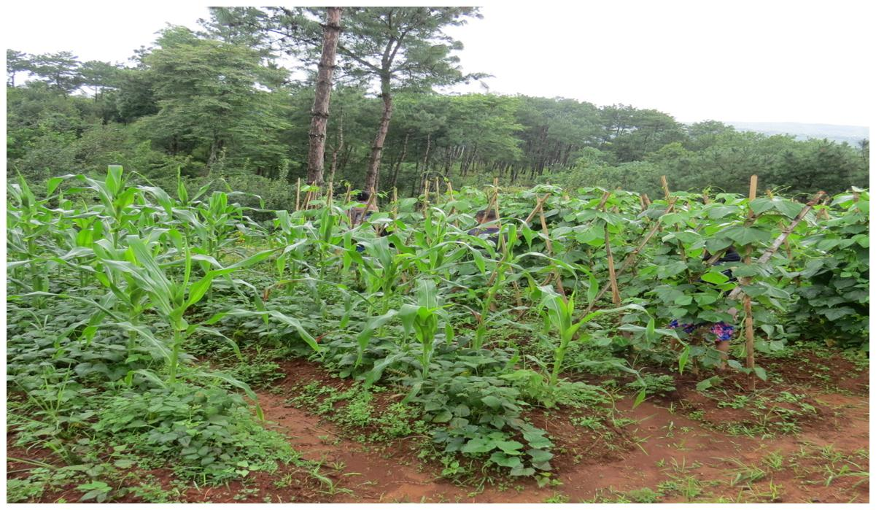

MAIZE INTERCROPPING WITH SOYBEAN WHICH IS ONE OF THE INTERVENTIONS ON COARSE CEREALS IN EAST KHASI HILLS

2.CLIMATE AND SOIL
Maize requires humid climate from the time of sowing to the end of its reproductive phase. Extremely high temperature and low humidity during flowering period results in poor grain formation. Optimum rainfall requirement of 50 cm to 75 cm results in proper growth and development. This crop usually grows well under temperatures varying from 21°C to 27°C, although it can tolerate temperatures as high as 35°C. Frost is injurious to this crop. Maize can be grown on a wide range of soil but thrives well in well drained loamy and sandy loam soil. Low laying area where water stagnation during rainy season occurs must be avoided.
3. SOWING TIME
- For higher altitudes: mid- March to mid-April
- For lower regions: April to May
- Rabi (winter) crop: October to November in lower altitudes(Irrigated)

4. SEED RATE & SEED TREATMENT
- Seed Rate: 15 -20 kg/ha
- Seed Treatment: Seed Treatment with Beefamrut and Trichoderma @ 5 gms/Kg Maize seeds is advocated before sowing.
5. LAND PREPARATION
Maize requires a firm and compact bed free from stubbles and weed. One deep ploughing should be given, followed by two or three harrowing to bring the soil to a fine tilth. Application of Panchagavya 15 days before transplanting.

6. MANURES
Spread 12.5 tonnes/ ha of FYM or compost on the unploughed field along with 2kgs /ha of Azospirillum and incorporate in the soil.
7. SOWING
Furrows are made in the beds at a distance of 70 cms and depth of 7.5 -10 cms. Manure is applied as basal dose in the furrows and mixed well with the soil. Seeds are then sown in these furrows in lines, at a distance of 20 cms (8 inches) and covered over with soil.
8. IRRIGATION
The Kharif crop requires irrigation only when there is an extended period of water stress. However the Rabi crop needs frequent irrigation at intervals of 15-20 days.
9. INTERCULTURE
Weeding is necessary as weeds interfere with the plant growth, particularly during the initial stages. 2- 3 weeding may be required. Plants should also be earthed up after every weeding for a better crop stand. Intercultural operations should not be continued after flowering.
10. PLANT PROTECTION
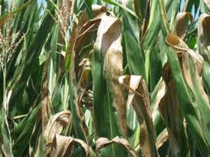
(A) DISEASES:
Leaf Blight: Manifestation of oval to round, yellowish-purple spots on leaves. The affected leaves dry up and appear as if burnt. In severe cases, the plants may become stunted, resulting in poorly-formed ears. The crop can be sprayed with Trichoderma @ 5 gms/litre water + Pseudomonas fluorescence @5 ml /litre water.

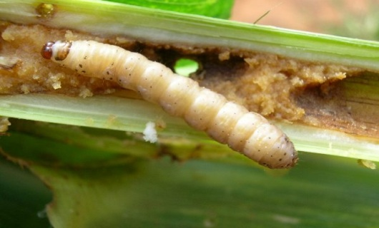
(B) INSECT PESTS:
1) Stem borer: These borers feed on leaves in the earlier stages. Later on they bore into the stem and cobs, rendering the plant unproductive. After harvest, the stalks and stubbles should be collected from the field and burnt.
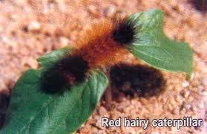
2) Red Hairy Caterpillars: Caterpillars feed and destroy the whole plant if the attack is in the early stages of growth.
Control:
- Egg masses and young caterpillars should be collected as soon as detected, and destroyed.
- The field should be ploughed out after the crop is harvested, so as to expose pupae.
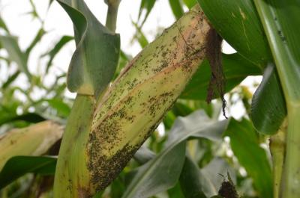
3) Aphids: Tiny, soft bodied insects, usually green in colour. Nymphs and adults suck the sap from leaves and young shoots. The crop can be sprayed with Beauveria bassiana @5gms/ litres
4) Termites: These pests attack young seedlings as well as mature plants; attack is also visible on roots and lower parts of the plants.
Control: Soil treatment with Soldier @ 2 kg per hectare is applied and mixed well with the soil. Soil drenching should be done with Metarhizium @5gms /litre water.
11. HARVESTING
Cobs which are to be utilized as grain should be harvested when the grains are almost dry or containing roughly 20 % moisture. The appearance in the grains of composite and high yielding varieties however may be misleading as grains become dry while the stalk and leaves are still green. The cobs are removed from the standing crop and sun dried before shelling, otherwise retained in their jackets, if kept for seed or to be consumed or utilized at a later stage.
12. YIELD
- Local Varieties : 15 to 20 quintals (grain) per hectare.
- High Yielding Varieties : 40 to 50 quintals (grain) per hectare

TRAINING PROGRAMME UNDER NFSM SCHEME FOR THE YEAR 2018-19
- Training under Kharif Season (2nd Session)
Sl. No. | Date | Time | Subject | Resource Person
1. |  | 10:30- 12:30 pm | Management of pest and diseases in rice using bio control/bio rationals) | Crop/Subject Matter Specialist- ICAR/KVKs/SAUs
2. |  | 1:00- 3:00 pm | Seed production of Cereals and Pulses | --do--
3. |  | 3:00- 5:00 pm | Paddy cum fish culture | --do--

2ND SESSION
TIME: 10:30AM TO 12:30PM (2 HOURS)

1. MANAGEMENT OF PEST AND DISEASES IN RICE USING BIO CONTROL/BIO RATIONALS
Indigenous Technical Knowledge (ITK) refers to the unique traditional local knowledge existing within and developed around the specific conditions by women and men indigenous to a particular geographic area. This indigenous technical knowledge that people in a given community have developed over time and continue to develop it, is based on human experiences on mass scale, dynamic and changing, tested in most cases over centuries of use, endowed with highest possible adaptability to local culture and environment and put greater weightage on minimizing risks rather than maximizing profit. The indigenous technical knowledge (ITK) covers a wide range of subjects, viz. crop production, livestock rearing, natural resource management, food preparation, healthcare, insect pest management and many others.
Identify Problem
Do local Practices Exist?
Are local practices effective and sustainable?
Can local practices be improved?
Improve local technologies or blend with introduced technologies
Test appropriate outside technologies
Promote local technologies
Test appropriate outside technologies
NO
YES
NO
INTEGRATED INDIGENOUS KNOWLEDGE DEVELOPMENT

The use of non-chemical methods for pest control and crop protection is already gaining importance in several countries including India. The integrated pest management strategies developed and promoted by the Governments is now based on the use of plants extracts. If an effort is made towards production of Indigenous Technical Knowledge (ITK) based products on cottage scale, it can be an economically viable option for sustainable development of ecofriendly pesticides/insecticides.
ITK and plant disease control:-
Traditional system of crop protection that farmers have learnt from their long association with the land, its flora and fauna were based on eco-friendly systems of suitable cultural practices, judicious rotation of crops and knowledge of pests and their life-cycle
- In case of rice, spreading of bamboo shoot in the field act as insect/rodent repellent.
- Banana, neem, lantena leaves use in storage, as protection against insect-pest attack.
- Rotten Crab Trap for protection from Gandhi bug of rice in milking stage.
- Indigenous grass with defensive mechanism (Thorn) as protection against rodents in field crops.
- In case of soil-borne disease, root rot and collar rot were used castor cake, karanj cake and neem cake as control measures.
- 20 kg of Pine Tree (Casuarina equisetifolia) leaves are boiled in water for 20 min. After cooling, the solution should be filtered. Then the extract is diluted with water and can be given to control some bacterial and fungal disease.
- Prepare solution from 2 kg fresh leaves of papaya in 3-4 litres of water and keep in overnight. After filtration, this is diluted with 50-60 litres of water and 250ml soap solution added to it, is effective to control brown spot disease of rice.
- Leaves of khair (Acacia catechu) can be put into water cannel to control brown spot disease of rice.
- Rice seedlings raised from seed treated with extract of neem kernel are resistant to leaf hopper.
- A solution prepared from neem leaf paste in water (10 kg: 2 litre) is effective to control leaf folder in rice.
- Use of tobacco leave by dipping the leaves for 1 night.
- A solution of grinded chilli/pepper mixture.
- Local trap for Rodent.
- There is a common practice of storing food grains by using neem leaves to prevent storage pest damage.
Bio agents and biopesticides:-
The use of bio-inoculants (bio-agents & bio-pesticides) and bio-control agents are gaining importance as supplementary source of pest management tools in agriculture, forestry, horticulture and in public health programmes. Increased emphasis is being given by the Government agencies, Non-government agencies to promote the use of bio-inoculants and bio-pesticides. In organic farming, use of bio-control agent and bio-pesticides are emerging as most viable pest management strategy. Excessive use of chemical pesticide also exposes farmers to serious health risks and has negative consequences for the environment, and sometimes for crop yield.
Biological control is the use of natural enemies (called biological control agents) to reduce populations of pests such as insects and weeds. Biological control can also be defined as the use of living organisms to depress the population of pest. This can be achieved through the use of natural predators and to establish the economics and risk reduction potential of a bio-control/IPM (Integrated Pest Management).
List of Bio-agents and Bio-Pesticides & their control:
Sl No. | Bio-agents | For the control of | Dose per ha
 | Trichogramma japonicum | Paddy stem borer | 5 cards
ii) | Trichogramma chilonis | Paddy leaf roller, Maize stem borer, | 5 cards
iii) | Pseudomonas flourescens | Soil borne, foliar fungal and bacterial diseases | 2.5 litres
iv) | Trichoderma harzianum | Soil & Seed-borne diseases | 2.5kg
v) | Beauveria bassiana | Sucking and Lepidopteran insect pests | 2.5kg
vi) | Metarrhizium anisopliae | Soil insect pests like white grubs etc. | 2.5kg
a.Method of use for Bio-control agents (Trichogramma spp.):
- Trichogrammas are supplied as Trichocards. Cut along the lines into 24 bits per card.
- Clip in the underside of leaves and spread them at a distance of 5-8m from each bit.
- In case of paddy, clip the bit inside the disposable cups to prevent from heavy rain.
- At least three releases are needed @ 2 cards each in the first and second releases and 1 card in the third release at 15 days interval each release.

- Method of use for Bio-pesticides:
- Seed treatment: Mixing 5g or 5ml of any bio-pesticides per Kg of seed and make slurry, leave it for around 15-20 minutes and then shade dry for 15-20 minutes. Then the seed can be sown in the field.
- Seedling dip treatment: Mixing 5g or 5ml of any bio-pesticides per litre of water, dip the seedling roots for 15-20 minutes and then shade dry for 15-20 minutes. Then the seed can be sown in the field.
- Foliar spray: Mixing 5g or 5ml per litre of water (i.e. 75 grams in a 15 Litre sprayer) and then spray.
- Soil application: Drenching the soil with 5g or 5ml. per litre of water during land preparation.
- Multiplication in the Compost: Mixing 1 kg of any bio pesticides with 100 kg well decomposed dried manure/compost/FYM. Then, sprinkle the mixture with water and cover with polythene and leave it for two weeks. Turn the mixture at alternate days and check the moisture content. The compost will be enriched with the bio-pesticides after the end of two weeks and ready for use in the field.
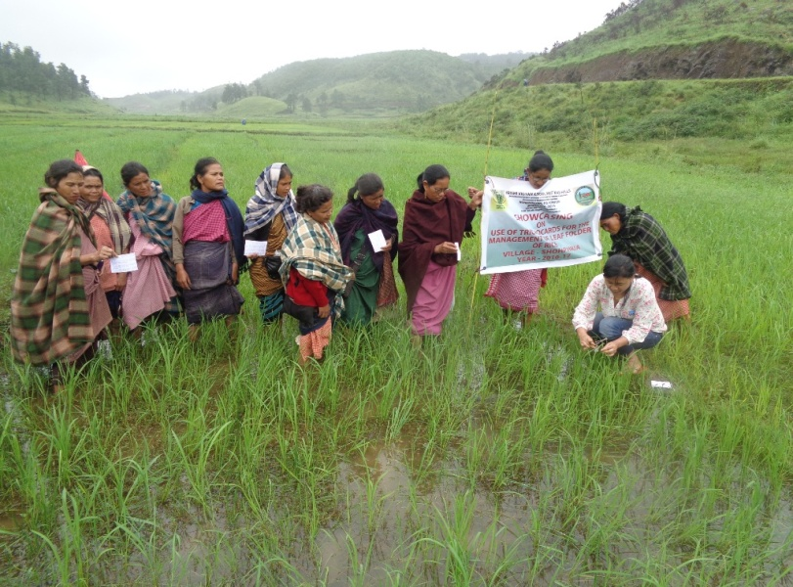
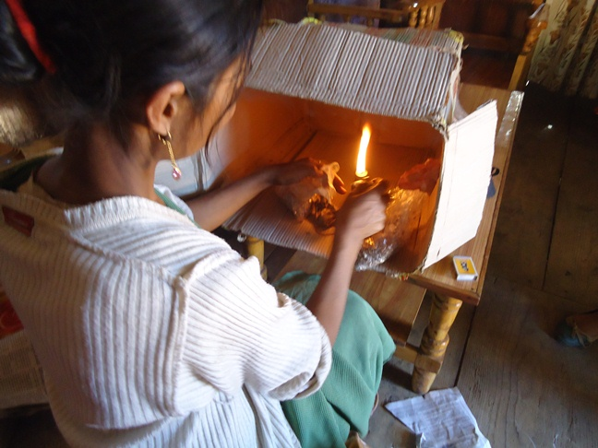
ITK METHOD TO TRAP INSECT FROM STORED SEEDS AND USE OF TRICHOCARDS IN PADDY FIELD IN WEST KHASI HILLS

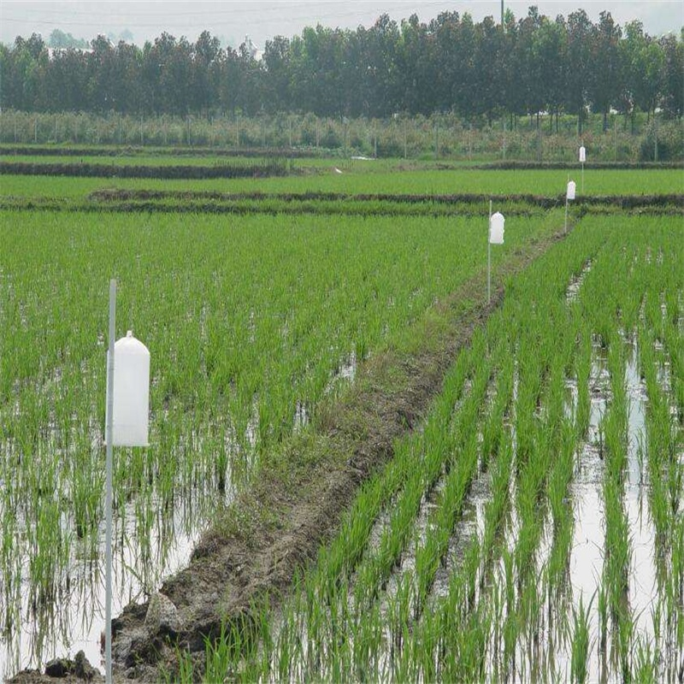

PHEROMONE TRAP IN PADDY FIELD

2ND SESSION
TIME: 01:00 PM TO 03:00 PM (2 HOURS)

2. ORGANIC SEED PRODUCTION
Organic seed production and its importance
Organic agriculture is a kind of diversified agriculture wherein crops and livestock are managed through use of integrated technologies. It depends mostly on on-farm resources rather than on external inputs. It emphasizes more on the optimising the yield potential of crop and livestock rather than maximization. The system does not deplete natural resources in and around the production site but maintains agro-biodiversity. The dependence of the state on other states for procuring seeds of HYVs and also sometimes the seeds of varieties procured are not properly tested for its adaptability. The seeds procured from the other states are not produced organically. Large gap has been felt in the demand and supply of the seeds due to its short supply and even if available, timely availability of seeds to the farmers is an area of concern. One basic strategy to fulfil this gap is to strengthen the seed production in the state.
Seed production constraints
- Unavailability of Breeder seed- The state has to take steps to produce its own seeds. Availability of Breeder/ Foundation seed of the desired varieties can solve the problem as the seed can be multiplied in the state under organic conditions.
- Storage conditions- High humidity and moisture conditions favour infestation of fungus and storage pests. Besides, the famers are ill-equipped with the efficient storage facilities.
- Technical know-how of seed production- For producing certified seeds various parameters and handling techniques are to be addressed of which farmers are unaware. Seed production in maize and other cross-pollinated crops needs technical knowledge and lack of it may lead to loss of genetic purity.
- The topography of the state is highly variable. Varieties performing well in one district may not perform similarly in other regions of the state. Varietal performance varies according to the altitude and local climatic conditions; thereby one variety does not perform well in all locations in the state.
Steps for efficient seed programme
- Availability of breeder/foundation seeds of the recommended variety in the state will solve the problem of seed shortage in the region as seeds can be multiplied in the farmer’s field or in Government farms.
- Institutions like ICAR and KVK’s should be actively involved in imparting technical knowledge to the farmers and linked the seed production programme of the state. These agencies shall be involved in breeding and multiplication of the breeder/foundation or production of breeder seed of the varieties released in the state or outside in the region. ICAR and other institutes may be involved in identifying suitable varieties for the region and procuring seed from the source institution.
- Storage facilities at the farmer’s level have to be improved. The infrastructure related to seed production, seed processing and storage has to be upgraded so that the seed availability shall be of good quality and purity.
- The concept of Seed Village and seed production at farmer’s level has to be implemented and undertaken at large scale.
- Post harvest management of the seed produced is equally important. Minimum support price in seed production and subsidies in the transportation may be provided for supporting farmers’ efforts.
- Seed production will be successful only when it is economical. Seed producing villages/communities/farmers may be linked to marketing agencies for uplifting quality organic seed produce.
Strengthening stakeholders
Implementation of the seed program requires assessment of the topography of the region and various other issues like participation of the farmers in area specific varietal selection etc. Enhancing technical skill and knowledge of the farmers and other stakeholders in seed production technologies, safe storage, seed health and training farmers in better selection of the plants to be kept for seed will be important. Availability of varieties released by ICAR through multiplication and dissemination is essential.
Foundation and certified seed production of rice:
- Land requirements- Land to be used for production shall be free of volunteer plants. The selected plots should be levelled and the soil preferably clay loam.
- Isolation- Rice is self-pollinated crop but about 0 to 6.8 per cent cross-pollination occurs. Fields must be isolated at least by three metres from other fields of rice for pure seed production.
- Cultural practices
- Land preparation- It is desirable to grow rice under puddle and transplanting systems for seed production.
- Nursery- Select land on which rice nursery or rice crop was not grown in the previous season. It is better to broadcast seeds on raised nursery beds and cover it with broad leaves or grasses to avoid bird damage.
- Seed rate and source- about 30 kg seed for coarse varieties and 25 kg see for fine varieties is adequate for one hectare area. Obtain nucleus/breeder seed/foundation seed from a source approved by the certification agency.
- Transplanting- Three to four week-old seedlings are uprooted and transplanted in the main field at spacing of 20cmx15cm with 2-3 seedlings per hill.
- Seed Yield- Average seed yield varies from 35-45 q/ha depending on the variety.
Foundation and certified seed production of maize:
- Land requirements- Selected fields should be free of volunteer maize plants and well drained. The soil should be well-aerated and suitable for maize growing.
- Isolation- Maize is normally cross-pollinated by wind and the genetic purity is contaminated by the movement of foreign pollen. The seed fields must be isolated at least by 400 meters for foundation seed class and 200 meters for certified seed class from fields of other varieties of maize and fields of the same variety not conforming to varietal purity requirements for certification.
- Seed rate and source- Obtain nucleus/breeder seed/foundation seed from a source approved by the certification agency. Seed rate of 20 kg/ha is enough for one hectare area with row to row and plant to plant distance of 60cmx20cm.
- Seed Yield- Average seed yield varies from 25-30 q/ha.
Foundation and certified seed production of Blackgram:
- Land requirements- Selected fields should be free of volunteer plants.
- Isolation- Isolation distance of 10 metres for foundation seed and 5 metres for certified seed production from fields of other varieties and same variety not conforming to varietal purity for certification is necessary.
- Seed rate and source- 15-20 kg for one hectare area. Maintain spacing of 30cmx15cm between row to row and seed to seed respectively. Obtain nucleus/breeder seed/foundation seed from a source approved by the certification agency.
- Seed Yield- 10-15 q/ha.
Foundation and certified seed production of Pea:
- Land requirements- Selected fields should be free of volunteer plants. The land should be well-drained and with neutral pH.
- Isolation- Isolation distance of 10 metres for foundation seed and 5 metres for certified seed production from fields of other varieties and same variety not conforming to varietal purity for certification is necessary.
- Cultural Practices- Mid-October to November is appropriate time for sowing pea for seed production. 60-75 kg seed/ha is required. Spacing of 45cmx15cm is optimum for pea seed production.
- Seed Yield- Average seed yield of 20-25 q/ha
Foundation and certified seed production of French bean/Rajma:
- Land requirements- Selected fields should be free of volunteer plants. The land should be well-drained.
- Isolation- Isolation distance of 10 metres for foundation seed and 5 metres for certified seed production from fields of other varieties and same variety not conforming to varietal purity for certification is necessary.
- Cultural Practices- Nucleus/breeder seed/foundation seed shall be obtained from a source approved by the certification agency. Seed rate of 25-30 kg/ha for pole type and 80-85 kg for bush type is optimum. Row to row and plant to plant distance of 60 cm and 15 cm is adequate. Ridge sowing is preferable.
- Seed Yield- Average seed yield varies from 12-18 q/ha.
Foundation and certified seed production of Soybean:
- Land requirements- Selected fields should be free of volunteer plants. The land should be well-drained.
- Isolation- The crop is self-pollinated and usually less than 1 per cent cross-pollination takes place by insects. Isolation of 3 metres from other fields of soybean to maintain genetic purity.
- Cultural Practices- Last week of June to first week of July is the optimum time for soybean seed production. Nucleus/breeder seed/foundation seed shall be obtained from a source approved by the certification agency. Seed rate of 65 kg/ha is required with row to row and plant to plant distance of 45cm x 15cm, respectively.
- Seed Yield- Average yield varies from 20-25 q/ha.
2ND SESSION
TIME: 03:00PM TO 05:00PM (2 HOURS)

3. PADDY-CUM-FISH CULTURE

Introduction:
Rice is one of the major crops and staple food which is grown particularly in Meghalaya.Water logged rice field forms natural habitat to many aquatic organisms and offers a good environment for fish which can be integrated and enhanced to improve the livelihood of the farmers. This kind of integration is very well suitable for fish as well as paddy and they function together. Rice-fish culture system is relatively easy, low cost and low risk.
Advantages of Rice-Fish Culture
- Plenty of natural fish food.
- Biological control of pest as fish eats a number of harmful insects.
- Rooting activity of fish helps control weeds.
- Increase in organic fertilization by fish excreta and remains of artificial feeds.
- Better tillering of the paddy seedlings.
- Fish stir up soil nutrients making them more available for rice.
Lay-out of the field
- Modifications in the paddy field involved digging canals or trenches in various forms with or without central pond and the dykes have to be elevated. Trenches should be about 0.5 m – 0.8 m deep and at least 1 m wide and they serve as refuge for fishes. Inlet and outlet with fine screening are also important.
- Sufficient water should be available for maintaining a depth of 10-15 cm in areas planted with paddy after introduction of fingerlings.
- The trench area should not be more than 10 % of the paddy area or it will reduce the paddy area leading to decline in paddy yield.

Transplanting of paddy
Sowing/transplantation of paddy are usually done when the field is ready. However, it is advisable to grow transplanted paddy as it gives better paddy yield and also fish can move freely in search of food. A spacing of 25-30 cm between the rows of the plant is recommended.
Stocking of fish
Stocking of fish is done after 15-20 days of transplanting when the root system is established properly and when the paddy field is flooded. Common carp which has the ability to survive in extreme habitat and climatic conditions along with catla, mrigal, silver carp, gonius, etc are stocked @ 4000 no. or 6000-7500 no. of advanced fingerlings per hectare of paddy area.
Supplementary Feeding
Fish are fed with rice bran and mustard oil cake in the ratio of 1:1 on a daily basis @ 2-3 % of their body weight.

Liming and manuring
Liming and manuring are done as per the following rate :
Item | Rate | Time of application
Lime | 10 mg/lit of water initially and 5mg/lit of water monthly  (for 1000 m² paddy area, 6 kg initially i.e. 1st month , 3 kg monthly) | When water level raises
Cow dung | 50-60 kg/2500 m²/month  or  37-45 kg/1000 m²/month | 7 days after liming
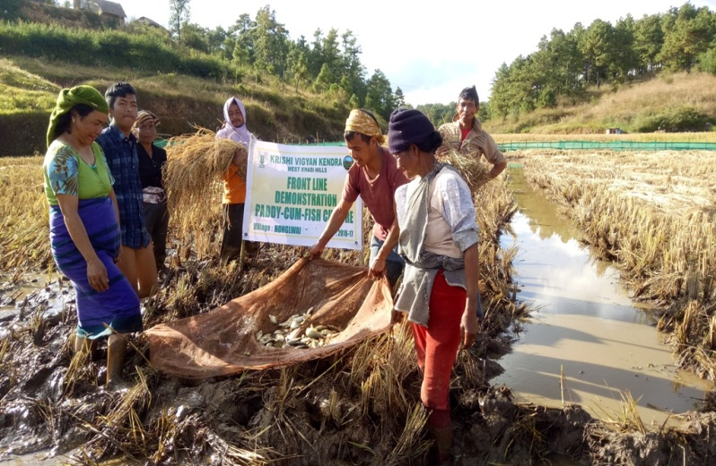
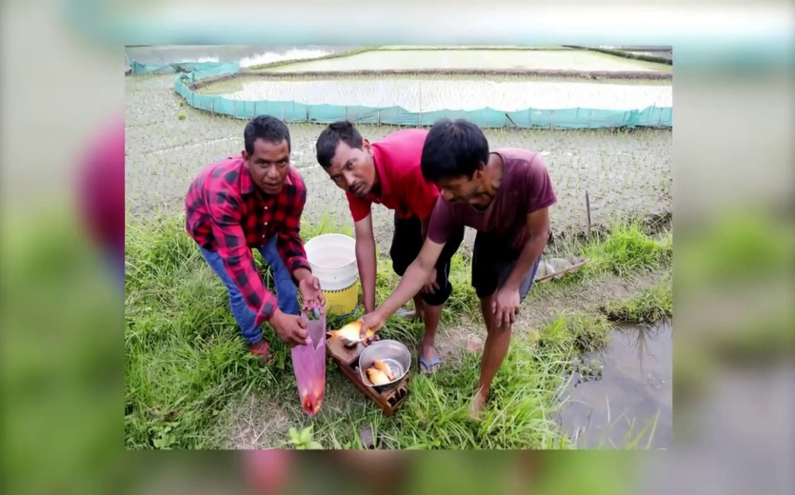
PADDY CUM FISH CULTURE IN MEGHALAYA

Harvesting

- Paddy and fish can be harvested at the same time and in 4-5 months culture period, an average fish production of 300 - 600 kg/ha can be achieved depending on the agro climatic conditions and management practices. Rice production from this system varies from 25 qt/ha to 40qt/ha.

- However, depending on the availability of water, fish can be further reared after the harvest of paddy where the field can be filled with water which allows the fish to move around and graze in the harvested field.

TRAINING PROGRAMME UNDER NFSM SCHEME FOR THE YEAR 2018-19

- TRAINING UNDER PRE- RABI SEASON
(3RD SESSION)

Sl. No. | Date | Time | Subject | Resource Person
1. |  | 10:30- 12:30 pm | Package & Practices of Pulses (Blackgram, Lentil, Rajma) | Crop/Subject Matter Specialist- ICAR/KVKs/SAUs
2. |  | 1:00- 3:00 pm | Package & Practices of Rapeseed & Mustard | --do--
3. |  | 3:00- 5:00 pm | Demonstration on Cultivation of Rice based cropping system (Boro Paddy) | --do--

3RD SESSION
TIME: 10:30AM TO 12:30PM (2 HOURS)

1. PACKAGE OF PRACTICES OF PULSES
  - LENTIL (Lens esculenta L.)
Introduction
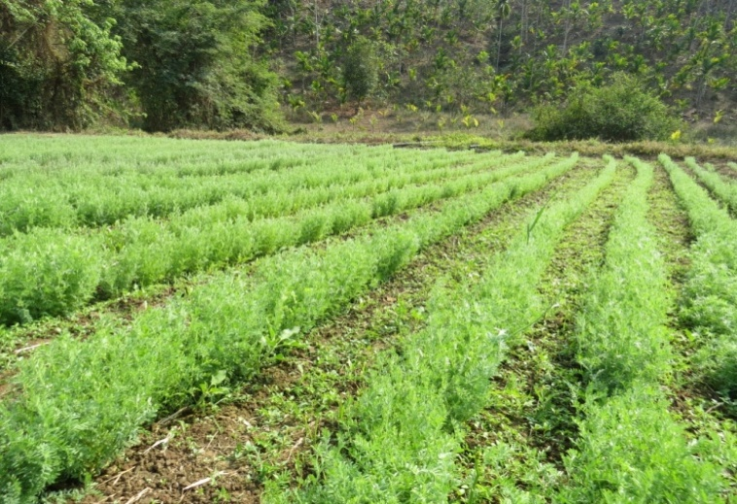
Lentil is one of the most important and most nutritious rabi pulses. It has that potential to cover the risk of rainfed dry land agriculture due to its better adaptability under moisture and temperature extremes. This can also be use as a cover crop against soil and water erosion. Lentil is mostly eaten as “dal”. The nutritious value of the seeds of the plant is quite high as it is rich in carbohydrates, fibres and proteins. It is extremely good in fixing nitrogen from the atmosphere and forming nitrogen nodules in the soil that rejuvenates the nutrients and keep the soil productive for a long time. Lentil can be grown successfully both in upland and lowland condition of this region after harvest of the kharif crop. In upland, it can be grown with minimum tillage after harvesting of maize or upland rice. In late harvested lowland paddy field, zero tillage can be adopted with Lentil for avoiding any further delay in its sowing.
Improved Cultivation Practices
Climatic and Soil Requirements
Lentil requires a cold climate. It is a very hardy crop and can tolerate frost and severe winter to a great extent. It can be grown to conserve moisture in the soil during the rainy season. It requires cold temperature for vegetative growth and warm temperature during maturity. Light loam soils are suitable for lentil. This crop can also be grown in less fertile soils and lowland rice fallows.
Seed and Sowing
Good quality seeds of any of the short to medium duration variety (120 to 140 days duration) can be chosen. Small seeded varieties are more suitable for this region.
Varieties:
Following varieties have been found suitable for the state of Meghalaya as recommended by the ICAR NEH, Umiam: HUL-57, T-36, PL-6, PL-8, NDL-1, DPL-62, Moitree.
Sowing time
For high Altitude: 15th October to 15th November
For Low Altitude : 15th November to 15th December
Soil and its preparation
Application of lime in soil approximating 2 tons per ha 15-20 days before its sowing especially in upland is required. Being a legume it requires good aeration for nodule development and that can be achieved by one deep ploughing followed by one cross harrowing. Application of Panchagavya 15 days before sowing is advantageous.
In lowland after paddy harvest
Seed rate and crop spacing
Small seeded timely sown = 30-40 kg/ha
Bold seeded timely sown = 50-60 kg/ha
Row spacing (Normal sowing) = 30cm
(Delayed sowing) = 25cm
Depth of sowing = 4-5cm
Plant to plant spacing = 5cm
Seed treatment
Lentil is susceptible to wilt, root rot and other fungal diseases during establishment hence, seed should be treated with Beefamrut and seed should be inoculated with dual culture of Rhizobium and PSB. About 3-4 packets of both the culture is sufficient for treating the seeds for one hectare area.
Plant nutrient management
FYM@ 5t/ha to be applied in soil about 15 days before sowing of seed and application of Rock Phosphate in furrows method @ 250kg/ha.
Weed management
Hand weeding, one at 35-40 days after sowing and another at 55-60 days after sowing depending on the crop growth and intensity of weed infestation
Water Management
It can tolerate drought to a greater extent but under conditions assured irrigation is required. In lowland rice fallow, usually irrigation is not required. Irrigation may be given to the crop, if water is available, at flowering and pod filling.
Plant protection measures
Minor incidence of pod borer can be controlled with 5% Neem seed kernel extract (NSKE). Disease can be controlled by applying Bio- fungicide like Bacilluss sp. Application of Jeevamrut in 15 days interval is also advisable.
Harvesting storage and yield
Crop becomes ready for harvest when leaves begin to fall, stem and pod turn brown or straw in colour.
Threshing and winnowing
The crop should be allowed to dry for 4-7 days on threshing floor and threshed by beating with sticks or trampled under the feet of bullocks.
Storage
The clean seed should be sun dried for 3-4 days to bring their moisture content at 9-10%
Yield
- 8-10q/ha grain
- 15-20q/ha straw
ZERO TILLAGE PRACTICES OF LENTIL IN RICE FALLOW
Opportunity of zero tillage for lowland rice fallow
Rice is the main staple food of the region occupying an area of 3.37 million hectare which is more than 80% of net cultivated area in North East India. The cropping intensity in the region is hardly about 120%. Conventionally, after kharif rice, field remain fallow in lowland, mainly due to excess moisture owing to seepage from surrounding hillocks in mid altitude. Draining water from rice field completely at physiological maturity (about 10days before harvest) creates favourable condition for successful cultivation of rabi pulses like lentil. A simple drainage channel of 30 cm width and 20 cm depth of 5 m interval creates the desirable soil moisture situations.
Characteristics of lowland rice ecosystem in hill.
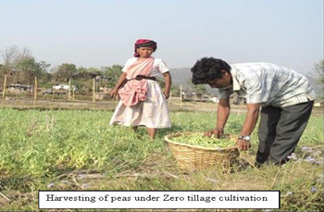
Lowland rice is cultivated during April to November in hills depending upon the altitudes. At mid hills (950m MSL), rice is transplanted during first fortnight of July and harvested during November. After rice harvest, the moisture level remains high owing to release of moisture from surrounding hillocks. Cultivation of second rice is not possible due to early onset of winter that results spikelet sterility. Under such situation, cultivation of lentil is possible following zero tillage after rice harvest for enhancing cropping intensity, farm income and livelihood.

Pea can be grown in lowland rice follow in Rabi Season
Zero tillage in lowland at as glance
Transplant rice in line with at least 20cm spacing between row to row.
- Apply FYM or any other organic manure 5 t/ha for better soil health.
Avoid excessive tillage. Only one or two ploughing followed by levelling in sufficient for a
good crop of rice.
Follow all other cultural operations as followed for conventional cultivation of rice.
Provide a narrow drainage channel (30 cm width x 20 cm depth) around the standing rice
crop at an interval of 5 m during physiological maturity of the rice crop. This will ensure a
fairly dried field for sowing of lentil within 15-20 days of rice harvest.
Harvest rice by leaving at least 20 cm standing stubble above the ground uniformly.
Sow lentil by opening a narrow furrow using manual furrow opener in between two
rows of previous rice crop as shown in mechanical/animal drawn furrow opener
could also be used if feasible/available.
Plant to plant spacing in a row should be maintained at 1-2 cm for lentil
Organic Manure and seed are placed in the narrow furrows created by a ‘V’ shave furrow opener.
Cover the seed with the soil after placing fertilizer and seeds.
Alternatively, the lentil seed can be broadcasted in the field just one week before
rice harvest if soil moisture condition is good ( only moist field and no standing water).
The lentil seeds get germinated before rice harvesting.
Rest of the cultural operations are done as recommended.

Opportunity of zero tillage for upland rice fallow
In upland, after rice harvest no crop is cultivated due to severe moisture stress. The conventional tillage for sowing of rabi crop further aggravates the soil moisture problem by completely exposing the soil. With the help of zero tillage, the rabi crop can be grown directly in standing rice stubbles soon after the harvest of the rice crop. As the soil is not tilled, the rate of soil moisture loss is reduced and rabi crop can be grown successfully with conserved soil moisture and life saving irrigation
Zero tillage in upland – at glance
- Line sowing of rice crop with 25 cm spacing between row to row
- Apply compost of FYM at 5t/ha for better soil health.
- Avoid excessive tillage. Only one or two ploughing followed by levelling is sufficient for a good crop of rice.
- Follow all other cultural operations as followed for conventional rice cultivation.
- Harvest rice by leaving at least 30cm standing stubble above the ground uniformly.
- Soon after the rice crop harvest, sow lentil crop by opening a narrow using manual furrow opener in between two rows of previous rice crop mechanical/ animal drawn furrow opener could also be used if feasible / available.
- Plant to plant spacing in a row should be maintained at 1-2cm for lentil.
- Organic manure and seeds are placed in the narrow furrows created by a ‘V’ shape furrow opener.
- Cover the seeds with the soil.
- Mulching can also be done with available biomass (rice straw, weed, etc) at 5t/ha
- Rests of the cultural operation are done as followed in conventional agriculture.
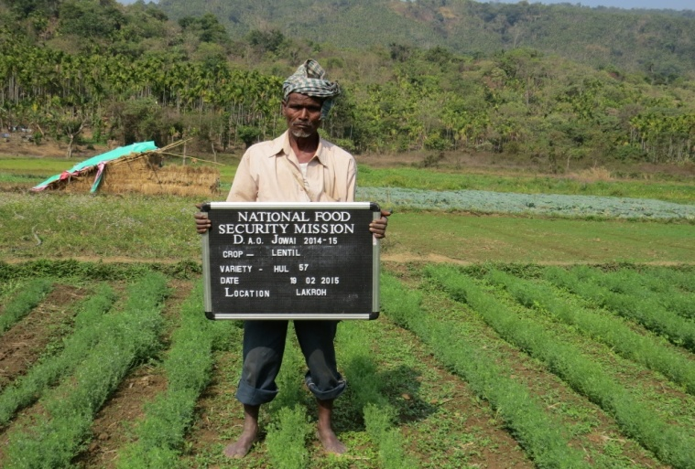

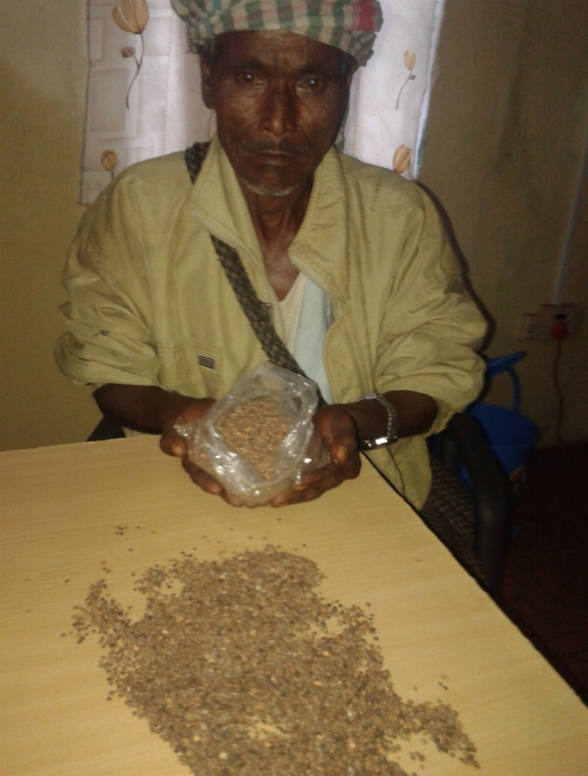

LENTIL CULTIVATION UNDER ZERO TILLAGE OPERATION IN THE VILLAGE OF LAKROH, WEST JAINTIA HILLS

  - RAJMA (Phaseolus vulgaris L)
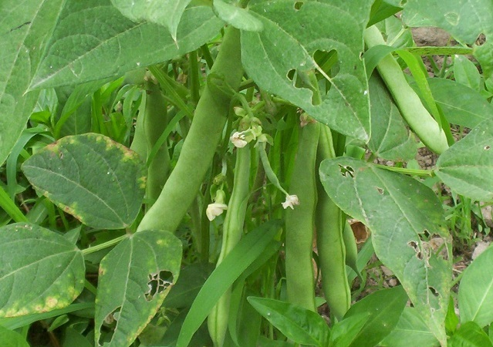
Rajma (Phaseolus vulgaris L.) is also known as kidney bean, common bean, navy bean, haricot bean or snap bean. Rajma is consumed as green vegetable as well as grain pulse. For vegetable purpose round podded type with more flesh and less string is preferred. Flat podded types are mainly grown for whole seed. Rajma called Raja in Hindi is a rich source of protein and its protein is rich in many essential amino acids.
Traditionally, Rajma is cultivated in the hills during Kharif. However, with development of new varieties its cultivation in the plains is also increasing day by day. Among all pulses it fetches the highest price, almost double the price of other pulses. Thus, from economic point of view, this is a very profitable crop. Rajma is therefore gaining popularity as cash crop. In the hills, Rajma is mainly grown in Kharif. If irrigation is available it can be cultivated during rabi season too. Cultivation of Rajma under rain-fed conditions in rabi is not recommended.
Varieties:
Improved varieties like Arka Anoop, Contender, Pusa Parvati, Arka Komal, Arka Sunidhi are recommended by ICAR NEH, Umiam.
Soil and Land Preparation:
In general, Rajma can be cultivated on almost all types of soil, however, deep light textured soil with 6.5-7.5 pH range are ideally suited. Drainage should be very good Land should be well prepared with one deep ploughing followed by 2-3 harrowing. Beds must be levelled, weed free and free from clods. Soil moisture is very critical at the time of sowing. If adequate moisture is not available at sowing time germination may be very uneven and poor. In such a case seed should be sown only with a pre sowing irrigation. Application of Panchagavya 15 days before transplanting is advisable for better growth.
Seed and Sowing
A seed rate of 120-125 kg/ha is essential for ensuring adequate plant stand. Optimum plant stand for a good crop is 3-3.5 lakhs plants/ha. Row to row spacing should be 40-45 cm and plant to plant distance should be 10 cm. Seeds should be places at 8-10 cm depth for good establishment of the plants.
Sowing time:-
High Altitude (Kharif season): April to May
Low Altitude (Kharif Season): March to June
Low Altitude ( Rabi Season) : October.
Organic Manure Management:
Rajma requires a dose 15-20 mt/ha organic manure/ rock phosphate @ 250kg/ha be applied to realize the full potential of high yielding varieties.
Water Management:
Rajma cannot withstand water stress. Sufficient soil moisture should be present during entire crop season. For good yield 3-4 irrigations are essential. Most critical stage for irrigation is 25 days after sowing. Subsequent critical stage is 75 days after sowing. For upland conditions the required frequency of irrigation is much more.
Weed Control:
Weeds are a serious problem in Rajma cultivation. Yield reduction of 25-30% has been reported due to uncontrolled weed growth. Hand weeding at 30-35 days after sowing reduces weeds infestations effectively.
Diseases and insect pests:
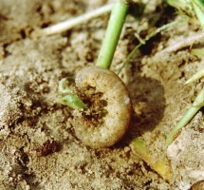
In general Rajma is affected by lesser number of insect pests and diseases in comparison to other pulses. However, main pests and diseases are described below.
Insect Pests:
Cutworm: In general this insect damages the crop at early vegetative stage. Sometimes it may damage grown-up plants also. Insect cuts the plant near the soil and drag away the cut portion.
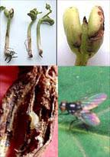
Stem fly: This also damages the crop at early vegetative stage. The fly enter stem near the soil and pupate inside.
Leaf hopper: Damage the crop by sucking cell saps from leaf. Leaves become dry and wrinkled. In severe cases this reduces bearing drastically. Its attack increases with increase in temperature.

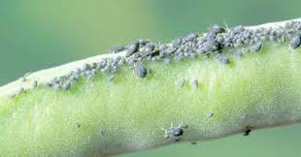
Aphid: This insect also damages the crop by sucking cell sap. Moreover, controlling aphids is important due to the fact that it acts as carrier for virus.

C. Blackgram (Phaseolus mungo L.)
Blackgram or urdbean ( Phaseolus mungo.L) is grown as sole crop, mixed crop, catch crop or sequential crop under rainfed or semi- irrigated condition in kharif and spring/ summer seasons. Blackgram is mainly consumed as dal, whole or slitted, husked or unhusked. Blackgram is also an integral ingredient of famous South Indian preparations like Dosa, Idli, Vada etc. Blackgram is highly nutritive and contains high proportion of digestible protein with many essential amino acids, mineral and vitamins.
Climatic Requirement:
Blackgram is a tropical crop and it requires hot and humid growing season. It is able to tolerate high temperature. As such it is a short day plant, but now day neutral varieties are also available for cultivation in summer season. Heavy rains during flowering stage are harmful and adversely affect the production.
Varieties:
Suitable varieties of Urdbean in Meghalaya are T-9, Kalindini.
Soil & land preparation:
Deep loam light textured soil with ph 6.5-7.5 is ideal. Drainage should be good. One deep ploughing followed by 2-3 harrowing and one planking optimally prepares the land. For spring/ summer crop soil moisture at the time of sowing is very critical. In the absence of rain, sowing should only be done after irrigation. For kharif crop, land needs to be levelled properly and care should be taken to provide adequate drainage. Water stagnation in field affects the crop adversely. In post kharif season, when blackgram is grown in rice fallow, seeding can be done without any tillage to conserve residual soil moisture. Application of Panchagavya 15 days before transplanting is advisable.
Seed and sowing:
Blackgram is grown as rainfed kharif for or post kharif crop but under assured irrigation it can be grown in spring season.. For kharif and post kharif sowing a seed rate of 12-15 kg/ha is optimum. A higher seed rate @20-25 kg/ha is recommended for spring sowing. For spring season row to row distance of 20-25 cm and plant to plant distance of 5-8 cm should be maintained. For kharif season row to row distance of 30-35 cm and plant to plant distance of 10 cm should be maintained.
Sowing time:
Low Altitude: first week of September
High and low Altitude: March
Organic Manure Management:
Blackgram being a leguminous crop requires a dose 15-20 mt/ha organic manure/ rock phosphate @ 250kg/ha be applied to realize the full potential of high yielding varieties

Water management:
Irrigation is not required during kharif and post kharif cultivation. However, soil moisture availability at sowing 25days after sowing and pod filling stage is critical and should be maintained at optimal level. During spring, 4-5 irrigation at 15 days interval may be essential.
Weed Control:
The crop faces severe competition from weeds during first 4-5 weeks after seeding. Weeds can be faced effectively controlled with good seed bed preparation, 2-3 inter culture operations or hand weeding during 3-5 weeks after sowing.
Diseases and Insect Pest Management:
The diseases that are specific to Black gram are Leaf Crinkle, Mosaic Mottle and Sterility Mosaic. Infected plants should be uprooted and burnt. Application of Jeevamrut in 15 days interval is advisable.

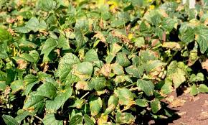

Leaf Crinkle in Blackgram
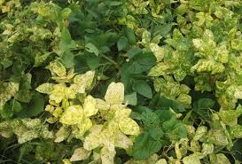

Yellow Mosaic in Blackgram
3RD SESSION
TIME: 01:00 PM TO 03:00PM (2 HOURS)
2. RAPE SEED AND MUSTARD
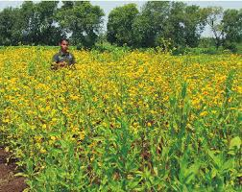
Rapeseed (Brassica campestries) and Mustard (Brassica juncea) are the major rabi
oilseed crops of India. India is one of the largest producers in the world. The production of
rapeseed and mustard in India accounts for about 18% of the total oilseed production of the country. In rice fallows areas, rapeseed-mustard has a very good potential for increasing farm income as well as cropping intensity and meet oilseed requirement. The seed and oil are used as condiment in the preparation of pickles and for flavouring curries and vegetables. The oil is utilized for human consumption throughout northern India in cooking and frying purposes. The oil cake is used as a cattle feed and manure. Green stems and leaves are a good source of green fodder for cattle. The leaves of young plants are used as green vegetables as they supply enough sulphur and minerals in the diet.
The oil content of the rapeseed and mustard ranges from 30 to 48 percent. The crop is
grown both in subtropical and tropical countries. Among the rabi oilseeds, rapeseed and mustard can play an important role in the north eastern hill region to boost oilseed production. In the region, rapeseed-mustard can be successfully grown as rabi crop up to mid altitude (<1300 m msl) and yield level of 8-12 q/ha can be achieved by adopting improved production technology.
Climate
Rapeseed and mustard requires a cool and dry weather for satisfactory growth and a fair supply of moisture during the growing period and a dry clear weather at the time of maturity. Cool temperature, clear dry weather with plentiful of bright sun shine accompanied with adequate soil moisture increases the oil yield.
Soil
Rapeseed and mustard are capable of growing under a wide range of soil conditions varying from sandy loam to clay loam soils but they thrive best on light loam soils. They neither tolerate water logging conditions nor do well on heavy soils. Plants can tolerate moderate salinity reasonably well but a soil having neutral pH is ideal for their proper growth and development.
Variety
- Mustard- PM 26, PM 27, PM 28
- Rapeseed- TS 67, Shillongani.
Cropping Systems
Generally in Meghalaya, the rainfall ceases in the last week of September and moisture stress starts after November, which is not suitable for taking rabi crop. If short duration varieties of rapeseed and mustards, which mature in 90-100 days, are sown after harvest of upland rice and maize, not only the cropping intensity would be increased but the production of oilseeds also will be increased. Under high moisture condition in low, wet and marshy lands where rabi crop is not possible due to excessive moisture, the permanent or temporary raised and sunken beds opens up new vistas for growing any crop including oilseeds during rabi Season. The inclusion of rape seed and mustard in cropping systems on raised beds increase the production and productivity of oilseeds. The adoption of intercropping system on raised bed although decreased the productivity of individual crop but overall system productivity increased markedly. The following cropping systems have been identified for the Meghalaya –
Mid and low altitude:
(a) Dry upland terraces
Maize-mustard, Maize + French bean mustard, Rice - mustard,
French bean – mustard, Groundnut - mustard
(b) Marshy/lowland/wetland conditions (raised beds)
Maize-mustard, Rice mustard Rice- mustard-tomato,
Rice- mustard-potato, Groundnut- mustard
Intercropping on raised beds
Cabbage + mustard, Broccoli + mustard, Coriander + mustard
Field Preparation
A clean and well pulverised seedbed of good tilth is needed for better germination. The land should be well prepared first by ploughing deep with soil turning plough, followed by two cross harrowing. Each ploughing should be followed by planking so that the soil is well pulverised and levelled. Care should be taken to see that weeds and stubbles are well removed from the field and the soil contains adequate moisture to ensure good germination. Zero tillage cultivation of toria after rice and maize is a viable proposition which saves time, energy and reduces cost of cultivation. Immediately after rice harvest, a narrow furrow should be opened in between two rice rows with the help of furrow opener and the manure should be applied and the sowing of seeds should be undertaken followed by covering of the seeds.
Sowing time:
- Low Altitude: Mid October to Mid November
- Mid Altitude: Late September to Mid October.
Seed Rate and Spacing
Spacing has no absolute value in the cultivation of rape and mustard as it fluctuates a great deal with the growth habit of variety, date of sowing, manuring and irrigation practices. Thinning is done three weeks after sowing to maintain a plant to plant distance of 10 to 15 cm. In case of mixed cropping they are generally sown in rows 1.8 to 2.4 metres apart in the main crop, 5 to 6 kg seed should be sown in rows at a depth of 2.5-3.0 cm in case of a pure crop. When sown mixed with some other crop, 1.5 to 2 kg seed per hectare is sufficient. Sowing' could be done either behind the local plough or through seed drill.
Manures
Apply 10 tonnes of farm yard manure or vermicompost @5t/ha during last field preparation along with 150 kg rock phosphate.
Water management
Normally, no irrigation is required in the rape seed-mustard as it is sown on residual soil moisture and it receives one or two showers during October and November months. However, in case of moisture stress, one irrigation at flowering is required to obtain good yield. Irrigation increases yield of rapeseed and mustard significantly. Flowering and siliqua formation stages are critical stages for irrigation in rapeseed and mustard. Two irrigations at pre-bloom and pod filling stages are beneficial.
Weed management Weeds in rape and mustard crop cause approximately 20-30 percent reduction in yield. Care should be taken to remove all weeds in the early stages of crop growth to avoid competition on the reserve of moisture. One intercultural operation with hand hoe is very beneficial. This, besides creating soil mulch and thus reducing moisture losses through evaporation helps in better growth and development of crop plants. Thinning operation helps in better growth and development of crop plants. Thinning operation should be accompanied by intercultural operations to provide the plants proper space within the rows. Hand weeding at 30 and 60 Days after Sowing (DAS) recorded maximum seed yield.
Mulching
Under Meghalaya condition, mulching with rice straw resulted increase in mustard seed yield significantly. Mulching helps in conserving soil moisture, reduces weed problems and maintains soil temperature. Mulching with thin black polythene film gave highest seed yield compared to other mulch at Umiam, Meghalaya.
Plant protection
White rust and Alternaria blight are two important diseases of rapeseed and mustard in the region. Spraying of Derisom or neem oil @ 2.5 g/lit of water at 10 days intervals found to be effective in controlling the diseases and Panchagavya 3 % also control the diseases and
increasing the yield. Application of Jeevamrut in 15 days interval is advisable. The most serious insect-pest of mustard is aphids. To control aphids, spraying of Derisom or neem oil @ 2.5 g/lit of water two to three times is recommended. As the cold and cloudy weather favours the pest multiplication, sowing the crop earlier than the normal sowing escape the pest attack.
Harvesting and Threshing
As soon as the pods turn yellowish-brown, harvest the crop. Normally, the crop is ready for harvest after 90 - 105 days of sowing. Preferably, harvesting should be done in the morning hours to avoid shattering loss. The crop is liable to shattering, hence it should be harvested just before the pods open in order to avoid losses. Sarson is less liable to shattering as compared to toria and mustard. Crop is harvested with the help of sickles. The harvested crop should be stacked in threshing floor for five to six days before threshing. Threshing is very easy with the help of sticks. The pods easily shatter and give away seeds. Threshing could be done with bullocks or tractor. The threshed grain is separated from the husk with the help of slow moving natural air current. Cleaned seed must be dried in the sun for four to five days or till the moisture content comes down to 8 percent.
Yield
With the use of improved varieties, agronomical and plant protection techniques, the farmers may expect to harvest per hectare A well managed crop gives a seed yield of about 10-15 q/ha.

3RD SESSION
TIME: 03:00 PM TO 05:00PM (2 HOURS)

3. DEMONSTRATION ON CULTIVATION OF RICE BASED CROPPING SYSTEM
Conservation Agriculture (CA) is a set of soil management practices that minimize the disruption of the soil's structure, composition and natural biodiversity. Despite high variability in the types of crops grown and specific management regimes, all forms of conservation agriculture share three core principles. These include: maintenance of permanent or semi-permanent soil cover (using either a previous crop residue or specifically growing a cover crop for this purpose); minimum soil disturbance through tillage (just enough to get the seed into the ground; regular crop rotations to help combat the various biotic constraints;
CA also uses or promotes where possible or needed various management practices listed below: utilization of green manures/cover crops (GMCC's) to produce the residue cover; no burning of crop residues; integrated disease and pest management; controlled/limited human and mechanical traffic over agricultural soils.
Farming rainfed is a high risk activity and characterized as complex-diverse-risk prone (CDR) type. An intensive natural resource mining and continuous degradation of natural resources (Soil, Water, Vegetation) under conventional agriculture practices will not ensure farm productivity and food security for the coming years. In order to keep production system in different land situations sustainable, CA based on minimum/zero tillage (no- till), residue retention/incorporation and crop diversification is an alternative to conciliate agriculture with its environment and overcome the imposed constraints of the climate change and high input cost. Resource Conserving Technologies (RCTs) using locally available resource or input- use efficiency and provide immediate, identifiable and demonstrable economic benefits such as reduction in production costs, saving of irrigation water, fuel, labour requirements, and timely establishment of crop resulting in improved yields, soil health and income.
Basic Principles of Conservation Agriculture
- Reduction in tillage-The ultimate goal is zero tillage or controlled till seeding for all crops in a cropping system if feasible.
- Retention of adequate amount of crop residues on the soil surface: The ultimate goal is retention of sufficient crop residues to protect the soil from water run-off and erosion, improve water infiltration and reduce evaporation to improve water productivity, increase soil organic matter (SOM) and biological activity and enhance long term sustainability.
- Use of sensible crop rotations: The ultimate goal is to employ economically viable, diversified crop rotations to help in moderation of possible weed, disease and pest problems, enhance soil biodiversity, take advantage of biological nitrogen fixation (BNF) and provide farmers with new risk management opportunities.
- Improved economic benefits and livelihood from sustainable CA systems. The ultimate goal is secure farm level economic viability and stability
The following terms are often confused with conservation agriculture:
(1) No-till (NT)/ Zero till (ZT)
NT and ZT are technical components used in conservation agriculture that simply involve the absence of tillage/plowing operations on the soil. Crops are planted directly into a seedbed not tilled after harvesting the previous crop. Not everyone utilizing no-till technologies adopts other important components of CA. One major difference is that NT or ZT do not necessarily leave residue mulch.
(2) Conservation tillage/ Minimum tillage/ Reduced tillage
These are tillage operations that leave at least 30% of the soil surface covered by plant residues in order to increase water infiltration and cut down on soil erosion and runoff. Conservation tillage is an intermediate form of CA since it keeps some soil cover as residue from the previous crop. But some tillage is usually done.
(3) Direct seeding
This term is usually associated with growing a rice crop like any other cereal crop without producing seedlings that are then transplanted into the main field. However, it can also be called NT or ZT if the seed are drilled without tillage.
(4) Organic farming
Organic agriculture does not permit the use of synthetic chemicals to produce plant and animal products, relying instead on the management of soil organic matter (SOM) and biological processes. In some parts of the world, farms must be inspected and certified before their food products can be sold as organic, indicating that no synthetic chemicals were used in producing them. But organic farming uses the principles of CA to some extent and one objective similar to CA is to maintain and improve soil health. Unlike organic farming, CA does allow farmers to apply synthetic chemical fertilizers, fungicides, pesticides and herbicides. Many farmers rely on using these to control weed and pest problems, particularly during the early transition years. As soil physical, chemical and biological health improves over time; the use of agrichemicals can be significantly reduced or, in some cases, phased out entirely.
(5) Conservation agriculture in rice fallows
In rice fallows, pea and lentil crops were grown under zero tillage. Among various pea varieties tried, IPFD 99-13 recorded maximum green pod yield (41 q/ha) followed by IPFD 110- (32.9 q/ha), IPFD -99-25 (30.32 q/ha) and HUDP (17 q/ha). Among the lentil varieties tried, DPL-15 recorded maximum seed yield (10.9 q/ha) followed by DPL 62 (8.71 q/ha) and IPL 406 (4.8 q/ha) under zero tillage.
(6) In-situ fertility management in wetland rice
The farmers of the Meghalaya has apathy towards use of agro-chemicals in crop production. In-situ fertility management technology by recycling crop and weed biomass was developed in wetland rice. Soil fertility including the growth of micro-flora improved over the years. By adopting this technology, yield can be increased by at least 25 % over the farmers practice.
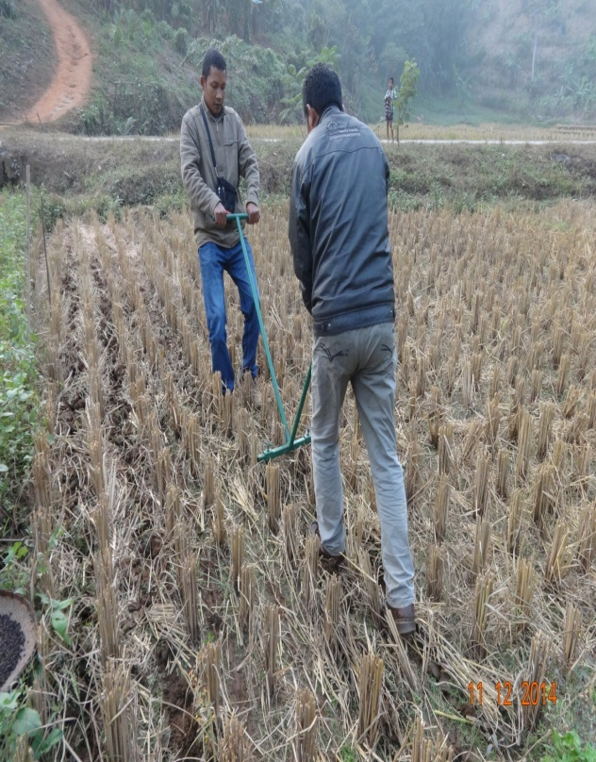
MINIMUM TILLAGE AFTER HARVEST OF PADDY FOR PEA CULTIVATION
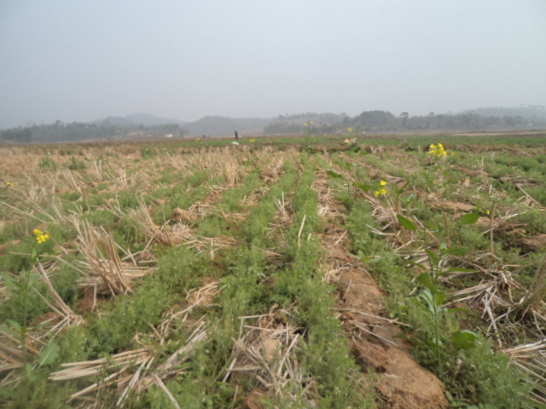

CONSERVATION AGRICULTURE FOR CULTIVATION OF LENTIL USING RICE STRAW AS MULCHING

TRAINING PROGRAMME UNDER NFSM SCHEME FOR THE YEAR 2018-19

- TRAINING UNDER RABI SEASON (4TH SESSION)

Sl. No. | Date | Time | Subject | Resource Person
1. |  | 10:30- 12:30 pm | Post harvest losses in pulses. | Crop/Subject Matter Specialist- ICAR/KVKs/SAUs
2. |  | 1:00- 3:00pm | Milling of pulses. | --do--
3. |  | 3:00- 4:00pm | Organic Compost | --do--
4. |  | 4.00- 5.00pm | Interaction with farmers

4TH SESSION
TIME: 10:30AM TO 12:30PM (2 HOURS)

1. POST-HARVEST LOSSES IN PULSES

Definition
The expression “post-harvest losses” means a measurable quantitative and qualitative loss in a given product occurred during the various phases of the post-harvest system. In economic terms, sum of the losses in quantity and quality of the products inevitably leads to loss of money. In addition to direct economic losses, some losses result from poor management of postharvest systems.

Post harvest system and losses
Seeds of poor quality, inappropriate farming practices and insect infestation in the field can obviously cause loss of produce even before harvest. From the harvest onward, the grain undergoes a series of operations during which quantitative and qualitative losses may occur. Table indicates the type of losses that take place at prevailing conditions at various stages of post-harvest system:
Stage of operation | Type of loss
Late harvest | Shattering losses, losses due to attack of birds and other pests
Insufficient drying of grain | Losses due to development of moulds and insects
Improper threshing | Broken grains and threat of insect development at a later stage
Poor storage | Losses caused by combined action of insects, moulds, rodents and other pests
Improper milling | Broken and powdering loss
Transport | Quantitative loss
Defective packaging | Quantitative and Qualitative loss

Types of Losses:

(a) Losses in Weight

The loss in the weight of grain does not necessarily mean a loss of product. Loss of weight results in reduction of physical substance of the product. For instance, the decrease of the moisture content brings about a lowering of weight, but this is not a food loss. On the contrary, an increase of weight by absorption of moisture due to rains or high humidity can cause severe damage and thus, is a considerable loss. Weight losses take place mainly due to prolonged action of pests (insects, birds, rodents), or due to leakage of products (perforated bags, spillage during grain handling etc.) and can occur at any stage during the harvest, storage and transport or handling.

(b) Losses in Quality
The quality of grains can be ascertained on the general principle according to which grains must be “wholesome, sound, odorless and of market quality”. The criteria of quality vary widely and involve the exterior aspect, such as, shape, size, smell and taste. A clean wholesome product is of primary importance in marketing. An experienced trader can easily predict the quality by taking a handful of grains from a bag. The presence of a floury dust will indicate the presence of insect infestation or the presence of a bad smell can lead to suspected rodent attacks, which can be confirmed by the presence of rats or mouse excreta or hairs. Losses in quality are, thus, evidenced by a decrease in the market value of the grain.

Criteria for evaluation: The quality of grain can be ascertained based upon some well laid tests, measurements and laboratory analyses. Important among these criteria are based upon standards related to the physical condition of grain and to its food, nutritive and germinative values.
The quality of a given batch of grains can be evaluated by:
- Moisture content : suitable for the storage or further handling of the grain
- Colour : homogeneous and appropriate to the type of grain under consideration
- Odour; it must not hint that any biochemical change is going on
- Cleanliness : the number of impurities must conform to established standards of quality
- Infestation : the absence of insects or other living organisms must be ascertained
Generally, multiple criteria are combined to define the quality of the products. The quality criteria may vary according to eating habits of the community. Losses in quality are mainly the result from mechanical injuries sustained by the grains during processing operations, the action of pests (insects, rodents) and micro-organisms (moulds), or the chemical changes produced within the grains under the effect of environmental conditions (temperature, humidity, duration of storage). These losses can occur at any stage of production, especially during hot and humid climatic conditions.

(c) Losses due to Physical Conditions
These depend on the physical condition of the grain during a given stage of the post-harvest system. The physical characteristics generally considered in evaluating the incidence of such losses are: shape and size of the grains, percentage of moisture, presence of impurities (foreign grains, grains that have germinated, broken, deteriorated or damaged, pebbles, earth, plant residues, fragments of glass or metal, animal hairs or excrement, etc.), degree of infestation by insects or micro-organisms.
These losses are caused due to alteration of the organoleptic features like taste and smell, presence of toxic products such as toxins, pesticide residues, etc., and from alteration in its content of proteins, carbohydrates and other important nutrients. These are especially critical when the grains are intended for human consumption.
The grains that are to be used for seed purposes, must have a minimum of germination percentage standardized for that particular grain. Seeds should have good vigour, good growth rate of seedlings and absence of anomalies in the plants thus obtained. The alteration of these properties results into production losses by decreasing the capability of the grain to germinate.

(d) Economic Losses
Economic loss results not only due to deterioration in the quantity or quality of the grain but is also influenced by some factors within the post-harvest system that can hamper the growth of production and income. These include production systems, work schedules and methods, infrastructure, organization models, credit mechanisms etc. For example, adoption of mechanized or semi-mechanized systems for some operations (harvesting, threshing, drying, etc.) can cut working time while, at the same time, permitting an increase in production by reducing the labour required and exploiting the land to better advantage. Commercially, if the transport system is inadequate, the farmer may find it impossible to sell the produce within the required time-limits and in the places where market prices are the most attractive. The fact of having to forgo a potential profit is loss of money beyond doubt. If a farmer is not able to store the produce in complete security in available storage facilities, the produce need to be sold immediately after the harvest, thus making farmer unable to earn profit through selling the produce at maximum market prices. Once again, missing a profit is an economic loss for the farmer. The sequences of such situations often go beyond individual losses. This affects the production and the economy of entire nation.

4TH SESSION
TIME: 01:30PM TO 03:00PM (2 HOURS)

2. MILLING OF PULSES
Pulses are mostly consumed in the form of dehusked splits, commonly known as dal. The outer layer of the grain (husk) is attached to the protein and starch bearing cotyledons of the pulse grains. In some grains like pigeonpea, mungbean and urdbean, this bonding is strong due to the presence of a layer of gums in between the husk and the cotyledons. These are known as difficult-to-mill pulses. In other grains like chickpea, pea, lathyrus etc., this bonding is comparatively weaker. Such grains can be milled easily and are categorized as easy-to-mill pulses. This outer husk layer is required to be separated from the cotyledons and subsequently split in two halves before consumed as dal. The process of removal of husk from the cotyledons is called dehusking and the entire process of dehusking and subsequent splitting of cotyledons, its cleaning, polishing and grading is known as milling. Dehusking improves product appearance, texture, product quality, palatability and digestibility. A substantial amount of avoidable loss takes place at different stages of milling. This may vary from 10-15% depending upon the type and quality of grain milled, the process and machinery used for milling and other factors. It is, therefore, important to look at different aspects of milling so that proper process and machinery are used to obtain maximum recovery of good quality dal from the grain and take corrective measures to reduce milling losses to the minimum.
Pulse milling is the third largest food processing industry after rice and flour milling. An estimated 75% of pulses produced are processed for making dal in mills of different capacities.
Milling of pulses involves two major steps:
- loosening of husk and
- removal of husk and splitting into cotyledons with the help of suitable machine.

All kinds of pulses require some pre-milling treatment for ease of husk removal. However, processes and equipments for loosening of husk, separation of husk from cotyledons and its splitting differ from crop to crop, cultivar to cultivar and place to place. Dehusking is an age-old practice, which originated at home and later developed into a cottage industry and now has grown into a large-scale organized industry.

Home scale milling
This involves pounding of grains for dehusking by using a mortar and pestle after mixing with small quantity of water and drying in the sun for a few hours. Sun-drying after water application helps to loosen the husk from the cotyledons. In mortars, dehusking is achieved due to shearing action between pestle and grains, and abrasive effect between the grains. Once the pounding is done for several minutes, the husk gets detached from the grains. Winnowing separates husk and split cotyledons are separated from the whole dehusked and unhusked grains by manual sieving. The whole grains are again pounded for further dehusking and splitting. This technique of dehusking is generally adopted when small quantity i.e., up to 5 kg of pulses is to be dehusked. Dal yield by this process is quite low (50-60%) due to breakage and chipping of the edges of cotyledons.

Cottage scale milling
Traditionally, villagers use the hand operated wooden or stone chakki/ sheller when comparatively large quantities of pulses are to be dehusked. The technique is similar to those of the home-scale methods. The preconditioning of grains before milling is done either by prolonged sun drying until the hulls are loosened or through application of water followed by several hours of sun drying and tempering. The heating of the grains in pan with or without sand along with vigorous stirring is also in practice. The duration of treatment depends upon the variety of pulses to be milled. There are no standard dehusking techniques at the cottage level. Different combinations of methods, depending upon the experience and available facilities, are followed. Of late, mechanized shellers and plate mills are used for custom milling of preconditioned pulses. At cottage level milling, often the husk is not completely removed and breakage is also quite high. This reduces the consumer appeal and value of the product. The yield of head dal obtained from these techniques may very in the range of 55-70% depending upon the variety of pulse and pre-treatment used.

Commercial scale milling
Commercial scale milling involves processing large quantities of pulses in plants of bigger capacities. Even though, the basic milling procedure is similar, specifics of dehusking methods vary widely from one dal mill to another dal mill and region to region. Two methods for large scale processing or pulses are in practice. Traditional method, most commonly followed by dal millers, is almost similar to cottage level treatment in principles. A modern method of milling has been developed at CFTRI which is independent of weather conditions.

Traditional milling
It has already been said that the milling process varies from mill to mill and region to region and no standard or common process is in practice. The sequence of operations like pre-milling treatment, conditioning, dehusking, and splitting is normally common. Large variation exists in the steps followed in milling but basic unit operations remain the same.

Milling process
Essentially milling process involves cleaning, grading, pitting, treatment milling and polishing operations. Usually milling processes are described for the toughest to mill pulse grains i.e., pigeonpea. The major steps involve in pulse milling are discussed below:
- Cleaning and grading: It involves removing dust, dirt, foreign material, off sized, immature and damaged grains and grading in two or more fractions to process separately.

- Pitting: Use of emery-coated roller is a common practice in commercial dal mills. The emery coating is used for abrasive or refractory action. Whole pulses are passed through abrasive roller machine for scratching of seed to facilitate the entry of oil/water in the grain during pre-milling treatment.
- Pre-milling treatments: The treatment is given for loosening of husk from cotyledons, which is attached through a gum layer is called pre-milling treatment. Mostly pre-milling treatments are developed for pigeonpea. Water soaking, oil and water application, mixing of sodium bi-carbonate solution and thermal applications are commonly recommended and adopted pre-milling treatments. For commercial milling in large capacity dal mills, oil and water treatment is commonly adopted, whereas for household milling, water treatment is popularly used.
Different methods are employed in different regions depending upon type of grain. This also varies from mill to mill. Pre-treatments can be broadly classified into
i) wet treatment and ii) dry treatment.
i) Wet treatment:
In this method of treatment, soaking and drying are considered as effective technique to loosen the husk. This method has the advantage of facilitating dehusking and splitting the cotyledons, giving less breakage. This can be attributed to lower deshusking percentage of grains in water treatment process. However, it has the disadvantage of being weather dependent and labour intensive. Dal produced by this method cooks better but takes longer time to cook. Commonly adopted red earth treatment is considered as wet method. In this method, grains are thoroughly mixed with a paste of red earth after soaking in water for about 12 hours and heaping for about 16 hours. The grains are spread in thin layer in drying yards for 2–4 days. When dried, the red earth is removed by sieving and the grains are then milled on power operated stone or emery coated vertical chakki to yield dal
Water Treatment
Pulse
Cleaning & Grading
Water soaking (4-6 hours)
Pitting
Milling
Drying ( 8-10%)
Husk & Powder
Finished Product

ii) Dry treatment:
Dry milling treatment is reported to produce dal that cooks faster, however, losses due to broken and powdering are high. In dry method, oil/water application followed by drying are important steps in processing of pulses.In this process, after cleaning and grading, grains are pitted and then mixed with about 1% oil (linseed), thoroughly and spread for sun drying in thin layer, for 2–3 days. At the end of drying, 2-5% of water is sprayed, mixed thoroughly and tempered for overnight. Tempered grains are dehusked in roller machines to give dehusked grains and dal.
Pulse
Cleaning & Grading
Oil (0.7%) Water soaking (1:30)
Pitting
Milling
Conditioning (14 hours) & Drying
Husk & Powder
Finished Product
Oil & Water Treatment

- Tempering:

Once the pre-milling treatment is given, conditioning is done to have uniformity of treatment throughout the grain mass. This process gives time for better penetration of oil/water beneath the seed coat to dissolve gums.

- Drying:

In most of the mills in India, sun drying method is commonly practiced. Grains are spread in thin layer on pucca floor under the sun and stirred frequently with rake/feet for even drying. This operation makes process of dal milling a very lengthy requiring (2-3 days). In this case, sun-dried grains require more passes and consumes more energy. The drying time with the use of dryers ranges between 2-3 hrs, which results in tremendous time saving. Dryers are used in few mills that too in rainy seasons for drying of treated grains.

- Dehusking and splitting:

Dal mills by and large use emery rollers for dehusking and splitting. It takes one or two passes in emery mill in order to achieve maximum milling. The physical, chemical and structural strength of grain coupled with the functional and mechanical characteristics of processing units jointly play an important role. Grain properties such as hardness, load deformation behaviour, shape, size density and variety of grain etc. have considerable effect on dal yield. The machine parameters such as roller speed, clearance, emery size etc. have vital role to play on dal recovery. As a result of milling, unhusked and dehusked whole grains, split cotyledons, broken, husk and powder are obtained. Whole grains are passed again for further dehusking and/or splitting after water treatment. Husk and powder produced during milling is generally separated with the help of aspirator and are used as cattle feed.

- Polishing:

Polishing is done to increase consumers appeal and is a form of value addition, though not desirable. Dal is polished in different ways, such as nylon polish, oil/water polish, leather and makhmal polish. Generally polishing is done using soap stone, oil or water. Polishing gives uniform look and shine to each grain.

4TH SESSION
TIME: 03:00 PM TO 05:00 PM (2 HOURS)

3. ORGANIC COMPOST
18 Days compost (BERKELEY COMPOST)
Introduction
18 Days compost is a method developed by University California, Berkeley. Berkeley compost can help increase compost production within a short period and works by trapping the heat of the natural resources thereby increasing the rate of decomposition. The objective of this method is to obtain carbon and nitrogen in the ratio of 3:1 in-order to help supplement the soil which allows favourable environment for the growth and multiplication of beneficial organisms.
Materials Required
- Wire mesh measuring 1.5 meters wide and 1.2 meters high
- Dead twigs and branches (1-2 inches)
- Chopped Leaves and grass (dried)
- Chopped Weeds and leaves (live)
- Cowdung
- Water
- Plastic

1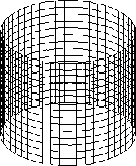 2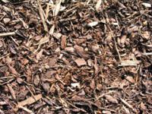 3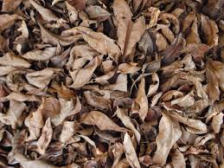 4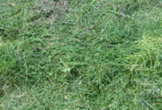 5 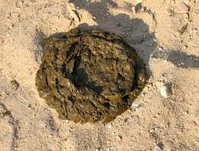 6 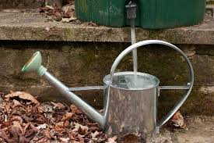
7
Method of preparation
First Day
- Select an area with proper drainage and depending upon the size of your operation
- Using the wire mesh tie the ends to form a conical shape and put on a levelled ground
- First spread the twig and branches inside the mesh to about 5 cm. and sprinkle a little water
- Add the dried leaves and grass approximately 15 cm. and sprinkle little water
- Add the live Weeds and leaves to form the third layer roughly 6-8 cm. and sprinkle little water
- Finally add cowdung 2-3 cm and again sprinkle little water

After the final layer is added, the procedure is continued again till it reaches the brim of the wire mesh (fig 1.). On completion, cover the mesh with the plastic and tie it properly to avoid heat loss (fig 2).
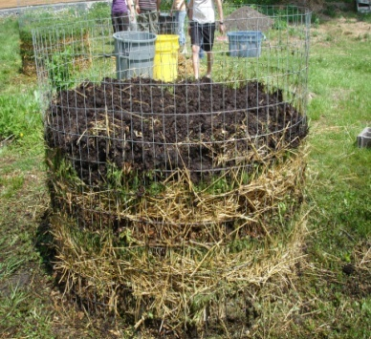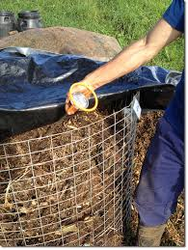
Fig 2. JINGMYNTOI BA NGI IOH LYNGBA KANE KA SBOH:
- Kane ka rukom pdem sboh ka pynmih kham bun ka sboh ban ia kiwei kiwei pat ki rukom pdem sboh.
- Ka shim por ban long sboh tang kumba 18 sngi katba kiwei pat ki rukom shna sboh ki shim por ym duna iaka 2-3 bnai.
- Ki symbai kynbat, ki khniang jingpang bad ki pylleng khniang kim la ban im bad ki iap noh namar ka jingkhluit jong kane ka sboh haka por ba pdem iaka. Kane ka pynlong ban ioh ka sboh ba khuid bad ba bha (infestation free).
- Namar kane ka rukom pynmih sboh ka long kaba kloi, kumta kan pynsuk ban pynmih sboh shibun khnang ban ioh pyndonkam ha man la ki por.

Fig 1. KI JINGMYNTOI BA NGI IOH LYNGBA KANE KA SBOH:
- Kane ka rukom pdem sboh ka pynmih kham bun ka sboh ban ia kiwei kiwei pat ki rukom pdem sboh.
- Ka shim por ban long sboh tang kumba 18 sngi katba kiwei pat ki rukom shna sboh ki shim por ym duna iaka 2-3 bnai.
- Ki symbai kynbat, ki khniang jingpang bad ki pylleng khniang kim la ban im bad ki iap noh namar ka jingkhluit jong kane ka sboh haka por ba pdem iaka. Kane ka pynlong ban ioh ka sboh ba khuid bad ba bha (infestation free).
- Namar kane ka rukom pynmih sboh ka long kaba kloi, kumta kan pynsuk ban pynmih sboh shibun khnang ban ioh pyndonkam ha man la ki por.

Fifth Day
After five days, remove the plastic and measure the temperature of the compost by inserting your hand inside. If it is found that there is presence of heat, then the compost is ready for turning.

- Prepare a suitable land for laying the compost
- Remove the plastic and the wire mesh
- Take the outer layer of the compost and lay it on the prepared area and then add the inner layer on top.
- If it is found that the compost is dry then water can be added
- Cover the compost again with the plastic (fig 3)
- Turn the compost regularly at three days interval for a period of 18-20 days (fig 4)
- Indications of the compost is ready when earthworms starts aggregating together

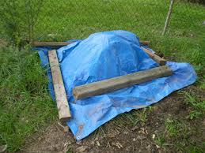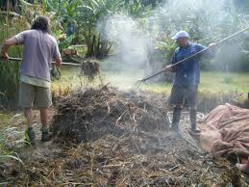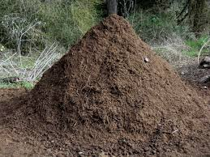
Fig 5.
Fig 4.
Fig 3.

Advantages

- Less time is needed for making this compost which means more having large amount of organic matter
- The compost if infestation free as the environment inside is hot for any microbial organism or insects to survive
- It is cheap and easy to make
JEEVAMRUT
Jeevamrut is a concoction that can be organically prepared at home. It acts as a deterrent for pest from consuming the crop or vegetables as well as help plants fight against diseases. Jeevamrut helps farmers by reducing their dependency on synthetic chemicals such as insecticides and pesticides
BENEFITS
- It helps increase microbial population in the soil which in-return protects the plant against any diseases.
- It also helps in nutrients uptake such as Nitrogen, Potassium, Phosphorous, etc., from the soil
- Jeevamrut acts as a pest repellent by deterring the pest from eating the plant
- Pest that feed on plants that have been applied with Jeevamrut stop eating and eventually die out of starvation
Materials and Ingredients
- Plastic bucket(20 Litre)
- Fresh cowdung (1Kg)
- Cow urine 3-4 days old (1 litre)
- Chick pea powder (250-500gm)
- Jaggery (250-500gm)
- A handful of soil
- Water (10 litres)
- Black cloth.
Method of Preparation
Step 1. In the bucket mix together Fresh cowdung, cow urine, chick pea powder, jaggery and a handful of soil
Step 2. After mixing the ingredients pour water into the bucket and stir.
Step 3. After stirring cover the bucket with a black cloth and keep it away from sunlight.
Step 4. The product can be used after 7 days.
APPLICATION OF JEEVAMRUT
- Take one litre of the stock solution and add 10 litres of water to it.
- The solution can be used from the third day onwards.
- The solution can be added to irrigation channels in the rice fields.
- The conditions for application should be on cloudy days and on moist soil.
- It is recommended to apply after 15 days at three day interval.

PRECAUTION:
- Avoid using metal/iron bucket.
- Avoid using the mixture during flowering.

