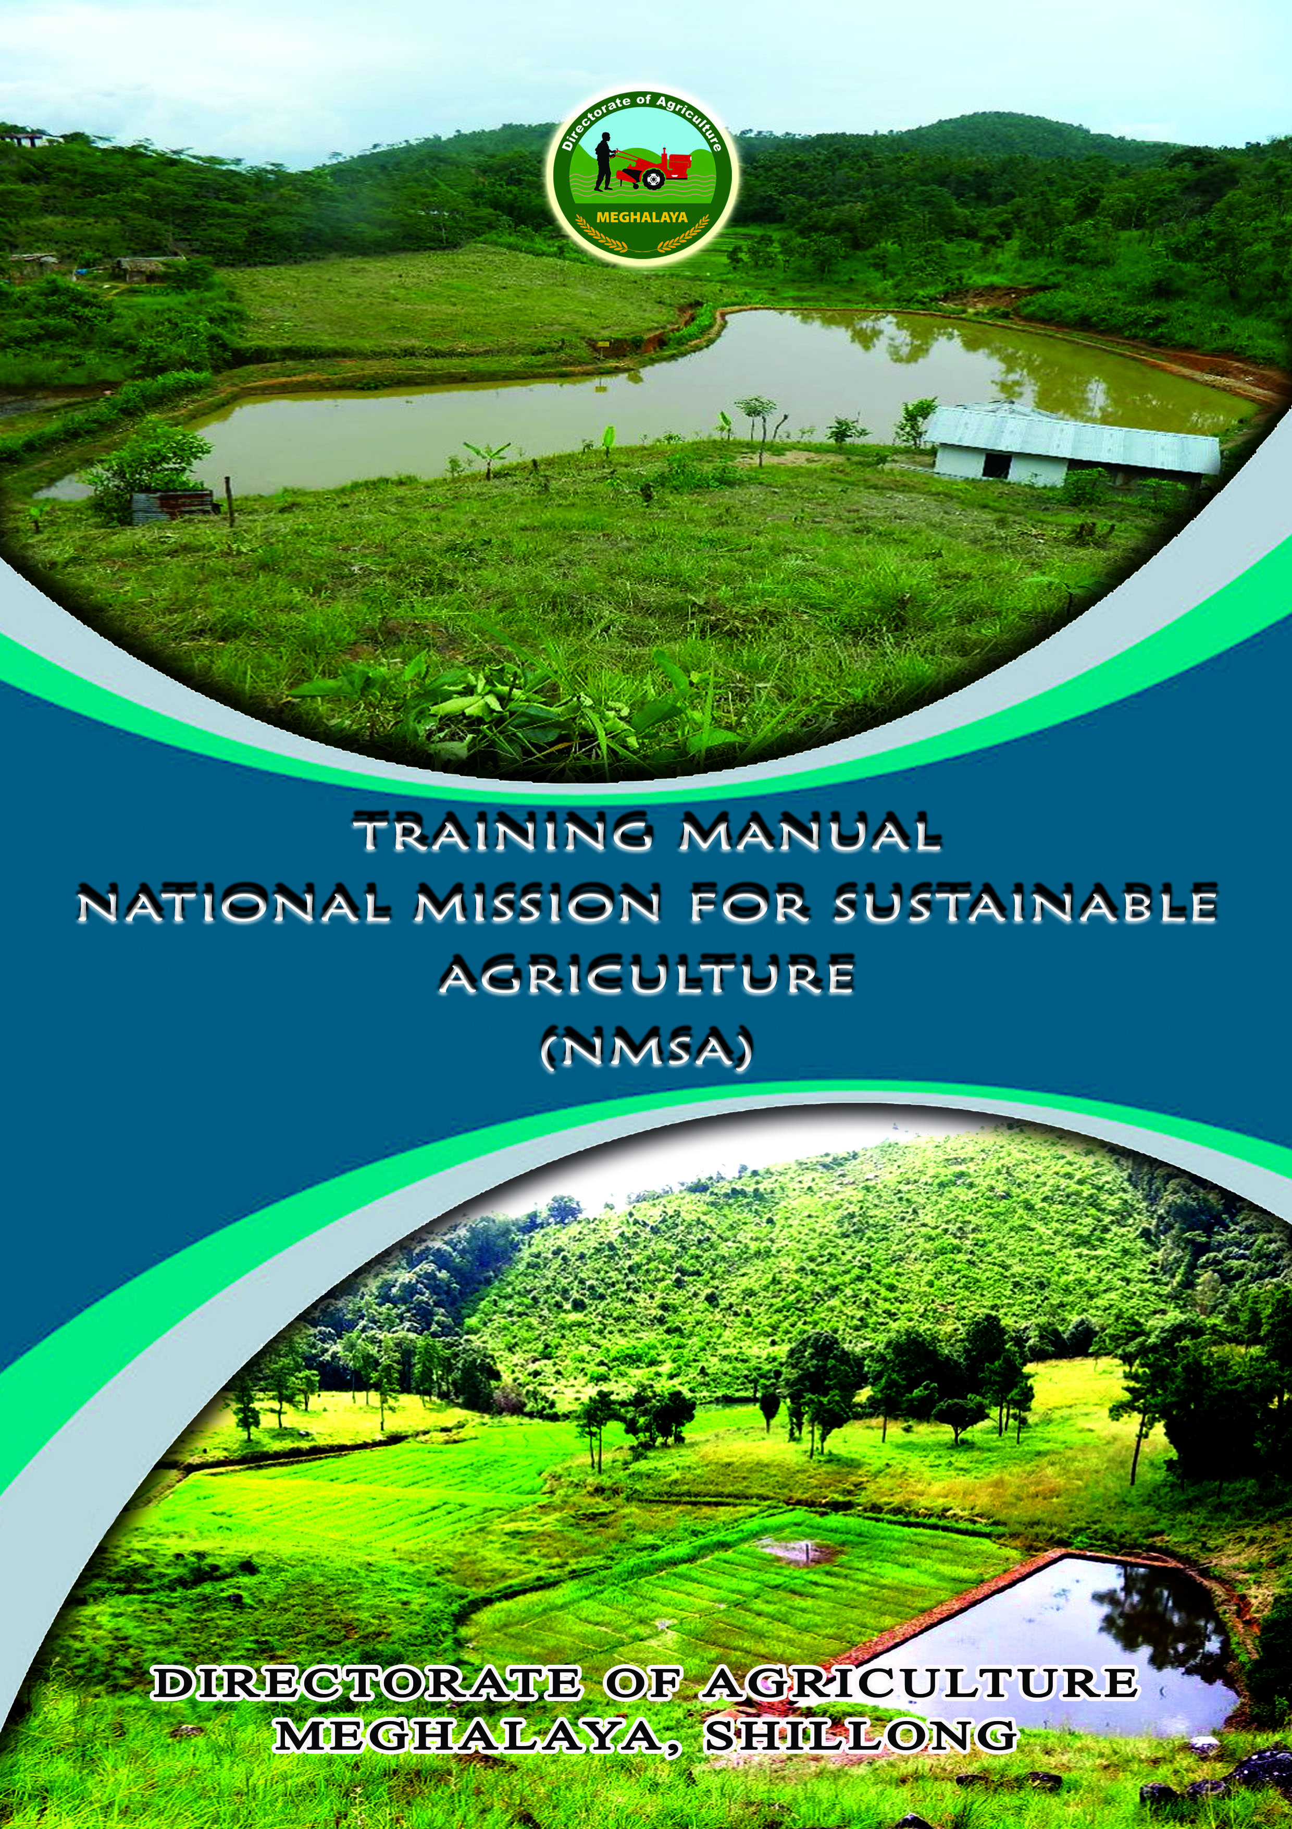

Foreword
To address to the need in fostering the capacity building of the stake holders for successful implementation of the scheme on National Mission for Sustainable Agriculture (NMSA), we have developed the training manual to guide the functionaries in imparting effective and uniform trainings to the farmers of the State in accordance with the prescribed guidelines laid down for its implementation.
The manual per se is designed to provide technical know how to the Stake holders with the sole aim to foster and step up integrated Agriculture development thereby boosting the rural economy of the State.
The department is confident that the participants in the training will benefit immensely from this exercise and acquire the knowledge intended for achieving the purpose of the scheme.

Date: 7th Aug, 2018 Shri. R. Langstieh Director (Research &Training)
Meghalaya::Shillong
CONTENTS
Sl no. | Particulars | Page
1 | Objective for the training on NMSA | 1
2 | Budget estimate for the training programme | 2
3 | Training programme under NMSA scheme for the year 2018-19 | 3
4 | Water Harvesting structure | 4-7
5 | Resource conservation:
 | - In situ moisture conservation  - Contour Bunding | 8-11
 |  | 14-19
 | - Reclamation of eroded soil, field bunding acid soi/Al and Fe toxic soil | 20
6 | Horticulture Based Farming System | 21-23
7 | Livestock Based Farming System
 | - C B cows + mixed farming | 24-26
 | - Piggery/Poultry | 26-27

OBJECTIVES OF THE TRAINING ON
NATIONAL MISSION FOR SUSTAINABLE AGRICULTURE

Training of farmers play a very crucial role in speedy dissemination of technical knowhow to the stake holders for efficient implementation of the scheme. In this context, the training module for the National Mission for Sustainable Agriculture is formulated according to the objectives of the scheme which aims
To make agriculture more productive, sustainable, remunerative and climate resilient by promoting location specific Integrated/Composite Farming Systems.

To conserve natural resources through appropriate soil and moisture conservation measures.

To adopt comprehensive soil health management practices based on soil fertility maps, soil test based application of macro & micro nutrients, judicious use of fertilizers etc.

To optimize utilization of water resources through efficient water management to expand coverage for achieving ‘more crop per drop’.

To develop capacity of farmers & stakeholders, in conjunction with other on-going Missions e.g. National Mission on Agriculture Extension & Technology, National Food Security Mission,National Initiative for Climate Resilient Agriculture (NICRA) etc., in the domain of climate change adaptation and mitigation measures.

To pilot models in select blocks for improving productivity of rainfed farming by mainstreaming rainfed technologies refined through NICRA and by leveraging resources from other schemes/Missions like Mahatma Gandhi National Rural Employment Guarantee Scheme (MGNREGS), Integrated Watershed Management Programme (IWMP), RKVY etc.

To establish an effective inter and intra Departmental/Ministerial co-ordination for accomplishing key deliverables of National Mission for Sustainable Agriculture under the aegis of NAPCC..

 | Budget Estimate for Training Programme under NMSA-(RAD) as per
 | AAP 2018-19 submitted to the Government of India
 | Sl. No. | Training Programme |  | No. of Training | Location of the Training |  | Nos. of Trainee/ Training | Rate/ Training | Total Amount
 | 1 | Training Programme under NMSA (RAD) 2018-19 |  | 36 Nos. for 36 Nos. of clusters | For the clusters at cluster level |  | 20 | Rs. 10,000/- | Rs.3,60,000/-
Details Budget Estimate for the Training
 | Sl. No |  | Item |  |  | Rate |  | Amount for 4 Sessions
 | 1 |  | Honorarium for 1 trainer |  |  | Rs. 500/- session |  | Rs. 2,000/-
 | 2 |  | Training materials and stationeries. |  |  | Rs. 500/- session |  | Rs. 2,000/-
 | 3 |  | Refreshment for the trainees, supporting staff |  |  | Rs. 30/- per head for 25 trainees |  | Rs. 3,000/-
 | 4 |  | Contingency, POL Transport |  |  | Rs. 750/- per session |  | Rs. 3,000/-
 |  |  | Total |  |  |  |  | Rs. 10,000/-
 |  |  | Note: The training programmes NMSA (RAD) under C.S.S. 2018-19 is to train the
 |  |  | clusters which implementing the scheme at the District level for the following
 |  |  | purposes: -
 | 1 |  | Integrated Farming System (Horticulture based), Fruit and Mixed Farming.
 | 2 |  | Livestock based farming system, Piggery, Poultry, cattle, etc.
 | 3 |  | Conservation works like
 | (a) |  | Water Harvesting Structure
 | (b) |  | Contour Bunding
 | (c) |  | In situ moisture conservation
 | (d) |  | Reclamation of problem soil
 | (e) |  | Vermi composting/18 days composting.
TRAINING ON
NATIONAL MISSION
FOR SUSTAINABLE AGRICULTURE
FOR THE YEAR 2018-19

- Training Programme (1 Day Programme)
Sl No. | Date | Time | Subject | Resource Person
1. |  | 10:30- 11:30 am | Water Harvesting structure | Soil and Water Conservation Officer
2. |  | 11:30- 1:00 pm | Resource conservation:  a)In situ moisture conservation  b) Contour Bunding
3. |  | 1:00-2:00pm | Resource conservation:  Reclamation of eroded soil, field bunding acid soil/Al and Fe toxic soil
4. |  | 2:30-3:30pm | Horticulture Based Farming System  Maize intercropping with soyabean/frenchbean-vegetable/potato/Fruits + Mixed Farming | Crop/Subject Matter Specialist- ICAR/KVKs/SAUs
5. |  | 3:30-5:00pm | Livestock Based Farming System:  a)C B cows + mixed farming  b) Piggery/Poultry | Department of Animal Husbandry and Veterinary Sc.

TIME: 10:30AM TO 11:30PM (1 HOUR)

1. Water Harvesting
WATER MANAGEMENT & WATER HARVESTING
INTRODUCTION
Water is indispensible for life and more so for man. The need for water is felt more and more for better living with modern services. The per capita consumption has increased from a few litres in the Stone Age to as much as 600 litres in developing countries today. The demand for water for irrigational and industrial complexes also increased to meet the requirements of the growing populations. The involved problems are becoming more and more complex with the vagaries of precipitation and recurrence of droughts. In drought affected areas, tanks and reservoirs are repeatedly left unfilled, thereby causing acute scarcity for water and leaving millions of hectares of irrigated tracts without sowing.
IMPORTANCE OF WATER
Water is one of the most essential of all natural resources. The supply of potable fresh water has assumed critical dimensions both in terms of quality and quantity. Large stretches of rivers have no water and are heavily polluted giving rise to grave environmental consequences. Ground water is depleting fast and also being severely affected in terms of quality at places. It is also likely to become a critically scarce resource in many regions of the Country. It is therefore very important that this national resource is managed very cautiously. Water has to be used and recycled most efficiently to produce adequate quantity of food, fodder, fiber and oilseed to meet the ever increasing demand of the nation and to bring stability in agricultural production.
The scope of water harvesting has therefore come up to collect, store and convey the rainwater on watershed basis for more production purpose and greater stability.
WATER MANAGEMENT & WATER HARVESTING
Water harvesting means collection and storage of water by some mechanism to make water available for future use. An appreciable amount of precipitation which is generally lost as surface flow can be harvested and stored for useful purposes like drinking and providing supplemental irrigation to the crops.
The effort to collect water for completing the need and the use of water in efficient ways is becoming very urgent. Water harvesting techniques are promoted to be introduced to community for handling the water scarcity and disaster due to flood. Collected water from direct rainfall and runoff will be very valuable for covering the needs. Water harvesting may also increase recharge of the groundwater leading to increase groundwater storage. This is the reason why water harvesting techniques is important for sustaining water resources management.

Water Harvesting Techniques
Water harvesting has been practices from primordial days in various ways. It is based on the following three basic criteria:
Source of water available
Required storage duration
Intended use of harvested water.
TRADITIONAL METHODS OF WATER HARVESTING
Traditional water harvesting, which is still prevalent in rural areas was done in surface storage bodies like lakes, ponds, irrigation tanks etc.
In urban areas, due to shrinking of open spaces rainwater will have to necessarily be harvested as ground water. Hence, harvesting in such places will depend on the nature of the soil viz clayey, sandy soil etc.
Some of the Traditional Techniques
Roof Top Water Harvesting
Slightly sloping roofs allow water to run into gutters, down pipes, and into specially prepared drums.
Filters of wire mesh, sand, gravel and charcoal clean the water. It is funnelled into the underground or above ground tanks.
Tanks are sealed to keep out air, sunlight, treatment with alum reduces turbidity and bleaching powder kills bacteria.
This water can be used for flushing toilets, gardening, washing clothes.
Percolation Tanks
Small tanks built on sandy or rocky soil to store rainwater.
Some of the water is used, but the remainder percolates through to aquifers which replenish wells.
Bhandaras
Underground tanks built to intercept water from springs, channelling it to storage tanks for city use.
Qanats
Vertical shafts in hilly areas to catch rain water.
The water is collected in underground channels that carry it by gravity over long distances to storage wells.
Integrated Tanks
Tanks that overflow into a series of lower tanks to catch the rainwater that is funnelled through gutters
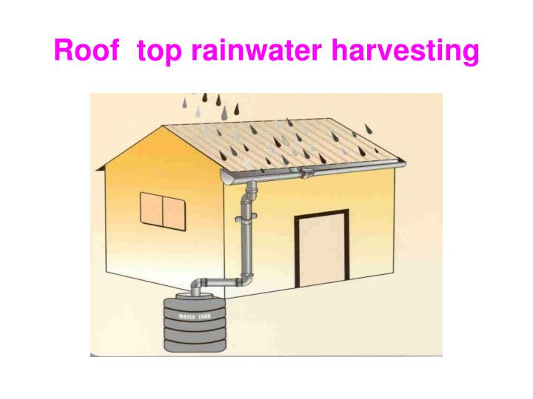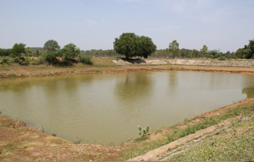
NEW TECHNIQUES
There are two main techniques of water harvesting
Storage of rainwater on a surface for future use such as in underground tanks, ponds check dams, weirs etc.
Recharge of ground water is a new concept of water harvesting.
The General Methods of Recharging Ground Water Are:
Pits Recharge: pits are constructed for recharging the shallow aquifers.
Trenches: these are constructed when the preamble strata is available at shallow depths.
Dug Wells: existing dug wells may be utilized as recharge structure and water should pass through filter media before putting into dug well.
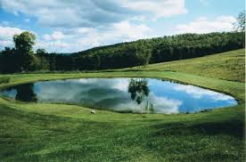
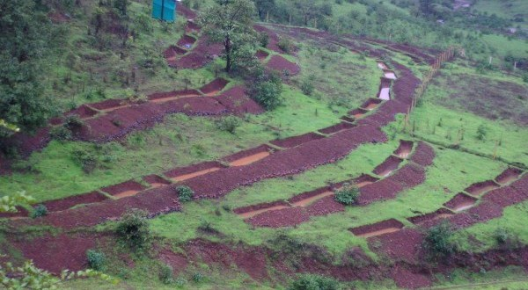
Dug out Pond
Water Recharging Trenches
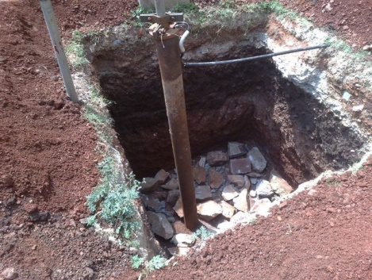

WATER RECHARGE PITS/WELLS

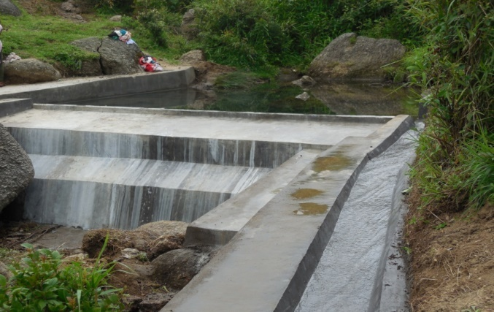
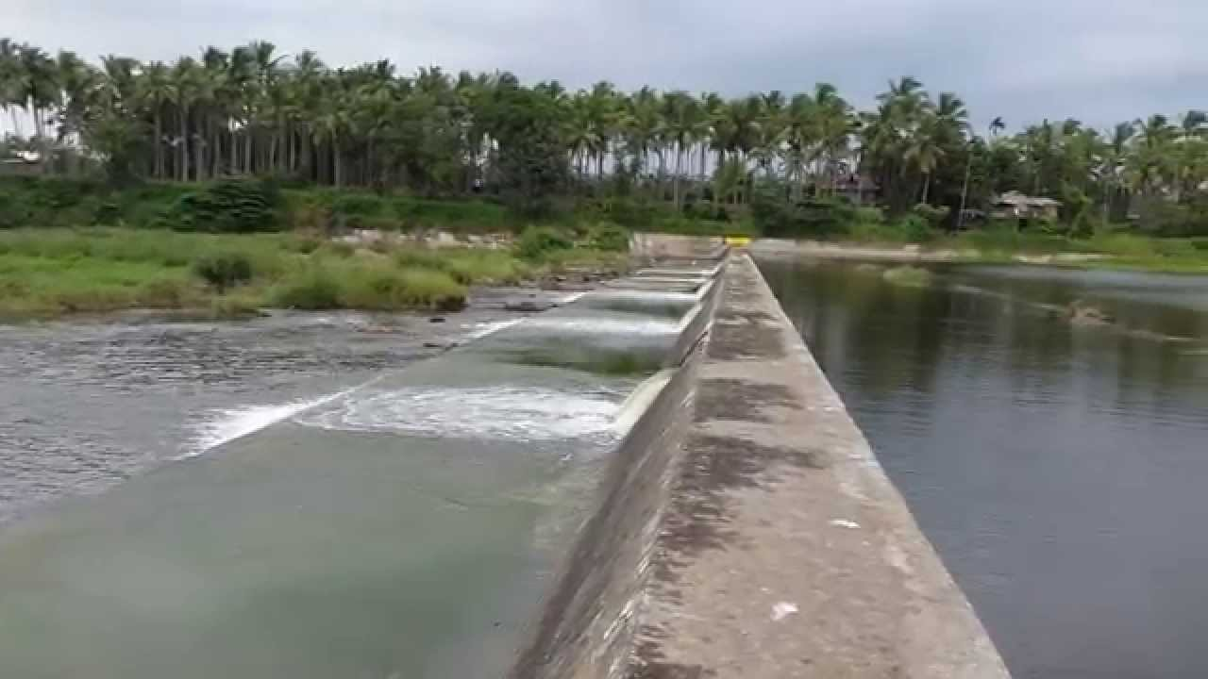

Diversion Canal
Check Dam

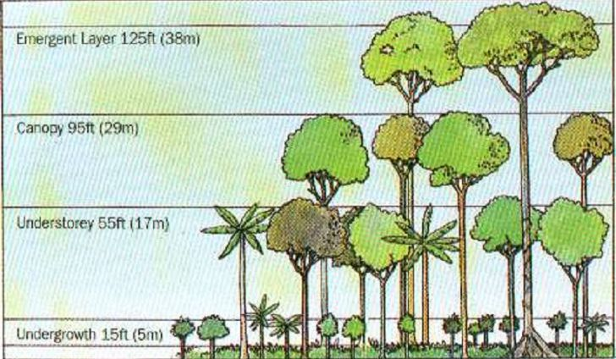

Multi-tier Cropping

TIME: 11:30- 1:00 pm (1.5 HOURS)

2. Resource conservation:
a)In situ moisture conservation
b) Contour Bunding

IN-SITU MOISTURE CONSERVATION

Definition
The conservation of ecosystems and natural habitats and the maintenance and recovery of viable populations of species in their natural surroundings: and in the case of domesticated or cultivated species, in the surroundings where they have developed their distinctive properties.
Convention on Biological Diversity (CBD) 1992.

Key points
- In-situ conservation is one of two basic conservation strategies, alongside ex-situ conservation. Article 8 of the Convention on Biological Diversity (CBD) specifies in-situ conservation as the primary conservation strategy, and states that ex-situ measures should play a supportive role to reach conservation targets.
- In-situ conservation aims to enable biodiversity to maintain itself within the context of the ecosystem in which it is found.
- In-situ management approaches can either be targeted at populations of selected species (species-centred) or whole ecosystems (ecosystem-based).
- Traditionally, protected areas have been seen as the cornerstone of in-situ conservation. Conservation approaches that are more adaptable to individual situations and applicable beyond protected areas, are being increasingly applied.

Introduction
In-situ (‘on site’, ‘in place’) conservation is a set of conservation techniques involving the designation, management and monitoring of biodiversity in the same area where it is encountered. The in-situ concept is best understood in contrast to ex-situ conservation. Ex-situ (‘off site’) conservation techniques are implemented away from the conservation target's natural habitat. While the identification of ex-situ initiatives leaves little room for ambiguity (e.g. zoos, seed banks, captive breeding), the notion of in-situ conservation covers a broad spectrum of situations ranging from the establishment of a protected area to the design of a sustainable management strategy for a particular habitat.

Purpose and use of in-situ conservation strategies
In-situ management approaches can either be targeted at populations of selected species (species-centred approaches), or whole ecosystems (ecosystem-based approaches). Both approaches follow the same purpose: To enable biodiversity to maintain itself within the context of the ecosystem in which it has been found, i.e. to enable a species population to self-replicate and maintain its potential for continued evolution. This requires conservation of the components of the natural system (populations, species, communities and biophysical systems) as well as the ecological and evolutionary processes occurring within that system. Conservation measures are aimed at the surroundings where a target-species developed its distinctive properties. This could be a natural habitat, or an environment heavily modified by human activity. For instance, agricultural or domestic species may have evolved characteristic traits in human dominated environments. The conservation of agricultural biodiversity therefore requires the conservation of agro-ecosystems by farmers, commonly using traditional farming practices.

Examples of in-situ conservation initiatives
Protected areas are the cornerstone of in-situ conservation, as is outlined in Article 8 of the CBD. A protected area network may contribute to conservation targets through the maintenance of target species and their habitats, as well as the conservation of natural or semi-natural ecosystems. There is a however growing awareness of the importance of extending in-situ conservation beyond protected areas. The socioeconomic and political context around a threatened habitat may prevent the establishment or success of a protected area, and the development of alternative in-situ conservation management approaches may prove more useful in these situations. For instance, it was shown that the protection of Indonesian coral reefs could be enhanced through the implementation of a management plan which included a cycle of open and closed harvesting of reef resources within prescribed locations. In-situ initiatives beyond protected areas may include:
- Habitat restoration, recovery or rehabilitation;
- Strategies for the sustainable use and management of biological resources;
- Recovery programmes for nationally or sub-nationally threatened or endangered wild species;
- On-farm agricultural biodiversity conservation targeted at traditional crop varieties and crop wild relatives;
- Genetic reserve conservation, i.e. monitoring of genetic diversity in natural wild populations within a delineated area (known as genetic sanctuaries or gene management zones).
- Control of threats to biodiversity such as invasive alien species, living modified organisms or over exploitation;
- Preservation and maintenance of traditional knowledge and practices; and
- Implementation of the regulatory, legislation, management or other frameworks needed to deliver the protection of species or habitats.
In-situ moisture conservation techniques
  - Micro catchments
  - Broad beds and furrows
  - Contour bund
Other methods:
Contour wash stops, Stubble mulching, Broad bed and furrow system, Basin listing , tied ridging, Contour bunding, Contour trenching, Staggered trenching, Conservation ditching.

Micro catchments:
Micro catchments -It is useful for insitu moisture conservation and erosion control for tree crops. -Micro catchments used for sloping lands.
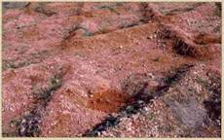
Functions
- To conserve insitu moisture and reduce soil loss
- Circular basin of one meter diameter for level lands depending upon infiltration and rainfall
- ‘ V’ ditches of size 5m x 5m with trees planted centre and height according to the rainfall and slope of slopy lands
- Saucer basins / semi circular bunds with 2m diameter to a height of 15-20cm across the slope.

Salient features:
- Salient features Slope ranges from 2 –8%.
- Soil type – Light to moderate texture.
- Insitu moisture conservation with staggered planting.
- Suitable for dry land Horticulture & Agroforestry.
- Bund height – 30 to 45 cm .
Broad beds and furrows:
The broad bed and furrow system combines an element of erosion control with surface drainage . Normal bed width adopted is 150 cm with 30 cm wide furrows at the end of the beds. The broad beds and furrows have been found to be suitable for managing the deep black soils in India where surface drainage during the monsoon period is a problem. In India, surface drainage during the monsoon period is a problem.
The beds function as mini bunds at a grade and they help in reducing the velocity of surface runoff and increase the infiltration opportunity time. The excess water is removed through the furrows.
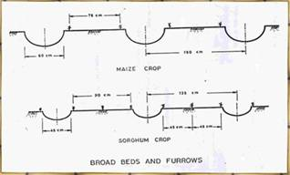
Function | To control erosion and to conserve soil moisture in the soil during rainy days
General information | The broad bed and furrow system is laid within the field boundaries. The land levels taken and it is laid using either animal drawn or tractor drawn ridgers.
Cost | Approximate cost for laying beds and furrows is Rs. 1000/- per ha.
Salient features | Conserves soil moisture in dryland, Controls sol erosion.  Acts as a drainage channel during heavy rainy days.
Contour bund:
Contour bund Contour bunding is the construction of small bund across the slope of the land on a contour so that the long slope is cut into a series of small ones and each contour bund acts as a barrier to the flow of water, thus making the water to walk rather than run, at the same time impounding water against it for increasing soil moisture.
Contour bunds divide the length of the slope, reduce the volume of runoff water, and thus preventing or minimizing the soil erosion. Contour bunds are constructed in relatively low rainfall areas, having an annual rainfall of less than 600 mm, particularly in areas having light textured soils. For rolling and flatter lands having slopes from 2 to 6% contour bunding is practiced, in red soils.
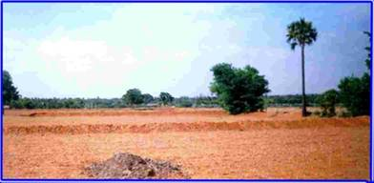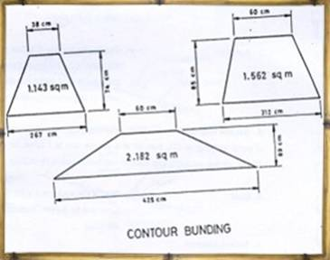
Fig: Contour bunding.
Function | To intercept the runoff flowing down the slope by an embankment.
General information | It helps to control runoff velocity. The embankment may be closed or open, surplus arrangements are provided whenever necessary.
Cost | Approximate cost for laying contour bund is Rs. 1500/- per ha.
Salient features | It can be adopted in light and medium textured soils.  It can be laid upto 6% slopes.  It helps to retain moisture in the field.

FIELD BUNDING
Compartmental Bunding (Field Bunding)
Introduction
It is proven sustainable land management practice for marginal, sloping, and hilly land where the soil productivity is very low. Farmers use a multi-step process to promote the formation of rough terraces along contour lines on sloping land. Compartmental bunding means the entire field is divided into small compartments with pre determined size to retain the rain water where it falls and arrest soil erosion. The compartmental bunds are form using bund former. The size of the bunds depends upon the slope of the land. Compartmental bunds provide more opportunity time for water to infiltrate into the soil and help in conserving soil moisture.
These bunds control the formation of rills, arrest soil erosion, reduce water velocity and increase soil moisture.
Purpose:
- Breaking the length of slope.
- Checking the soil loss.
- Improving local soil moisture profile.
Location:
- In irregular sized and very small land holdings.
- Where field boundaries/ bunds exists or in un-bunded land.
- Where laying of contour or graded bund is not practically possible, mainly due to resistance of farmers.
Constructed along the field boundaries in upper middle and lower reaches. Such structures should be constructed across the slope for maximum impact.
Types of farm bunding:
- Contour bunds(Contour ridges):
Applied to sloping land but even terrain in order to catch run-off water. It prevents soil erosion and stores nutrient from run-off. Not suitable for uneven terrain.

- Semi-circular bunds:
These bunds are possible to apply on uneven ground. It can be constructed on any slope, from almost flat terrain up to steep slopes.
Dimensions:
The general dimensions should broadly follow the dimensions of contour bund. Since, the total bund length per hectare is much more than the calculated length of bund per hectare. Due to small land holdings with irregular boundaries, the dimensions of such bund in general are less than the dimensions of contour bund. Generally, cross section is decided keeping the slope, soil and rainfall in view and mostly importantly with the consent of the farmers. The existing side bunds which run along the slope is not constructed/ renovated. Only the existing field bunds across the slope is renovated/ constructed after taking the pre measurement of the length and section. Provision of series of suitable outlets for each bunding is a must considering the total runoff to be handled/ cumulative runoff from the catchment.
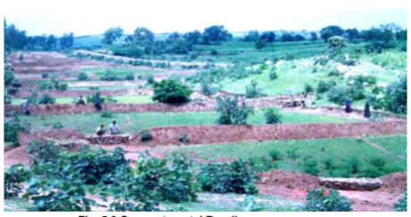
Fig.Compartmental Bunding.
Estimation for field bunding/graded bunding/contour bunding:
For 1 ha land (100m x100m field size)
Total length of bund =300m (bund will be on three sides, no bund on up stream side)
Area of cross section = 0.3375m²
Volume of earthwork= 0.3375 x 300=101.25m³
Cost of excavation and formation of bund @Rs. 46/ m³ =101.25 x 46=Rs. 4657.50
Assuming cost of brick masonry broad-crested rectangular weir/ prefabricated cement concrete drop structure= Rs. 662/-
Total cost of construction= Rs.5320/ha.

b) CONTOUR BUNDING
Contour is an imaginary line drawn across the slope. Contour bunding is a proven sustainable land management practice for marginal, slopping and hilly land where the soil productivity is very low. It is widely adopted in the hilly areas where shifting cultivation is practiced to prevent soil erosion.
Contour farming is growing crops “on the level” across or perpendicular to a slope rather than up and down the slope. The rows running across the slope are designed to be as level as possible to facilitate tillage and planting operations on the contour.
Contour or contour lines:
“A contour is an imaginary line of constant elevation on the surface of the ground”. Contours are represented on the map by contour lines. The contour and contour lines are often used inter-changeably.
Contour interval:
“The vertical distance between any two successive contours on a given map is called the contour interval”. Contour intervals usually vary from 25 to 250 cm in engineering work. In rough country, the vertical distance between contours is kept greater while in flat areas 25 to 50 cm contour intervals are used.
Types of contour bunding:
Contour bunding is sub-divided into following two types:
- Narrow based contour bunding; and
- Broad base contour bunding.
Narrow based contour bunding:
In narrow base contour bunding system, there is an obstruction for crossing of farm implements; natural vegetation cover the sides and more height is allowed for same cross-section. It has limitations that, there is considerable area lost in constructing the bund; the bund section is liable to get affected by erosion due to rain drop impact, hence requires a sincere maintenance. The narrow base contour bund also cause obstruction on farming operations.
Broad base contour bunding:
The broad base contour bunding is concerned, it does not create hindrance in farming operations; the entered area can be kept under cultivation. It has some limitations, such as disturbance of bund’s section due to crossing of farm equipments, as a result there is required an attentive care and maintenance. Apart from above, the soil of bund is also loosened during movement of farm machineries, causing reduction in the size of bund in a very short period, unless some proper maintenance is adopted.
Functions:
The main functions of the contour bund are given as under:
- It reduces the length of the slope, which in turn reduce the soil erosion.
- Impounds the water at u/s portion, and permits more water to get recharge into the soils that is utilized for crop cultivation.
Criteria for contour bunding:
- Slope: 2 – 6 %
- Soil texture: Light textured to medium textured soils.
- Annual rainfall: < 600 mm.
- Altitude: 500 – 1000 m above MSL
Characteristic of Contour Lines:
- All points on a contour line have same elevation
- Contour line close to each other on s plan view; represent very steep ground. Contour lines for apart indicate relatively flat land
- On uniform slopes the contour lines are spaced uniformly .along plane surfaces these lines are straight and parallel to one another.
- Contour lines Crosse ridge lines or valley lines at right angles valley contour are convex towards the stream.
- Contour lines cannot and anywhere, but close on themselves. Either within or outside the limits of map they cannot merge or cross one another.
- A series of closed contour on the map indicate a depression or a summit, depending whether the successes contour have lower or higher values inside.
- At ridge line the contour lines form curves of U shape. At Valley lines they farm sharp curves of shape.
Benefits of contour bunding:
- Decreased soil erosion and increased productivity of the soil through formation of permanent bunds and terraces; adds organic matter to the soil.
- Natural terrace formation and decreasing slope gradient over time, as more soil deposits on the bunds, the gradient is naturally decreased.
- As the organic matter content increases, humus soil is formed and the soil fertility increases. Continue to accumulate crop residues on the surface; these will decompose and increase the organic matter content of the soil.
Design of contour bund
Contour bunding is the construction of small bund across the slope of the land on a contour so that the long slope is cut into a series of small ones and each contour bund acts as a barrier to the flow of water, thus making the water to walk rather than run, at the same time impounding water against it for increasing soil moisture. Contour bunds divide the length of the slope, reduce the volume of runoff water, and thus preventing or minimizing the soil erosion. Contour bunds are constructed in relatively low rainfall areas, having an annual rainfall or less than 600 mm, particularly in areas having light textured soils. For rolling and flater lands having slopes from 2 to 6% contour bunding is practiced, in red soils.
Design of contour bunds
Vertical Interval between bunds (V.I)
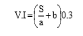
where, S – land slope (%); a and b are constants
a = 3 and b =2 for medium and heavy rainfall zones
a = 2 and b =2 for low rainfall zones.

Horizontal Spacing in between bunds (H.I)
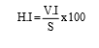
Length of bund per hectare (L.B)
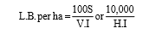
Depth of water impounding before the bund (h)
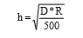
where, D – vertical interval (m),
R – maximum rainwater on area basis (mm)
Actual height of the bund = h + 20% of h as freeboard

General principles of design
1. Spacing of Contour bund:
Bund spacing is expressed as the vertical or the horizontal distance between corresponding points on two adjacent bunds. The horizontal spacing is useful in determining the row arrangement. Vertical distance is commonly known as the vertical interval or V. I.
Bund spacing should not be so wide as to cause excessive soil erosion between adjacent bunds. Spacing may be increased or decreased 10 to 20% to suit local conditions.

Table 1. Spacing of Contour bunds (Recommended by Gadkary)

Slope of land  [ c ] | vertical interval  [ m ] | Approx horizontal distance  [ m ]
0 to 1 | 1.05 | 105
1 to ½ | 1.2 | 98
1/2 to 2 | 1.35 | 75
2 to 3 | 1.5 | 60
3 to 4 | 1.65 | 52

2. Bund Grade:
Since the contour bunds are laid along the contours, they are level bunds
3. Bund length:
In general, 400 to 500m is the maximum length of bund. The bund retains the runoff and carries it over the distance equal to bund length in one direction. The length of bund should be such that the velocity of water flowing between bunds should be non- erosive.
4. Bund cross section:
The height of bund should provide sufficient storage above the bund to handle the expected runoff. In normal practice sufficient practice is provided to take care of runoff from rains expected in 10 year recurrence interval. The cross section area of of the storage space required can be calculated by the following formula
[Runoff, cm] X [Bund horizontal interval in m]
Cross section area of storage space = --------------------------------------------------------- 100
The height of bund should permit frees board of about 20% as design depth [after allowing settlement of the ridge.]
Table 2: Specification for bund cross-sections.
Depth of soil  (cm) | Base width  (m) | Top width  (m) | Height  (m) | Side slope
Shallow soils  (7.5-22.55cm) | 2.67 | 0.38 | 0.75 | 1 1/2 : 1
Medium soils  (22.5 to 45cm) | 3.12 | 0.6 | 0.85 | 1 1/2 :1
Medium deep soil  (45 to 90 cm) | 4.25 | 0.6 | 0.9 | 2:01

Design Criteria for Bunds:
The following factors are to be considered while developing design criteria for contour bunds.
1. Allowable submergence of land:
The amount of land submerged due to pending and duration of pending will affect crops.
Therefore the level of waste weir and the amount of land to be submerged should be decided by the cropping practice to be followed and the infiltration rate for the soil.
2. Moisture Conservation:
For paddy lands it is desirable to store all the rain water for the use of the plants. Therefore the bunds should be of such dimensions as to permit no runoff. For other crops, the capacity of the bund should be decided by the average consumptive use of the crop proposed and the maximum length of dry period in growing season. The heights of waste weirs should be such that the bunds store just sufficient water to meet requirement of crop.
3. Economy in Construction:
The cost of Bunding includes two main atoms which vary according to the spacing of the bunds.
i. Expenses of the earthwork
ii. Value of land lost permanently due to construction of bunds.
The sum of these two should be minimum.
4. Critical Length:
Another approach in fixing the spacing of bunds is by determining the critical length of land between adjacent bunds. Increase in drainage area increases both velocity and amount of runoff gathering in narrow channel. But the critical length approach, the attempt is to space bunds in such a way that the velocity remains within non-erosive limit.
5. Seepage consideration:
While designing the bund cross- section, the seepage through bunds due to accumulation of water behind it should be taken into account. The seepage rate is affected mainly by the head of water impounded, the side slopes of the bound and the permeability of the soil.
Impacts of the contour technology:

- Production and socioeconomic benefits - simplified farm operations, increased crop yield, diversified income sources.
- Socio-cultural benefits - improved knowledge of conservation/erosion, improved food security/self-sufficiency.
- Ecological benefits - increased organic matter in the soil, increased nutrient cycling/recharge.
- Off-site benefit - reduced downstream flooding, reduced downstream siltation.

Construction steps:
- Layout for construction should be started from top of the catchment.
- A horizontal line along the slope is marked at one end of the field.
- Using a pipe level, contour line is demarcated up to the end of the field.
- Next line for contour bund is demarcated on the line with elevation difference equal to vertical interval.
- Soil for construction of bunds should be taken from burrow pits of suitable chosen size.
- Size of burrow pits should be as per required volume of earth required for bund.
- Normal size of burrow pit is 3x3x0.3 m or 3x3x.045 m.
- Burrow pit should not be continuous, but interrupted with a gap of 0.6 m.
- A space of 0.3 m is provided as a gap between the bund and burrow pit which is called as berm.
- All bunds from the top are constructed to their full sections.
- All the burrow pits should be uniform in size and the berm gap should be uniform.
- Ramps are provided for the free passage of cattle, implements etc. on the bund.
- Suitable vegetation protection must be provided to ensure stability of the bund.

Do’s and Don’ts in contour bunding:

Do’s
- In highly sloping and permeable soil, increase the downstream slope, decrease the distance between bunds, and provide a berm and safe exit to the bund.
- Use plantation for bund protection.
Don’ts
- Never excavate continuously as it may cause formation of channel.
- No cultivation is allowed on the earthen embankments.

TIME: 1:00-2:00pm (1 HOUR)

3.Resource conservation:
Reclamation of eroded soil, field bunding acid soil/Al and Fe toxic soil

(1) ACID SOIL RECLAMATION.
Acid soils are counteracted by finely ground limestone.
(2) ALUMINIUM.
- Aluminium bound as oxides and complex alumina-silicates ranks third in abundance among the elements in the earth’s crust.
- Soluble aluminium is a major inhibiter of plant growth in acid soils.
- Aluminium inhibits root growth at the organ, tissue and cellular levels at micro-molar concentrations.
- Acid soils are present mostly in humid tropical and subtropical areas of the world.
- Acid soils have excess of H ⁺, Mn²⁺and Al₃⁺ and deficient in Ca²⁺ Mg²⁺ and PO₄ ³ ⁻.
- 40% of the arable land globally is acidic because of the solubilisation of the abundantly present Al₃⁺ generally limiting crop productivity.
(3) FEROUS TOXIC SOILS.
- Iron toxicity is a syndrome of disorder associated with large concentration of reduced iron (Fe²⁺) in the soil solution.
- It only occurs in flooded soils and hence affects primarily the production of lowland rice.
- The appearance of iron toxicity symptoms in rice involves the excessive uptake of Fe ²⁺ by the rice roots and its aero petal translocation into the leaves where an elevated production of toxic oxygen radicals can damage cell structural components and impair physiological processes.
- Typical visual symptoms associated with these processes is the “bronzing” of rice leaves and substantial associated yield losses.
- Iron toxicity is an important constraint to rice production together with Zn deficiency.
- Range of agronomic management interventions have been advocated to reduce the Fe ²⁺concentration in the soil or to foster the rice plants ability to cope with excess iron in either soil or the plant.
- The available rice germplasm contains numerous cultivars which are reportedly tolerant to excess Fe ²⁺. E.g., In the State of Meghalaya under the East Khasi Hills District, a variety by the name of Shahsarang has been released which can be cultivated under acidic conditions. However, none of these options is universally applicable or efficient under the diverse environmental conditions where Fe toxicity is expressed.

TIME: 2:30-3:30pm (1 HOUR)

4. Horticulture Based Farming System
Maize intercropping with soyabean/ frenchbean-vegetable/ potato/ Fruits + Mixed Farming

Maize is an ideal crop for intercropping, since the planting geometry of the crop has been traditionally exploited and/or manipulated to include leguminous crops (soyabean,cowpea,urd bean and millets) as intercrops at different growth stages of maize. Peas and potatoes are intercrops in the high hills. Turmeric and lady’s finger are intercrops in the lower and mid hills. In the high hills, maize + soyabean (one row of soyabean in between two rows of maize) is very good intercropping practise. Example: Maize-blackgram-coriander cropping sequence has been standardized for getting higher profitability under mid-hill ecosystem in Sikkim.
Maize intercropping with Soyabean/French bean-Vegetable/Potato/Fruits + Mixed farming.
Key features:
Main crop: Maize
- Scientific package of practice of maize
Local varieties :
Local white kernel, Local Yellow kernel
High Yielding varieties (HYVs) :
HQPM-1 (High quality protein Maize), RCM-75 (Research Complex Meghalaya), RCM-76, RCM-1-2, DA61A
HYV for lower Altitudes (below 800m)
HQPM varieties
Hybrid varieties
Hybrid All-rounder, HQPM varieties
- Intercropping with Soyabean(varieties: JS-9560, JS-335,BRAGG, JSG-19.1 ): Intercropping of Soyabean with maize (2:2) and rice (4:2) has been found to be promising. The most suitable cropping system found were maize + soyabean 2:2 (kharif) – mustard (Rabi) and maize + groundnut 1:2 (Kharif) – Mustard (Rabi). It has been noticed that resource conservation technologies, such as straw, mulching play an important role by conserving moisture in rabi oil seed production under a upland condition.
- Maize + Beans– Vegetable Pea cropping system for rain fed condition under organic management system:
Main season maize is sown at different altitudes from mid feb to april. Post-Kharif Maize is sown in July and 1st week of August along with pulses, beans. Varieties under frenchbean: Anupama, Shg Selection-1, Shg Selection-2, RCM 1-1, Contender, Arka anoop. It has been found dry matter accumulation and grain yield of rainfed maize grown in mixture with legumes increase compared to sole maize (gangwar & Kalra).Studies have indicated associations between morphological and physiological characters were stronger when maize was intercropped with Phaseolus vulgaris (common bean) than in monoculture.
Vegetable pea is sown in the second fort night of November (Varieties: Arkel, Pant sabzi matar-3). Studies have indicated that intercropping of maize with vegetable pea increase the dry matter accumulation and yield attributes namely viz. Length and girth of cub and also improve yield of maize over sole maize.Scientific package of practice for both beans and pea will be followed and practice.
- Intercropping of Maize with potatoes: studies indicate lower weed count and dry weight in intercropping system of maize with potato. Kufri Jyoti, Kufri Giriraj, Kufri Megha, Kufri Kanchan, Kufri Chipsona are improved varieties suitable for intercropping practices. Summer maize can be intercropped with potato. Time of application of soil nutrients in intercropping is critically dependant on the intercrop. Half dose of nitrogen component, full dose of phosphorus and potassium component is provided at the time of sowing and remaining 50 % at potato/maize intercrop in paired ridge row method at 30 days after sowing. Research have shown that in potato and maize intercropping system ,potato crop harvest was attained at 90-95 days after sowing while maize was harvested at 130-140 days after sowing. The potato yield increase with maize intercropping because it maintains the temperature during summer season.

Fish cum vegetable farming
Key Features:
- Farmers with fish pond size as small as 500-600m² in their backyards can apply this practise
- Farmers can grow at least 5-7 types of vegetables round the year near the pond and on the pond dykes
- Improves the socio-economic status of the rural farmers
- Value addition to be encouraged, if permissible
Important note: Apart from this, it is significant to point out that Rice-Fish culture has gained a rapid popularity in Meghalaya, which allows a field crop- agricultural component (rice) and fish farming component to be integrated successfully for an enhanced productivity and income.
Example:
Sl.No. | Particulars | Vegetables | Fishes
1 | Area | 0.1-0.5 ha | 500m²-5000m²
2 | Introduction/Improving existing methods | Cauliflower, cabbage, Frenchbean, tomato, radish, pumpkin, carrot | Purpose:  a.Introduction :Silver carp, rohu, mrigal, common carp, grass carp  b.Fish breeding:Spawn rearing

Integrated kitchen garden, potato and poultry/piggery farming for food security and income
Key Features:
- Farmers having fields far away from their households and as such utilizing unused land near their households, these kitchen/nutritional gardens concept can help approach issues of malnutrition, nutritional security and income generation.
- Tuber crops like tapioca, colocasia besides potato can be encouraged
- Value addition to be encouraged, if permissible
- Poultry birds like vanaraja, kroiler, giriraja etc can be encouraged to obtain better and bigger sized birds in comparison to the local breeds. This inclusion of backyard poultry farming would further enhance farmers’ income and livelihood
- Piggery farming can be done by identifying locally relevant and socially acceptable simple, cost effective interventions that best fit the local context
- Promote a market oriented production system within a rural household for increasing the overall productivity to ensure sustainability and community livelihood upliftment
Example:
Sl.No. | Particulars | Vegetables | Poultry Birds | Piggery Farming
1 | Household numbers | Existing/Introduction of Kitchen/nutritional gardens | Existing/Introduction of backyard poultry farming | Existing/Introduction of Piggery Farming for:  a.Piglet production  b.Local breed conservation  c.Cross-bred piggery farming  d.Pig manure production
2 | Introduction/Improving existing methods | Cauliflower, cabbage, Frenchbean, tomato, radish, pumpkin, carrot, chilli | Vanaraja, kroiler, giriraja etc | Local breed, Lumsniang, etc
 |  | Tuber crops: Potato, colocasia, tapioca

TIME: 3:30-5:00pm (1.5 HOURS)

5. Livestock Based Farming System

a)C B cows + mixed farming
Key Features:
- Grasses are king when it comes to growing cover crops for cattles. Warm season cereals grains are sorghum and millets, cold season cereals include wheat, oats, barley etc.
- Mulberry, Bael, Jackfruit, Ber etc are quality fodder from fruit trees. The rural community opting for cattle rearing and mixed farming can exploit fruit trees to a considerable extent for fodder alongwith the supplementary benefit from fresh and/or processed fruits. The leaves obtain from such trees are more nutritious than the trees used for fodders, fuel and timber
- The most common livestock species in mixed crop farming are cattles, buffaloes, sheep and goats
- It is highly favourable to incorporate high yielding fodder crops with demonstration plots to encourage farmers to adopt new practices else farmers will not be convinced enough to pursue it. New and stringent practices with emphasis on fodder and feed production will alleviate diary production in the state.
- While crops provide feed and fodder, livestock provide meat, milk and milk products such as cheese and ‘ghee’ (clarified butter) for subsistence and as a source of cash income.
- Livestock also supply draught power to till the land and provide power for other agricultural operations such as threshing and transport
- It is clear that livestock depend to a certain extent on fodder and grass: the animals then return the fodder, grass, and crop residues to the cropland via manure. Indeed, livestock are integral to the sustainability of hill and mountain farming.
- Good genetic background cows: Friesan cows, Gir cows, Jersey cows.
- Two types of specialised livestock production systems may be noted today. The first is in valley areas with good access to markets. Here, a specialist cattle milk production system based on Jersey cross-bred cattle is emerging. The second specialised system is emerging where smallholdings close to the main roads depend mostly on crop residues and fodder/grasses grown on private lands and common property resources to feed livestock. In these areas, commercial smallholder dairy farming is becoming common. These places are on (or close to) road heads where government organizations and private dairies establish milk collection centres. There is an increase in the trend for feeding animals purchased concentrate feed, an especially common practice with farmers who are raising improved cross-bred cows or improved buffaloes. Thus, dependency of dairy animals on common property resources is minimal in these areas, and stall feeding is the key management practice. Linkages between crops, livestock, and the forests have weakened. Farmers now rely more and more on private land to meet fodder needs, and there is a decline in the relative importance of farmyard manure (FYM)/compost in the nutrient management system.
Note: Compost materials (cow dung, cow urine) obtained from cattle sheds, hence Pit should be near to cattle shed and water source.
- Mixed farming systems are probably the most benign from the environmental perspective because they are, at least partially, closed systems. The waste products (crop residues) of one enterprise (crop production) can be used by another enterprise (animal production), which returns its own waste (manure) back to the ﬁrst enterprise. As a way of diversifying the sources of income and employment for resource-poor farmers, mixed farming oﬀers considerable potential for poverty alleviation in rural areas. Since women play an important role in animal production, the development of this sub-sector is also of relevance to the promotion of gender equity. There can be little doubt that small-scale mixed farming systems will continue to play a pivotal role in animal production in developing countries in the foreseeable future.
- The main tree crops are associated with mixed farming including various fruit crops and multipurpose trees (MPTS). Both single and multiple cropping systems are common. In many cases rotations are practiced. Thus, mixed farming systems produce a range of agricultural crops, whose residues and by-products are of importance in animal nutrition.
- A very large proportion of poor people still depend on livestock, which not only provide a means of security and survival, but also supply vital dietary animal proteins and a cash income. The latter is generated through the sale of milk, animals for slaughter or through the supply of live animals to more intensive systems in peri-urban and urban areas. However, the role of livestock in small-scale mixed farming systems goes well beyond the production of commodities such as meat and milk (Thomas, 1999). Animals are also important for the maintenance of soil fertility and the sustainability of the cropping systems.
- Draught power is essential for early land preparation and for soil conservation purposes; manure is produced as a source of organic matter to improve soil physical conditions and nutrients for crop growth. The dependence of people on livestock cannot be over-emphasised. Approximately 49% of the population in the sub-region is below the poverty line (World Bank, 1993), and there is a very high percentage of rural poor as a percentage of the total poor; in India this is about 79%. Currently, production and consumption levels of animal products are low. However, in the future, rising human populations, higher incomes, urbanisation and changing consumer preferences will fuel increased demands for these products (Vercoe et al., 1997).
- Constraints to animal production: animal genetic resources, animal health and diseases, processing of livestock products, marketing of animals in small-scale production system, Government interventions in the production and marketing chains, to provide incentives, have often been far from successful and, sometimes, counter-productive.
- Good recommendations are to (1) develop alternative feed resources for dairy cattle, (2) promote a better system of selection for local bulls for higher milk production, but taking into account trait such as adaptation to the local environment and feed resources, (3) shift the focus from disease treatment to health promotion practices, and (4) explore biorational pesticides for control and treatment of vector-borne diseases.
- Example: Crop-livestock integration with one crossbred cow and its calves or two female goats and kids or ten birds of poultry reared on kitchen waste imparted sustainability to the system. Pepper was trailed on coconut, arecanut and no separate standards were provided.

Table: Agro Ecological Zones and Mixed Farming Systems in Asia (Source: Devendra 1997)
Sl. No | Agroecological zone | Growing period (days) | Crops | Animals | Mixed farming benefits
1 | Rainfed temperature and tropical highlands (MRT) | <110 | Barley, millets, potatoes, fruits | Y ak, cattle, sheep | Traction, transport, income, manure, reduced risk, survival
2 | Rainfed humid and subhumid tropics (MRH) | 180-365 | Maize, rice, wheat, sugarcane, plantation crops | Bu ffalo, cattle, pigs, chicken, duck | Traction, transport, income, manure, crop residues
3 | Rainfed arid and semi arid tropics (MRA) | 75-180 | Sorghum, rice, millet, groundnuts, soyabeans, pigeon pea, cotton | Camels, donkey, cattle, goats, sheep, chicken | Traction, transport, income, manure, reduced risk, survival
4 | Irrigated humid/subhumid tropics (MIH) | 180-365 | As MRH | As MRH | As MRH
5 | Irrigated arid/ semiarid tropics (MIA) | 75-180 | As MRA | As MRA | As MRA

b) Piggery/Poultry
Fish-Fruit-Vegetable-Pig Farming system
Key Features:
- Integrated Farming System to develop integration of fish-fruit crops-vegetable crops-livestock(pig) components to increase income and the standard of living of the local poor
- Application of location specific package of practice of each component, as mentioned above, to provide better economic development for the farmers
- Fruit crops cultivation, depending on the specific area, location and topography must be designed, cultivated and its establishment maintained according to the life span of the crops that are selected. Consequently, development of orchards and nursery raising of fruit crops can be encouraged.
- Monitoring, evaluation and validation can further confirm sustainability and profitability
- Value addition to be encouraged, if permissible
- Ultimate supply and demand chain must be a significant criterion to promote a market oriented production system

Integrated kitchen garden, potato and poultry/piggery farming for food security and income
Key Features:
- Farmers having fields far away from their households and as such utilizing unused land near their households, these kitchen/nutritional gardens concept can help approach issues of malnutrition, nutritional security and income generation.
- Tuber crops like tapioca, colocasia besides potato can be encouraged
- Value addition to be encouraged, if permissible
- Poultry birds like vanaraja, kroiler, giriraja etc can be encouraged to obtain better and bigger sized birds in comparison to the local breeds. This inclusion of backyard poultry farming would further enhance farmers’ income and livelihood
- Piggery farming can be done by identifying locally relevant and socially acceptable simple, cost effective interventions that best fit the local context
- Promote a market oriented production system within a rural household for increasing the overall productivity to ensure sustainability and community livelihood upliftment
Example:
Sl.No. | Particulars | Vegetables | Poultry Birds | Piggery Farming
1 | Household numbers | Existing/Introduction of Kitchen/nutritional gardens | Existing/Introduction of backyard poultry farming | Existing/Introduction of Piggery Farming for:  a.Piglet production  b.Local breed conservation  c.Cross-bred piggery farming  d.Pig manure production
2 | Introduction/Improving existing methods | Cauliflower, cabbage, Frenchbean, tomato, radish, pumpkin, carrot, chilli | Vanaraja, kroiler, giriraja etc | Local breed, Lumsniang, etc
 |  | Tuber crops: Potato, colocasia, tapioca

